USDA Vaccinium Crop Vulnerability Statement FY 2023
Part 2: Cranberries
Small Fruit Crop Germplasm Committee

Jeffrey Neyhart, USDA-ARS, Chatsworth, NJ
Kim Lewers, Chair Small Fruit Crop Germplasm Committee, Beltsville, MD
Leslie Holland, University of Wisconsin-Madison, Madison, WI
Lindsay Wells-Hansen, Ocean Spray Cranberries, Inc., Chatsworth, NJ
Juan Zalapa, USDA-ARS, Madison, WI
Jennifer Johnson-Cicalese, Rutgers University, Chatsworth, NJ
Nahla Bassil, USDA-ARS, Corvallis, OR
Massimo Iorizzo, North Carolina State University, Raleigh, NC
Ioannis Tzanetakis, University of Arkansas, Fayetteville, AR

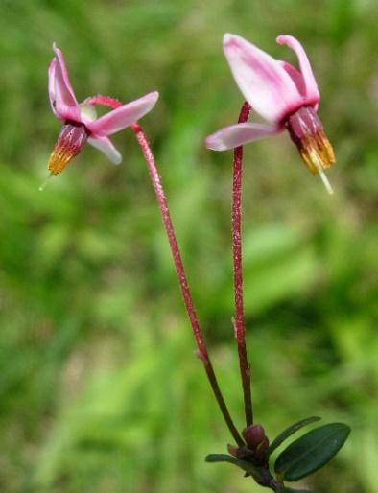
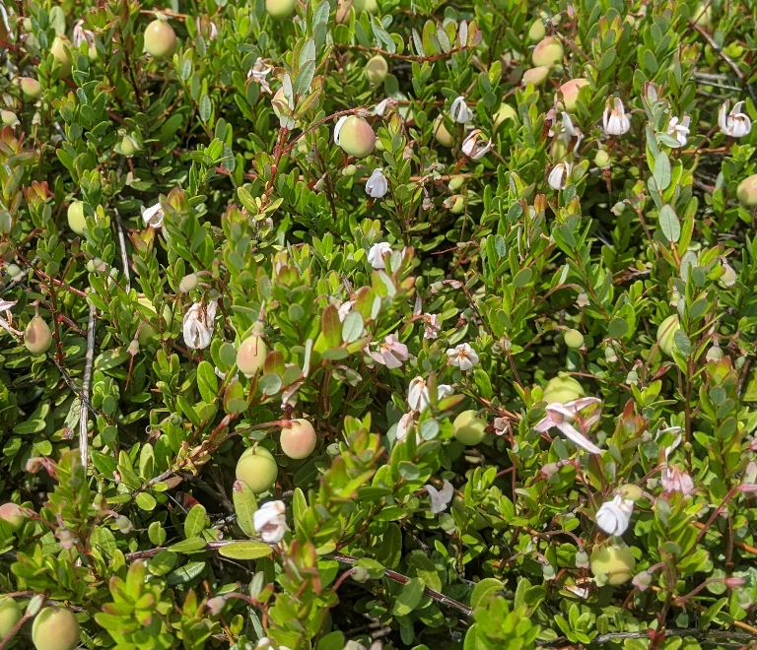

Flowers of the small cranberry (Vaccinium oxycoccos L.)
Flowers and developing fruit of the large cranberry (Vaccinium macrocarpon Aiton.)
Executive Summary
The American cranberry (Vaccinium macrocarpon Aiton) is a major small fruit crop native to North America. The United States is the largest producer of cranberries, with significant production in Canada and Chile. The top producing states are Wisconsin, Massachusetts, New Jersey, Washington, Oregon, and Maine. In 2022, total U.S. cranberry production was more than 8 million barrels (800 million pounds; 360,000 tonnes) (USDA, NASS). The economic value of fresh and processed cranberry production in the U.S. is $3.55 billion annually and represents > 11,600 jobs. In Canada, the value is $411 million and includes > 2,700 jobs.
The primary end products of cranberry have changed over the last 100 years, leading to a change in the desired fruit trait attributes of varieties. Initially high pectin content was a premium attribute for cranberry for sauce, followed by high anthocyanin content for juice drinks. Currently the main product is sweetend-dried-cranberry (SDC) for trail snacks. The fruit attributes for SDCs include homogeneous berry color, a narrow range in color intensity, large fruit size (>2g/berry), and higher fruit firmness.
A cranberry genebank for genetic improvement is available within the U.S. Department of Agriculture (USDA), Agricultural Research Service (ARS), National Clonal Germplasm Repository (NCGR) in Corvallis, Oregon. The NCGR genebank contains 333 cranberry/crop wild relatives of cranberry (146 V. macrocarpon, 77 V. oxycoccus, and 110 V. vitis- idaea). Wild species diversity is represented by seed lots stored at -18º C. Plants at Corvallis are tested for common viruses, viroids, and phytoplasmas as resources allow but this testing may not completely meet the requirements of some foreign countries. Identity is checked by comparison with written description, review by botanical and horticultural taxonomic experts, and evaluation by molecular markers, such as simple sequence repeat markers. A set of single nucleotide polymorphism (SNP) markers for cultivar identification is under development.
Landraces and wild accessions from unrepresented geographies are being sought to broaden the diversity of the cranberry collection. Specimens are especially needed from northeastern North America including the Eastern US and Northeastern Canadian Maritime Provinces; from the Appalachian Mountains; and from the Midwestern states, such as Minnesota, Michigan, and Wisconsin. During the past several decades, in situ conservation strategies have been initiated between the USDA and the U.S. Forest Service, as well as state heritage conservation programs in the Eastern U.S. American crop wild relatives of cranberry are prime candidates for in situ/ex situ conservation collaborations because of species distribution in many National Forests, state parks, and heritage sites from the Mid-western to the Eastern U.S.

- Introduction to the crop
Cranberry and related wild crop species are classified as members of Vaccinium section Oxycoccus and section Vitis-idaea. Section Oxycoccus (which means “sour berry”) includes plants that are perennial evergreen trailing woody vines, while section Vitis-idaea includes lingonberry (or mountain cranberry; V. vitis-idaea L), a circumboreal, evergreen, generally low-growing shrub that has been commercialized in Europe.
This statement will primarily focus on section Oxycoccus, but will mention section Vitis-idaea species as tertiary crop wild relatives (CWR). The cultivated cranberry of commerce is the American cranberry, Vaccinium macrocarpon Aiton, a native eastern North American species adapted to the temperate climate. Initially berries were collected from wild stands by native peoples; later, cultivation began with cuttings of elite native vines that were propagated in suitable moist ‘boggy’ soil locations. Genetic improvement was initiated in the 1930’s by scientists at the USDA and New Jersey, Massachusetts, and Wisconsin Agricultural Experiment Stations in response to ‘false-blossom’ phytoplasma disease and production issues (Chandler et al. 1947). What was an exclusive U.S. and Canadian production has now become international with Chile, New Zealand, and Eastern Europe producing the cultivated cranberry.
  - Botanical features and ecogeographical distribution
Cranberry and blueberry are botanically classified in the genus Vaccinum L. which is in the blueberry tribe, Vaccinieae, of the subfamily Vaccinioideae of the Ericaceae, the heath family (Stevens, 1969). The Vaccinieae includes those Vaccinioideae plants that have inferior ovaries and have more or less fleshy fruits.
Vaccinium is polyphyletic as determined by DNA sequence data of the matK gene and nuclear ribosomal internal transcribed spacer (Kron et al, 2002). Thus, a global taxonomic reassessment of the definition of the genus is needed (Vander Kloet and Avery, 2010). Given that the taxonomy is controversial, this genus, as presently described, contains more than 400 species of vines, epiphytes, shrubs or small trees (Galletta and Ballington, 1996). Most of the described species occur in Malaysia, Southeast Asia, Japan, Africa, Europe, and South America (Vander Kloet, 1988), though about 30 species occur in North America. A number of the North American species have highly palatable fruit and several have been domesticated as commercial crops.
Vander Kloet (1988) described 10 North American sections within this genus. Character traits for blueberry and its closer relatives include 5-merous flowers, a generally fused urceolate corolla, and 5-celled (or pseudo10-celled) ovaries. [For more information on blueberry, please see the Vaccinium Vulnerability Statement, Part 1.] However, cranberry and related wild species of these North American Vaccinium have 4-merous flowers with 4-loculed ovaries.
    - Section Oxycoccus
Section Oxycoccus contains the species V. macrocarpon and V. oxycoccos L. (the small cranberry). The American cranberry is endemic to northeastern US and southeastern Canada, while the small cranberry is circumpolar boreal in distribution and occurs broadly across northern North America (Fig. 1.1).

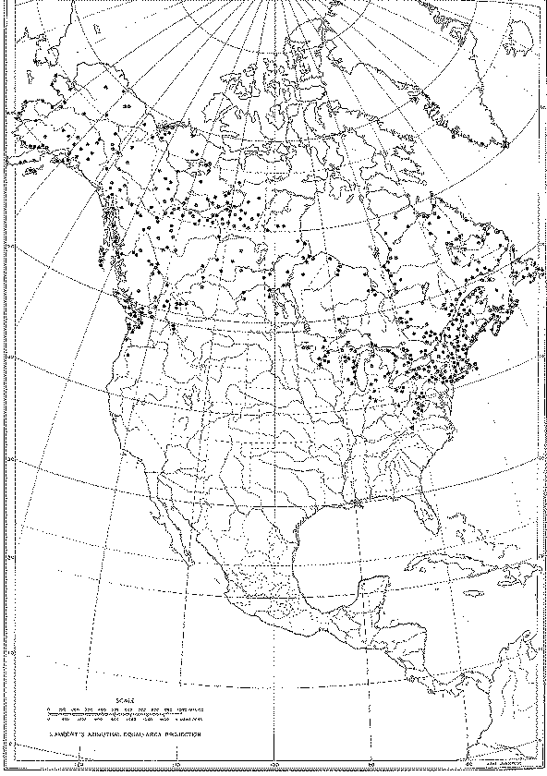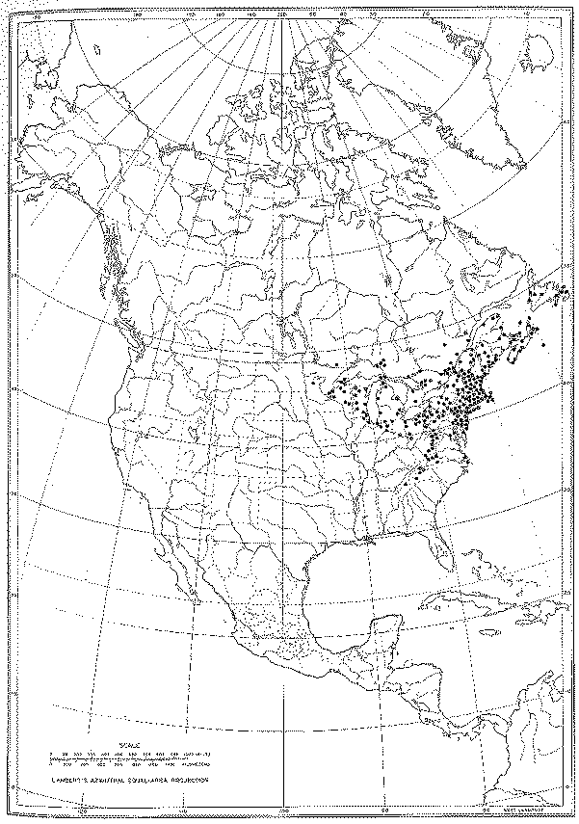
Figure 1.1. Distribution of Vaccinium oxycoccos L. (left) and Vaccinium macrocarpon Aiton (right) from Vander Kloet (1988).

V. macrocarpon is diploid 2n = 2x = 24 and V. oxycoccus members include diploids (2n = 2x = 24), tetraploids (2n = 4x = 48), and hexaploids (2n = 6x = 72) (Hummer et al. 2015). Diploid V. oxycoccos and V. macrocarpon are readily discriminated based on their allozymic variation and tetraploid V. oxycoccos appears to have an autopolyploid origin (Mahy et al. 2000). Autotetraploid V. oxycoccos may have undergone hybridization with V. macrocarpon or the autotetraploid retained the genetic variation present in an ancestral diploid species (Mahy et al. 2000). It has been suggested that V. macrocarpon is the more primitive species (Camp, 1944; Vander Kloet, 1988), however, the richer diversity of tetraploid V. oxycoccos suggests that an ancestral diploid species may be extinct. Intermittent co-migrations of these species following the onset of Pleistocene glaciation, and the occurrence of unreduced gametes in complex with parental isolation have been suggested as an evolutionary mechanism for the development of this ploidy series (Vander Kloet, 1988).
The American cranberry is a trailing, low-growing, woody, evergreen vine. Stolons, referred to colloquially as “runners,” colonize the cranberry bed surface during early establishment. Over time these stolons, juvenile stems, form a dense mat to cover the bog surface, followed by production of a high density fruiting vertical shoots, referred to colloquially as “uprights.” Commercial plantings of this long-lived perennial can remain relatively productive for decades. Leaves normally remain on the plant for two seasons before they abscise. Leaves on subsequent shoots and stolons arising from one year-old wood provide the photosynthetic source.

    - Section Vitis-idaea
The mountain cranberry, Vaccinium vitis-idaeus L. is also known as “lingonberry.” The mountain cranberry is circumpolar boreal in distribution and occurs broadly across North America (Fig. 1.2). The mountain cranberry has campanulate corollas with four small lobes. It is gathered from wild stands throughout Scandanavia, Europe and Russia, and is used commercially for processing into jams and jellies.

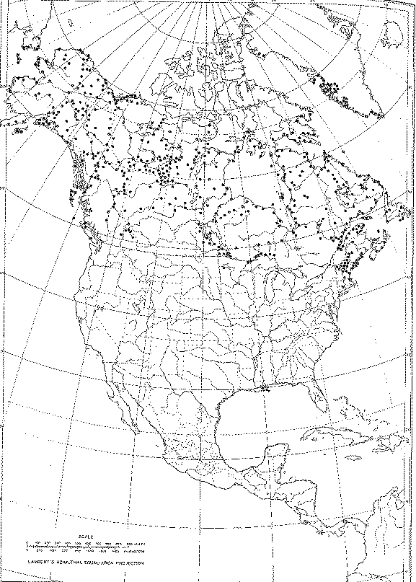
Figure 1.2. Distribution of Vaccinium vitis-idaea L from Vander Kloet (1988).

  - Cranberry production and economics in the U.S. and world
    - Production and economic impact
The total world production of commercial cranberry in 2021 was 495,000 tonnes (or about 11 million barrels; 1 barrel = 100 lbs = 0.045 tonnes), according to the United Nations Food and Agriculture Organization (FAOSTAT, 2023). The top cranberry producing countries (with percent of total production in parentheses) are the United States (62%), Canada (30%), and Chile (3.9%). Other countries that produce reportable amounts of cranberries include Azerbaijan, Belarus, Latvia, North Macedonia, Romania, Tunisia, Turkey, and Ukraine.
Since 2011, cranberry production has increased by 32,000 tonnes (7.0%) (Fig. 1.3). During this time, U.S. production decreased by 29,000 tonnes (8.3%) and Canadian production increased by 68,000 tonnes (76%).

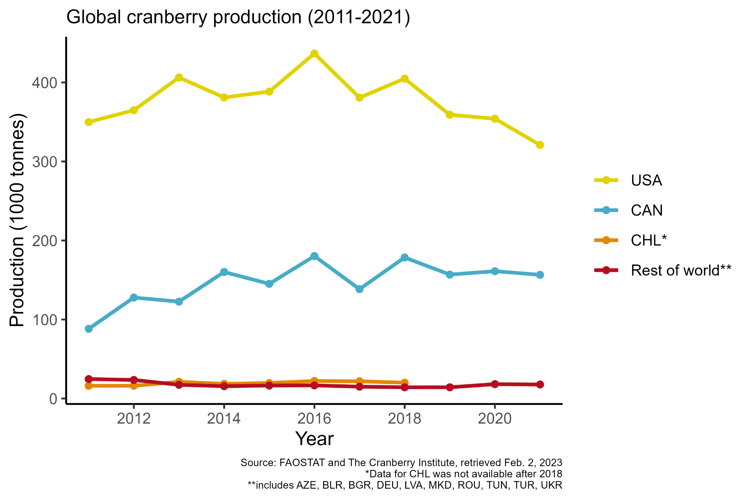
Figure 1.3. Annual cranberry production (tonnes) in countries with major cultivation along with the remaining global production. (USA, United States of America; CAN, Canada; CHL, Chile.)

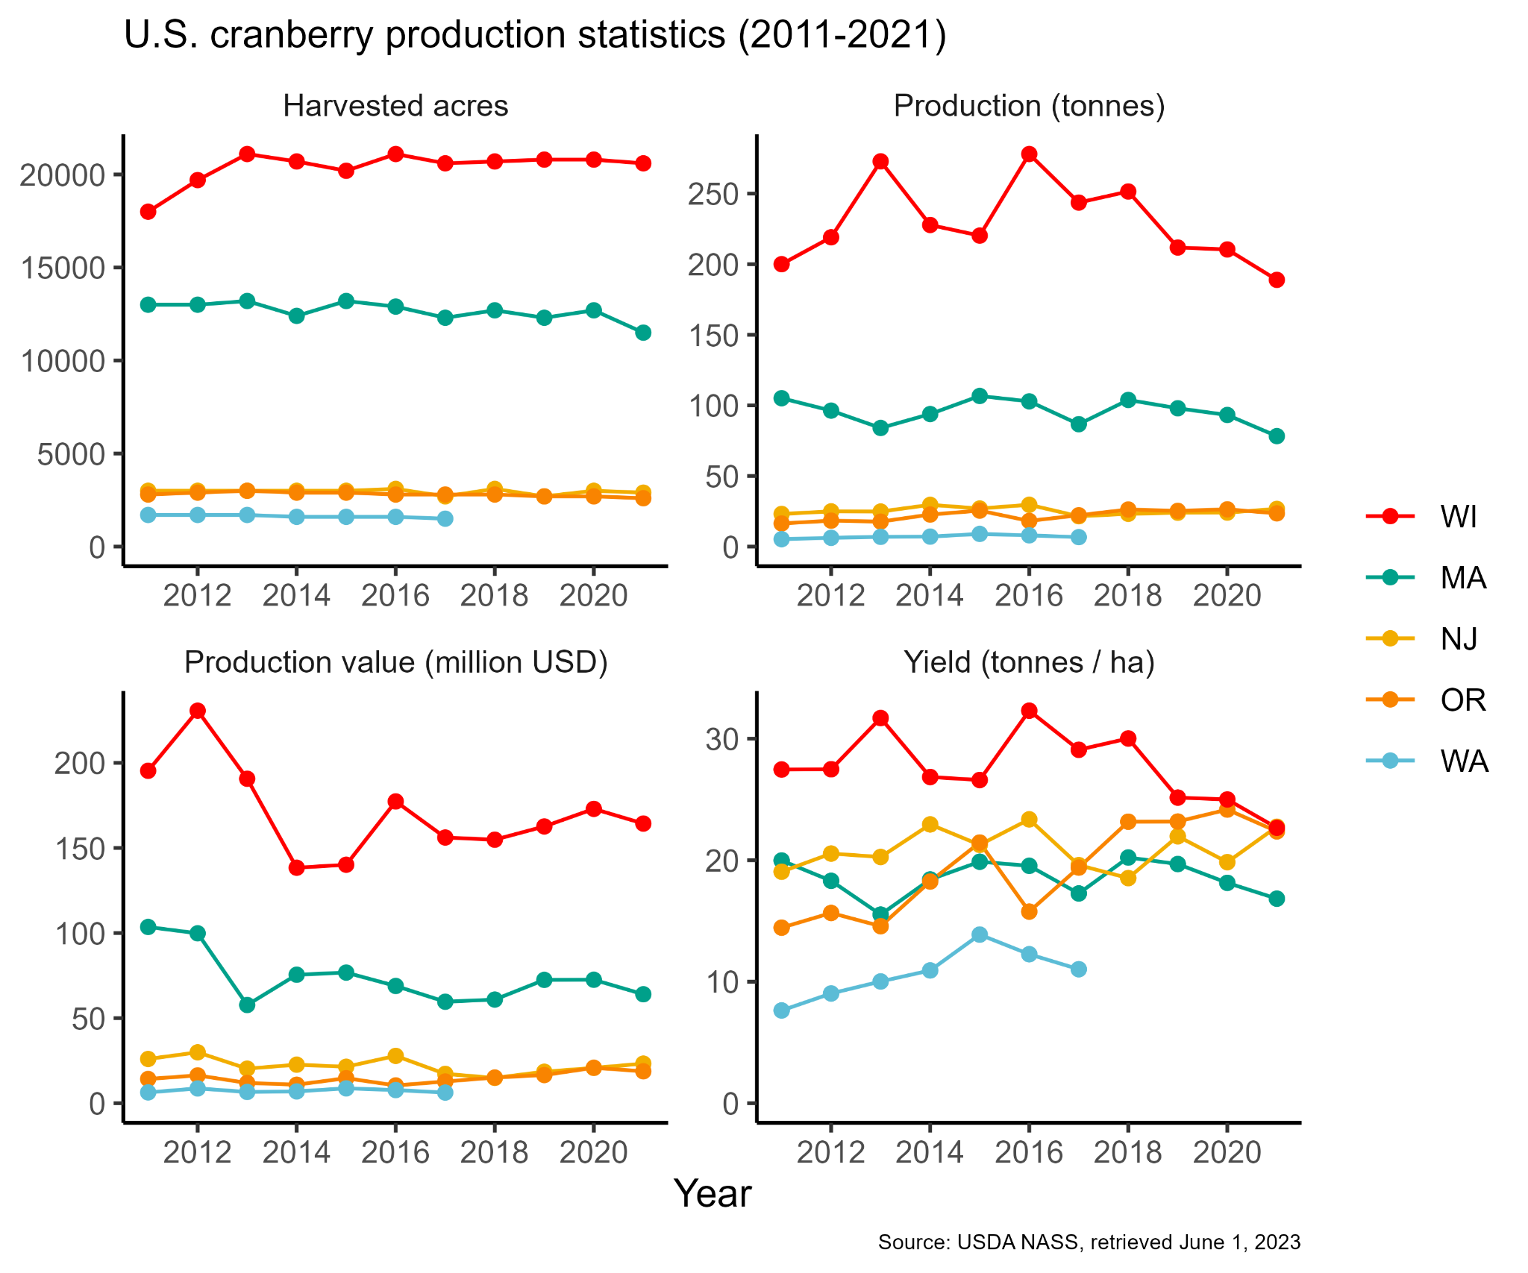
Figure 1.4. Annual cranberry production statistics (harvested acres, production, production value, and yield) for major cultivation States. (WI, Wisconsin; MA, Massachusetts; NJ, New Jersey; OR, Oregon; WA, Washington.)

In the U.S., five states account for the vast majority of cranberry production: Wisconsin (61%), Massachusetts (26%), New Jersey (6.7%), Oregon (6.5%), and Washington (0.88%). From 2011 to 2021, the amount of harvested acres in each state remained relatively stable; however, total production, the value of total production, and yield have been variable (Fig. 1.4).
In Canada, cranberry production primarily occurs in Quebec, the Maritime Provinces, and British Columbia. Quebec’s 2016 cranberry harvest reached almost 275.9 million pounds, a 32% increase compared to the 208 million pounds recorded in 2015. About 80% of Quebec’s cranberry producers are based in the Centre-du-Quebec region. In 2016, Quebec recorded 9,500 acres of cranberry production. The President of the Quebec Association of Cranberry Producers (APCQ), Louis-Michel Larocque, says that cranberry production has been recorded at an average of 29,000 pounds (290 barrels) per acre on Quebec farms. Quebec is the world leader in organic cranberry production. The sector saw a strong 87% increase in 2016 with harvest reaching 40.4 million pounds compared to the 21.6 million pounds recorded the previous year. Organic acreage will see a large increase over the next few years, and the APCQ says it will represents 31% of acreage put into production in 2018.
The Cranberry Institute (2017) estimates that the economic value of cranberry production, fresh and processed, in the U.S. is $3.55 billion annually and represents > 11,600 jobs. In Canada, the value is $411 million and includes > 2,700 jobs. The industry encompasses 59,000 acres of cranberry production in the U.S in 5 states and 3 Canadian Provinces. In addition, Chile, in South America, produces about 2% of the total product.

  - Cranberry genetics and breeding

    - Early selections and breeding (1840 - 1985)
Cranberry varieties were first selected more than 180 years ago from wild native stands in the U.S. (New Jersey, Maine, Michigan, Massachusetts, and Wisconsin) and Canada (Ontario, Quebec, and the Maritime Provinces). The best of these “native selections” were propagated and, in some cases, grown in many locations outside the original region in which they were selected.
The producing acreage in the early 1900’s of cranberry declined due to ‘false-blossom’
disease, a phytoplasma vectored by the blunt-nosed leaf-hopper. In response to this disease, a cranberry breeding program was initiated in 1929 by the USDA in cooperation with the
experiment stations at Massachusetts, New Jersey, and Wisconsin. This program was started by making crosses among elite native selections that were chosen based on productivity, pest resistance (e.g. less feeding preference by the blunt-nosed leafhopper), phenological development, and desirable fruit quality. C.S. Beckwith in New Jersey,
H. F. Bergman in Massachusetts, and H. F. Bain in Wisconsin made the first crosses and
selections for cranberry improvement through breeding.
By the early 1980s, active genetic improvement programs had released seven cultivars available to growers: ‘Beckwith’, ‘Bergman’, ‘Crowley’, ‘Franklin’, ‘Pilgrim’, ‘Stevens’, and ‘Wilcox’ (Eck 1990). These represented a small fraction of the more than 100 varieties that were named and described (Dana, 1983), the majority of which were still native selections. Since then, 16 new cultivars have been released product from breeding programs at the University of Wisconsin-Madison, Rutgers University, and a private Wisconsin breeder (Valley Corp.; http://www.cranberryvine.com/cranberry-varieties)

    - Modern genetic improvement (1985 - Present)
Active cranberry breeding programs include those at USDA-ARS, Rutgers University,
University of Wisconsin, and private breeders. These programs have released cultivars that are
highly improved for yield, fruit qualities, color intensity, fruit size, ripening season, storage
attributes, and keeping quality (Vorsa and Johnson-Cicalese 2012). During the past two decades,
growers began the transition from growing older heritage cultivars to those recently developed
from breeding programs.
The Rutgers University cranberry breeding program was started in 1985 and was led by Dr. Nicholi Vorsa until 2022. Initial breeding efforts focused on consistent higher yields, anthocyanin production (fruit color), fruit size, and season. Since 2006, the program has released seven cultivars: “Crimson Queen” (2006), “Demoranville” (2006), “Mullica Queen” (2007), “Scarlet Knight” (2010), “Haines” (2017), “Welker,” (2017) and “Vasanna” (2020). The program is focused on developing and releasing cultivars that perform well in any of the major cranberry production regions, including New Jersey, Wisconsin, Massachusetts, and the Pacific Northwest. Thus, Rutgers has planted replicated multi-state variety trials between New Jersey, Wisconsin, Oregon, Washington, and British Columbia. The current breeding trait priorities focus on improved yield, fruit quality (firmness, fruit chemistry), heat stress tolerance, and resistance to fruit rot. New Jersey is an ideal location for breeding for stress tolerance and resistance to diseases, due to the severe environmental and pathogen pressures. Newly developed cultivars are protected by plant patents and are licensed to nurseries for propagation.
The breeding program at the University of Wisconsin-Madison was established and led by Dr. Brent McCown and Eric Zeldin in the 1990s to help growers produce better cranberries. Starting in 2003, this program released several cultivars targeting all major cranberry production regions. The program released three cultivars: “HyRed”, “Sundance”, and “Ruby Star.” “HyRed” was the first modern cultivar released in 2003 from crosses between “Stevens” and “Ben Lear” (a selfed derivative called BL8 = open pollinated “Ben Lear”), with the goal of combining the reliable production of “Stevens” with the good color of “Ben Lear”. “HyRed” was selected for early and uniform fruit color development (up to 2+ weeks earlier than “Stevens”), uniform fruit color, good acid flavor, high bud and rebud set, high tipworm tolerance (will set buds despite damage), less prone to overgrowth than “Stevens,” and with reliably good yields. “Sundance” is a full sibling of “HyRed” (“Stevens” x “BL8”) and was selected for its limited overgrowth under high-fertility conditions, mid-late season maturation, reliable fruit color development, large and firm fruit, high bud and rebud set, high tipworm tolerance, and reliably yields over 450 barrels per acre. Finally, “Ruby Star” is a very early flowering and early maturation cultivar with uniform color development, high bud and rebud set, and high fruit set. These released cultivars are protected by UW-Madison through a plant patent and released to growers through the Wisconsin Alumni Research Foundation (WARF) for propagation and use.
In 2010, the USDA-ARS developed the Cranberry Genetics and Genomics Lab (CGGL) at the University of Wisconsin-Madison in the Vegetable Crops Research Unit. This program is currently led by Dr. Juan Zalapa. The goal of this program is to develop cultivars and germplasm that are useful for growers, consumers, and other researchers, in addition to identifying and studying traits that are useful for breeding and developing genetic and other tools to broaden the knowledge base of cranberry. Since its inception the Cranberry Genetics and Genomics Lab has worked on developing molecular tools useful for breeding, including the sequencing of the cranberry plastid and mitochondrial genomes, the development of chromosome scale genomes for the cranberry cultivar “Stevens” and the closest relative of cultivated cranberries, Vaccinium microcarpum. Additionally, the USDA-ARS cranberry breeding program has developed thousands of molecular markers, mainly microsatellites and single nucleotide polymorphisms (SNPs), based on cranberry sequencing data. These markers have been used for genetic fingerprinting of cranberry cultivars, genetic diversity studies, linkage mapping, quantitative trait mapping, and a pilot genomic selection study. The program has also worked extensively in standardizing and improving traditional phenotyping methods while developing and refining new high-throughput phenotyping methods to study traits of economic and horticultural importance. The initial focal traits for the genetic and breeding program included yield, field fruit rot, fruit number, average fruit weight, TAcy, total acid, total soluble solids, and proanthocyanidins. More recently, the CGGL has partnered with the Vaccinium Coordinated Agricultural Project (VacCAP) to allow the development of high-throughput phenotyping methods for fruit quality traits, particularly those related to sweetened and dried cranberry (SDC) production, including: external appearance traits such as color and color variation, fruit size traits and shape traits; internal structure such as fruit size, locule size, and total pericarp area; and fruit texture, such as single compression maximum compression force and the apparent modulus of elasticity. Finally, the CGGL has recently established 3,750 breeding and diversity plots in collaboration with the Wisconsin State Cranberry Growers Association (WSCGA) at the Wisconsin Cranberry Research Station (WCRS). The breeding and diversity plots at WCRS represent a renewed effort by the USDA-ARS at UW-Madison to identify, preserve, and utilize unique genetic materials to breed and release a new generation of improved cranberries. The CGGL use of the latest molecular tools in conjunction with traditional plant breeding will help meet current and future challenges of the cranberry industry, including increasing yield in sustainable production systems, improving berry quality and nutrition, and responding to increasingly variable and extreme climates, insects, and disease pressures.
The newest cranberry breeding initiative is the USDA-ARS pre-breeding program in New Jersey, started and led by Dr. Jeff Neyhart in 2021. This program is part of the Genetic Improvement for Fruits and Vegetables Laboratory. The objectives of this pre-breeding program are to discover and understand genetic variation for useful traits, develop new methods for cranberry improvement, and to deliver superior germplasm and parents for use in the cultivar development programs at Rutgers University and the USDA-ARS program in Madison, WI. To meet these objectives, the program is using high-throughput phenotyping, genomics, and applied quantitative genetics to facilitate efficient trait discovery, increase breeding efficiency, and rapidly improve populations. The breeding program is focused on traits such as tolerance to abiotic stresses, including heat, cold, and drought; resistance to diseases such as false blossom and fruit rot; and maintaining progress in fruit quality and productivity.
- Current and (re)emerging threats and needs
Developing new cranberry cultivars requires breeders to be aware of existing and emerging needs throughout the supply chain, from producer to consumer and germplasm as source of critical breeding traits. Many diseases and pests challenge the growth and production of cranberry. Along with the US Department of Agriculture, and universities in the major cranberry production regions, the cranberry industry is a strong supporter of genetic enhancement efforts through research and breeding. Recently, a study was conducted to investigate the relative importance of cranberry fruit and plant quality traits for growers and processors. Industry responses, in general, signaled that the most important trait clusters were fruit quality, and in particular, firmness, fruit size and anthocyanin content. Among diseases, resistance to field fruit rot ranked the most important trait across all states. There were differences across states in importance assigned to other disease resistance traits, insect resistance and tolerance to abiotic stress (Gallardo et al. in preparation).
Cranberry, being a minor crop, lacks appropriate security propagation protocols for maintaining genetic fidelity, and official certification programs are not present. Primary collections at national genebanks consists of living plants, protected in containers in greenhouses or screenhouses, or growing in the field.
Plant material grown outdoors cannot be certified as pathogen negative. Secondary backup collections are maintained in vitro under refrigerated temperatures. Long-term backup collections of meristems are placed in cryogenic storage at remote locations to provide decades of security. Species diversity is represented by seed lots stored in -18°C or backed-up in tissue culture. Conservation of clonally propagated material, where genotypes were maintained, is more complicated and expensive than storing seeds, where the objective is to preserve genes. The health status of both forms of storage was of primary importance for plant distribution to meet global plant quarantine regulations.
Cranberry and lingonberry, being specialty crops, have limited world resources available for conservation of these crops and their wild relatives. These limited resources constrain the management of Vaccinium genetic resources. Pathogen testing and elimination procedures are critical to maintain pathogen-negative plants to satisfy quarantine requirements.
  - Threats of genetic erosion in situ
According to Natureserve (2017) Vaccinium macrocarpon has a secure species designation (G5). This species is widespread as a native plant in northeastern North America (Kartesz 1999), being found in acidic soils and peatlands including bogs, fens, swamps, and interdunal swales (Vander Kloet 1988, Weakley 2000). This species is rare in the portion of its range along the Appalachians and the Southeastern coastal plain (Weakley 2000).

  - Biotic threats (disease and pests)
    - Viral diseases
Four viruses that infect cranberries have been reported (Appendix Table 3). Martin et al. (2012) describe their vectors and epidemiology whereas McFarlane et al. (2015) provided information on detection methods, regional occurrence, and common primers (Appendix Table 4 and 5).

    - Fungal and bacterial diseases
Cranberry plants and fruit are affected by a number of major fungal diseases including root rots caused by Phytophthora cinnamomi; diebacks caused by Phomopsis vaccinii, Fusicoccum putrefaciens, and Synchronoblastia crypta; fairy rings caused by Helicobasidium longisporum, and leaf spots caused by Pyrenobotrys compacta and Protoventuria myrtilli. Fruit rot is another major problem in all US cranberry growing regions. This “disease complex” is associated with 10 to 15 pathogenic fungal species, varying by year and location (Stiles and Oudemans 1999). Fungicides are the primary agents to target the fungal diseases, though integrated control strategies, such as sanding, improving drainage using tile, stones or installing ditches at the appropriate depth is essential. Despite these control measures, fruit rot is an increasing problem in the US with yield losses due to fruit rot of 50 to 100% on new cultivars. Exacerbating this issue are the diminishing fungicide chemistries available to manage the disease. Sources of fruit rot resistance and QTLs have been identified, however screening studies to evaluate germplasm performance are lacking. The continuum of host-pathogen interactions is not well understood for fruit rot. Due to the endophytic nature of these fungi, the environment plays a key role in how infections develop and spread. Previous fruit rot breeding efforts have centered on host-pathogen interactions, but future studies should address the host genotype interactions with the environment to evaluate stability. In the survey mentioned above, among 10 disease resistance traits, resistance to fruit rot was identified as the most important trait. Few commercially available varieties possess fruit rot resistance
http://journal.ashspublications.org/content/140/3/233.abstract
https://link.springer.com/article/10.1007/s11032-017-0639-3
The acidic environment of a cranberry bed is not hospitable to many bacterial pathogens. However, a subgroup 16SrIII-V phytoplasma associated with false blossom disease significantly affects cranberry yield (Lee et al., 2014). The phytoplasma is lethal to vines, reducing plant growth and yield, and has played a significant part in the development of cranberry cultivars (Caruso 2008). The false blossom phytoplasma is vectored by leafhoppers, namely the blunt-nosed leafhopper (Limotettix vaccinii). The disease has been a problem since cranberries first became cultivated in the early 1900s. The disease likely originated in Wisconsin but was transferred on planting material to New Jersey and Massachusetts. The disease had a significant impact on New Jersey cranberry production, sterilizing beds across the state leaving them unproductive. But despite the disease issue, researchers observed differential resistance by cultivar. ‘McFarlain’ and ‘Early Black’ were resistant, ‘Bennett Jumbo’ and ‘Vorse’s Pride’ had moderate infection, and ‘Bell’, ‘Berlin’, ‘Centennial’, ‘Howes’, ‘Metallic Bell’, ‘Palmeter’, ‘Prolific’, ‘Searles’, and ‘Wales Henry’ were susceptible. The resistance observed is hypothetically achieved due to the preference of the leafhopper to tissue of the different cultivars. In 1929, when the USDA initiated a cranberry breeding program, false blossom was considered a top priority. The cultivar ‘Stevens’ (derived from ‘McFarlind’ X ‘Potter’) resulted from these efforts and became established across the US production regions offering growers good production, good keeping quality, and false blossom resistance. ‘Stevens’ dominated the industry for many decades, and still does in states like Wisconsin. But with the development of newer hybrid varieties that favor agronomic traits such as yield and color, genetic resistance to cranberry false blossom (or its vector) is unknown in these varieties. Recent outbreaks of the phytoplasma and insect vector have significantly impacted the industry in New Jersey, and have since been identified in Massachusetts and Wisconsin.
    - Insect and arthropod pests
Insect pests include the black-headed fireworm Rhopobota naevana (Hübner) Cranberry fruitworm (Acrobasis vaccinii Riley), Sparganothis fruitworm (Sparganothis sulfureana Clemens), Cranberry weevils (Anthonomus musculus Say), cutworms, and green and brown span worm. Cranberry beds are monitored using a sweep net and integrated pest management strategies are applied according to the catch. Flooding of the bog, pheromones, mating disruption, and chemicals that interfere with insect growth stages are applied. In the early 1900s, the blunt-nosed leafhopper was an early challenge for the newly started New Jersey cranberry industry.
This leafhopper vectored the phytoplasma that caused “false-blossom” disease. Several US Department of Agriculture entomologists noticed differential feeding by the insect on different cultivars. The first breeding program was established with the goal of developing cultivars with blunt-nosed leafhopper resistance. Based on field observations and feeding preferences, Wilcox and Beckwith (1933) reported that ‘Early Black’ and ‘McFarlin’ were not preferred as compared with ‘Howes’. The cultivars ‘Plum, and ‘Shaw’s Success’ were also most resistant, while Bergman, ‘Franklin’, ‘Pilgrim’ and ‘Wilcox’ were resistant (Dana 1983). To control this disease crosses were made using the resistant cultivars, to obtain resistant offspring. However a false-blossom’ resistant variety was not forth coming. It should be noted that as organo-phospahte insecticides are banned or restricted new insect threats have emerged, e.g., toad-bud, myriads, thrips.
In a 2017 survey, differences were observed in the importance of selected insect pest resistance traits. In New Jersey, respondents indicated that the most important pest resistance trait was for blunt-nose leafhoppers, whereas in Wisconsin cranberry fruit worm, and in British Columbia, cranberry tip worm.
    - Abiotic (environmental extremes, climate change)
Abiotic stresses are major environmental challenges that impact cranberry plant productivity. In the 2017 survey, North American cranberry production regions differed in the ranking of abiotic stress traits (Gallardo et al.). In New Jersey, heat stress was selected as the most important abiotic stress trait, while in Wisconsin and British Columbia fall and spring frost tolerance was most important.
    - Production/demand (inability to meet market and population growth demands)
While cranberries used to be produced only for fresh use and sauces, then a product line of juices were developed. Higher amounts of fruit production encouraged innovative development of products. Cranberry product lines include juice, sweetened-dried-fruit, sauces, fresh fruit, nutraceutical powders, and other miscellaneous forms.
Processed cranberry product sales have been increasing over the past three decades and as of 2017 require > 9 million barrels of fruit. Unfortunately, over those decades there has been an increasing overproduction of fruit (oversupply) compared with the product sales (demand) which has kept price return for growers low.
As mentioned above, a renced breedind trait survey indicated that improving fruit quality is a primary need for cranberry industry. The most important fruit quality trait indetified in this survey were: fruit firmness, fruit size and color. These traits that can affect price premiums the grower receives, can positively drive consumer demand, and improve processing handling, which are all critical factors to the economic viability of the cranberry industry.

    - Dietary key nutritional requirements)
The North American cranberry has multiple health benefits linked to phytochemicals in the fruit. Cranberry juice is consumed for the prevention of urinary tract infections (Vorsa et al. 2002). This property is linked with the ability of proanthocyanidins to inhibit adhesion of uro-pathogenic P-fimbriated E. coli bacteria responsible for these infections.
Cranberry flavonoid extract has been shown to ameliorate metabolic syndrome molecular status, a precursor stage to diabetes II, through adiponectin modulation in a rat model (Shabrova et al 2012). Cranberry proanthocyanidins are active against dental caries Streptococcus mutans (Dongyeop et al. 2015, Koo et al. 2010). Additional studies have found that cranberry constituents also inhibit adhesion of a major cause of gastric cancer. Emerging evidence suggests that cranberry phytochemicals (particularly proanthocyanidins, quercetin, and ursolic acid) have a mitigating effect on other types of cancers as well and could be a dietary chemoprotective (Wang et al. 2015).

Fig. 2.3.4.1 Key Dietary nutritional compounds in cranberry
Nutrient | Unit | Value per 100 g
Proximates
Water | g | 87.32
Energy | kcal | 46
Protein | g | 0.46
Total Lipid (fat) | g | 0.13
Carbohydrate, by difference | g | 11.97
Fiber, total dietary | g | 3.6
Sugars, total | g | 4.27
Minerals
Calcium, Ca | mg | 8
Showing 33 nutrients
https://ndb.nal.usda.gov/ndb/foods/show/2191?fgcd=&manu=&lfacet=&format=&count=&max=50&offset=&sort=default&order=asc&qlookup=cranberries&ds=Standard+Reference&qt=&qp=&qa=&qn=&q=&ing=

    - Accessibility (inability to gain access to needed plant genetic resources because of phytosanitary/quarantine issues, inadequate budgets, management capacities or legal restrictions)
Because cranberries are a North American native crop, access to plant genetic resources are direct. The primary species is not threatened or endangered for the most part. Phytosanitary or quarantine regulations are not an issue. Recently released cultivars are under US Plant Patents. As these patents expire the germplasm will become available to the domestic collections. Wild species and heritage cultivars are available and accessible to researchers and the public.

- Germplasm resources for reducing vulnerabilities
  - Germplasm collections
The NCGR-Corvallis holdings include two types of accessions: clonal and species
1) Clonal plants (living collections) that are propagated vegetatively and represent specific genotypes. These include heritage cultivars, newer cultivars, selections that contain specific traits of interest and elite wild accessions.
2) Broader species collections are represented by seed lots or additionally by plant representatives of certain populations.

The NCGR-Corvallis collection presently has about 85 cultivars. A recent study was conducted using 12 simple sequence repeats (SSRs) to examine clonal purity and cultivar relatedness of 271 plants from 77 accessions representing 66 named cultivars in the NCGR collection (Schlautman et al. in preparation). Intra-cultivar variants (sub-clones) existed in the germplasm collection, a problem that likely stems from past misidentification or mixed clones of the accessions acquired by the NCGR. Consensus and true-to-type genotypes were found for many cultivars and wild selections by comparisons of genotypes in this study with previous ones, and a pedigree analysis. However, others were apparently absent suggesting that the collection can still be improved by sampling genotypes in cranberry bogs from commercial marshes across the growing regions or from breeders.

  - Conservation in situ
The USDA Agricultural Research Service and the US Forest Service (USFS) have joined forces to conserve CWR native to the US, specifically on lands in the National Forest System. The collaboration was formalized through an agreement between the agencies and further developed in The USFS-ARS Joint Strategic Framework on the Conservation and Use of Native Crop Wild Relatives in the United States, finalized in 2014. The foundation of the strategic framework is its emphasis on complementary conservation, with plants in living populations on National Forest Lands linked with germplasm conserved ex situ in genebanks of the NPGS. Two general approaches are established, one focusing on conserving the CWR of one specific crop, and the other on CWR of multiple crops within the boundaries of a specific protected area.
As a pilot study for the first approach to in situ conservation in the Framework, the USDA ARS Plant Exchange Office of the National Germplasm Resources Laboratory is collaborating with USFS botanists on the conservation of the wild relatives of cranberry, including wild stands of V. macrocarpon and V. oxycoccos. Representative populations of these species across the species’ native ranges in the US are being studied on National Forests. Standard protocols developed by the ARS and USFS are being used to collect leaf tissue for DNA analysis, collect fruit and seed, and prepare herbarium vouchers.
Representative germplasm is maintained as seedlots and plants at the National Clonal Germplasm Repository in Corvallis, Oregon. Herbarium vouchers are maintained by the U.S. National Arboretum in D.C. The goal is to identify those populations that are the highest priority for designation as In Situ Genetic Resource Reserves (IGRRs). This designation will be based on location, distance from other populations, sustainability, population size, genetic profile, ease of access, and cultural significance to Native Americans. Long-term management plans will be implemented by the USFS to monitor, manage, and safeguard the security of the populations. In the future, expansion of the study to populations outside the National Forest System is planned to encompass broader genetic diversity of the two American wild cranberry species, V. macrocarpon and V. oxycoccos.

  - Gaps in genetic coverage
Other heritage cultivars from the U.S. and wild accessions unrepresented geographically in the collection are being sought to broaden representation of cranberry diversity in the collection. Species representatives are especially needed from northeastern North America including the Eastern coast of the United States and Northeastern Canadian Maritime Provinces; from the Appalacian Mountains in the south; and from the northern Midwestern states, such as Minnesota, Michigan, and Wisconsin. Recent collections from USDA scientists in the mid-west will be donated to the NCGR ex situ collection.
During the past several decades, in situ conservation strategies have been established between the US Department of Agriculture and sister agencies, such as the U.S. Forest Service, as well as state heritage conservation programs in the Eastern U.S. American crop wild relatives of cranberry are prime candidates for in situ/ex situ conservation collaborations because of species distribution in many National Forests, state parks, and heritage sites from the Mid-western to the Eastern U.S.

  - List of designated primary, secondary, and tertiary crop wild relatives

Primary genetic relative: Taxa that cross readily with the crop (or can be predicted to do so based on their taxonomic or phylogenetic relationships), yielding (or being expected to yield) fertile hybrids with good chromosome pairing, making gene transfer through hybridization simple.
Secondary genetic relative: Taxa that will successfully cross with the crop (or can be predicted to do so based on their taxonomic or phylogenetic relationships), but yield (or would be expected to yield) partially or mostly sterile hybrids with poor chromosome pairing, making gene transfer through hybridization difficult.
Tertiary genetic relative: Taxa that can be crossed with the crop (or can be predicted to do so based on their taxonomic or phylogenetic relationships), but hybrids are (or are expected to be) lethal or completely sterile. Special breeding techniques, some yet to be developed, are required for gene transfer.

Crop: CRANBERRY
(compiled by Dr. Blanca León)
Crop taxon:
- Vaccinium macrocarpon Aiton – cranberry
Crop wild relatives:
Primary
- Vaccinium macrocarpon Aiton [wild types]
Secondary
- Vaccinium oxycoccos L.
Crop: LINGONBERRY
(compiled by Dr. Blanca León)
Crop taxon:
- Vaccinium vitis-idaea L. – lingonberry
Crop wild relatives:
Primary
- Vaccinium vitis-idaea L. [wild types]
Secondary
- Vaccinium myrtillus L.
- Vaccinium uliginosum L.

  - Expanding, maintaining, and disseminating germplasm collections

    - Acquisitions
      - Plants
From any country plant material must be obtained from the USDA Animal and Plant Health Inspection Service. Vaccinium plants and plant parts from Canada are prohibited and a permit is required. Permits can be obtained through application the USDA APHIS PPQ website
http://www.aphis.usda.gov/plant_health/permits/

APHIS works with state departments of agricultural, such as the Oregon Department of Agriculture (ODA) to provide inspection of plant material for the Vaccinium genebank in Corvallis.

      - Seeds
Fruit from foreign countries is prohibited. Seed must be extracted from the fruit prior to importation from foreign sources.

To extract seed, fruit are soaked in solution of 5% pectinase overnight. The solution is put in a blender with the blades masked. The solution and the fruit pulp are decanted. Floating seeds are eliminated. The seeds that sink are air dried on paper towels and then dried in desiccators to about 6% moisture. Seeds can be placed in coin envelopes and placed in aluminized plastic envelopes and stored at -20ºC. Seeds are germinated and plant representatives are chosen from vigorous seedlings.

    - Maintenance
      - Clonal storage
The pathogen-tested primary Vaccinium collection is maintained under screen. Two containers are preserved for each genotype. The highbush cultivars are alternated with prostrate-growing accessions on benches in the screenhouse to maximize useage of space (Fig. 1).

We apply a pumice topdress (collar) to finished and intermediate sized plant material. The goal is to create a sterile (dry and inorganic) surface that will prevent weed and moss growth. This also can prevent or reduce fungus gnats.
We dibble, or bury our fertilizer under the topdress as part of this goal. This topdress combined with our stable, bark-free medium creates a growing system that greatly reduces water usage. This in turn reduces nutrient leaching, salt build-up, and moisture stress.
The abrupt change from fine growing medium to coarse pumice breaks the hydrolic conductivity between these materials and prevents capillary movement of water to the pot surface. Water in the medium is lost primarily through transpiration via stomata and not evaporation from the pot surface.
This topdress is a third component to the physical structure of our growing system. The other two are: Pot height (distance of crown to perched water table) and percent free air space. Tall pots with good aeration give healthy growth. The pumice collar reduces maintenance effort (sanitation and watering) and conserves resources (nutrients). The drawback of this system is that it can be difficult to evaluate moisture levels and develop a watering schedule. Scratching the surface to see moisture and pot weight are effective in gauging watering frequency. Overall, for us, the pumice topdress reduces significantly reduces cultural risk to containerized plant material.
The pumice collar is ideal for vigorous or pot bound material that needs frequent water. If you put a pumice collar on weak or poorly rooted material that needs a well aerated medium, you can get saturated conditions and loss of material. In this case, it is better to allow the plants to get established and apply the topdress later. I’m recommending a pumice collar for healthy, typical material. For xeric or high montane material that needs superior drainage, or has a prolonged dry dormancy, a pumice collar should only be used over medium with superior porosity and only after establishment or not at all. For slow growing montane material this is a compromise between control of fungus gnats and root aeration.

      - Seed storage
After collection and extraction, seeds are put into manila seed envelops and then into plastic-aluminum envelops for storage in -20ºC chest freezers in Corvallis. With quantities above 2,000, roughly half are shipped to USDA Ft. Collins, Colorado, and about one quarter are shipped to Svalbard Global Seed Vault in Norway for long term remote conservation.

    - Distributions and outreach
Cranberries are distributed as stem cuttings, tissue cultures, pollen, flowers, leaves, or seed. For most plant requests, cuttings are available for distribution during the dormant season from November through January. Cold stored tissue cultured plants in plastic packets (depending on availability) or seeds can be distributed any time of year.

  - Additional information about the National Clonal Germplasm Repository cranberry collection
Information about the National Clonal Germplasm Repository is available from the NCGR website: http://www.ars.usda.gov/main/site_main.htm?modecode=53-58-15-00. Cranberry information is searchable on the new GRIN-Global database: https://npgsweb.ars-grin.gov/gringlobal/taxon/taxonomysearch. This database contains passport information, genotypic characterizations, and phenotypic evaluations of many accessions.

    - Significant accomplishments

- Significant plant collections from the US in multiple collecting trips over 30 years.
- Significant plant collections of blueberry crop wild relatives were obtained from Canada, Japan, China, Russia, and Vietnam (Hummer et al. 2016)
- Conservation of heritage cranberries dating back to the 1800s.
- Tissue culture core cultivars and species clones in the NCGR-Corvallis and at the NCGRP Ft. Collins.
- Wild cranberry populations in National Forests across the US are under evaluation for potential as in situ genetic reserves (USDA-ARS, USFS, Univ. of Wisconsin).
    - Future goals and emphases

- Obtain primary, secondary, tertiary crop wild relatives of cranberry with favorable or novel fruit quality, resistance to pests and diseases, and tolerance to abiotic stresses
- Obtain heritage cultivars from state agricultural experiment stations or elsewhere in the US
- Obtain wild cranberry relatives from Asia to Northern America
- Analysis of fruit content variability within the genus
- Develop molecular markers, SNPs, or sequencing to distinguish cultivars at the subclonal level.
- Screen cranberry germplasm for resistance for the regionally important key insects and diseases
- Improve efficiency of containerized collections of cranberry plants for long-term conservation.
- Regenerate seedlots of accessions that were wild collected for more availability to requestors.
- Continue and expand on-going in situ efforts for cranberry conservation.

    - Curatorial, managerial and research capacities and tools

Staffing for Vaccinium management
0.1 FTE Cat. 4 support scientist Curator
0.1 FTE Cat. 4 plant pathologist/ testing and clean up
0.1 FTE Cat. 4 geneticist for identity confirmation/diversity assessment
0.1 FTE Program Assistant (GS-7)
0.1 FTE Bio Sci Res Tech (GS 9) – greenhouse manager
0.1 FTE Bio Sci Res Tech (GS 9) – tissue culture/cryogenic technician
0.1 FTE Bio Sci Res Tech (GS 9) – distribution
0.5 FTE Bio aid (GS 5) – propagation
0.1 FTE time slip labor- for plant management
1.3 FTE total USDA labor for cranberry efforts

Facilities and equipment ft² m²
1 Screenhouses for Vaccinium only 6,000 700
1 polycarbonate growing area 6,000 700
(below only 1/10 for blueberry)
Main Office and Laboratory Space 9,830 929
Four Greenhouses 10,229 937
Headhouse 6,500 614
One Shadehouse 1,720 164
Boiler Room 400 38
Shop Work Area 1,704 161
Two Storage Sheds 3,960 374
Two Walk-in coolers 360 36
North Farm Building 2,220 210
Additional facilities and support
Fuel Tanks
Above ground diesel 2 @ 500 gal
Above ground gasoline 1 @ 500 gal
4 wells
Land
Buildings and Grounds 5 acres (2.23 hectares)
(25 year lease from OSU starting January 1, 1978)
(Lease has been signed for additional 25 year extension 2004 through 2029)
Planted (other non-strawberry crops)
20 acres (8.09 hectares) at 33447 Peoria Road, Corvallis, OR 97333
(Agreement with OSU Department of Horticulture on Lewis Brown Farm)
Additional Plantings 42 acres (17 hectares) USDA-ARS owner
33707 S.E. Peoria Road, Corvallis, OR 97333
Staffing for Facilities Management
Location Engineering Technician GS-9 available for consultation and advice
Unit Maintenance Technician WG-5 provides 0.15 FTE of facilities maintenance.
Janitor WG-1, 0.15 FTE

Equipment
Tissue culture laboratory (media prep, culturing, growth room, cryogenic option)
Molecular marker laboratory (molecular marker determination)
Pathogen testing laboratory (bio assays, ELISA, PCR, rtPCR)
Plant propagation equipment (mistbed, propagation houses, quarantine facility)
Field propagation

Fiscal and operational resources
Federal funding to support federal Vaccinium germplasm management at NCGR- Corvallis: FY 2016 – $153,000.

About $10,000 per annum to fund small fruit germplasm evaluation proposals from USDA Crop Germplasm Committee evaluation grants. In addition plant exploration/exchange funding can be applied for through the USDA annual granting process.

6. References
Camp WH (1944). A preliminary treatment of the biosystematy of Oxycoccus. Bul. Torrey Bot. Club 71: 426-437
Caruso F (2008). Disease management 2008. pp 1-6 in in: MM Sylvia and N. Guerin (eds.) Cranberry chart book-management guide for Massachusetts. UMass Cranberry Sta. Ext. Publ. East Whareham, Massachusetts
Chandler FB, Wilcox RB, Bain HF, Bergman HF, Dermen, H (1947). Cranberry breeding investigation of the U.S. Dept. of Agriculture. Cranberries 12: 6-9 (May); 12:6-10 (June)
Cranberry institute (2017). Crop statistics about cranberries. http://www.cranberryinstitute.org/about_cran/Cropstatistics_about.html accessed 09/03/2017
Dana MN (1983). Cranberry cultivar list. Fruit Var. J. 37:88-95.
Daverdin G, Johnson-Cicalese J, Zalapa J, Vorsa N, Polashock J. (2017). Identification and mapping of fruit rot resistance QTL in American cranberry using GBS. Mole. Breed. 37:38.
Dongyeop K, Huang G, Liu Y, Wang Y, Singh AP, Vorsa N, Koo H (2015). Cranberry flavonoids modulate cariogenic properties of mixed-species biofilm through exopolysaccharides-matrix disruption. PLoS ONE 10(12): e0145844. doi:10.1371/journal.pone.0145844
Eck P (1990). The American cranberry. Rutgers, The State University. New Brunswick. 420 pp.
Gallardo RK, Zhang Q, Klingthong P, Polashock J, Rodriguez-Soana C, Vorsa N, Harbut R, Atucha A, Zalapa J. and Iorizzo M (2018) Breeding Trait Priorities of the cranberry Industry in the United States and Canada. In preparation.
Galletta, GJ, Ballington, JR (1996). Blueberries, cranberries and lingonberries. Chapter 1, pp. 1 – 109 in: Janick J and Moore JN, (eds.) Fruit Breeding, Vol. II, Vine and Small Fruit Crops. John Wiley and Sons, Inc. New York.
GRIN-Global. Germplasm Resources Information Network-Global (2017). Taxonomy for the National Plant Germplasm System. https://npgsweb.ars-grin.gov/gringlobal/taxonomybrowse.aspx
Hagerup O (1940). Studies on the significance of polyploidy. IV. Oxycoccus Hereditas 26:399-410.
Humfeld R (2017). Cranberry overview. The Cranberry Institute. Presentation notes from North Carolina meeting in May 2017.
Hummer KE, Bassil NV, Rodríguez Armenta HP, Olmstead JW (2015). Vaccinium species ploidy assessment. Acta Hortic. 1101:199-204. DOI 10.17660/ActaHortic.2015.1101.30
Hummer KE, Oliphant J, Kien NV, and Hoai, T (2016). Wild Vietnamese relatives of blueberry. Acta Horticulturae. In press.
Kartesz JT (1999). A synonymized checklist and atlas with biological attributes for the vascular flora of the United States, Canada, and Greenland. First edition. In: Kartesz, J.T., and C.A. Meacham. Synthesis of the North American Flora, Version 1.0. North Carolina Botanical Garden, Chapel Hill, N.C.
Koo H, Duarte S, Murata RM, Scott-Anne K, Gregoire S, Watson GE, Singh AP, Vorsa N (2010). Influence of cranberry proanthocyanidins on formation of biofilms by Streptococcus mutans on saliva-coated apatitic surface and on dental caries development in vivo. Caries Res 44:116–126.
Kron KA, Powell AE, and Luteyn JL (2002). Phylogenetic relationships within the blueberry tribe (Vaccinieae, Ericaceae) based on sequence data from mat K and nuclear ribosomal ITS regions, with comments on the placement of Satyria. Amer. J. Bot. 89: 327-336
Lee I, Polashock JJ, Bottner-Parker KD, Bagadia PG, Rodriguez-Saona C, Zhao Y, Davis RE (2014). New subgroup 16SrIII-V phytoplasmas associated with false-blossom diseased cranberry (Vaccinium macrocarpon) plants and with known and potential insect vectors in New Jersey. European Journal of Plant Pathology. 139:393-400
MacFarlane S, McGavin W, and Tzanetakis IE (2015). Virus-testing by PCR and RT-PCR amplification in berry fruit. Methods Molec. Biol. Pl. Path. 1302: 227-248
Mahy G, Bruederle LP, Connors B, Van Hofwegen M, Vorsa N (2000). Allozymes revealed genetic autopolyploidy and high genetic diversity in tetraploid cranberry, Vaccinium oxycoccos (Ericaceae). Amer. J. Bot.87:1882-1889
Martin RR, Polashock JJ, and Tzanetakis IE (2012). New and emerging viruses of blueberry and cranberry. Viruses 4: 2831-2852
Moerman DE (2009). Native American medicinal plants: an ethnobotanical dictionary. Timber Press. Portland, Oreon. p. 205
NatureServe (2017). NatureServe Explorer: An online encyclopedia of life [web application]. Version 7.1. from NatureServe http://explorer.natureserve.org
Shabrova EV, Tarnopolsky O, Singh AP, Plutzky J, Vorsa N, Quadro L (2011). Insights into the Molecular Mechanisms of the anti-atherogenic actions of flavonoids in normal and obese mice. PLoS ONE 6(10): e24634. doi:10.1371/journal.pone.0024634.
Stevens PF (1969). Taxonomoic studies in the Ericaceae. Ph D. thesis. University of Edinburg, Scotland
Stiles CM, Oudemans PV (1999) Distribution of cranberry fruit-rotting fungi in New Jersey and evidence for nonspecific host resistance. Phytopathology 89:218–225
Turner NJ (1975). Food plants of British Columbia Indians Part 1-Coastal peoples. Brigish Columbia Provincial Museum Handbood 34. Victoria, B.C. 264 pp
Tuner NJ (1978). Food plants of British Columbia Indians Part 2- Interior peoples. Brigish Columbia Provincial Museum Handbood 34. Victoria, B.C. 259 pp
UNFAO (2017) UN Food and Agricultural Statistical Database for agricultural production. http://www.fao.org/faostat/en/#data/QC accessed 08/08/2017
Vander Kloet SP (1988). The genus Vaccinium in North America
Vander Kloet SP, Avery TS (2010) Vaccinium on the edge. Edinburgh J. Bot. 67(1):7-24
Vorsa N, Polashock J, Howell A, Cunningham D, Roderick R. (2002). Evaluation of fruit chemistry in cranberry germplasm: potential for breeding varieties with enhanced health constituents. Acta Hortic. 574: 215-219
Vorsa N, Johnson-Cicalese J (2012). American cranberry. Chapter 6, pp.191-223 In: Badenes, ML and DH Byrne Fruit Breeding Springer New York
Wang Y, Han A, Chen E, Singh RK, Chichester CO, Moore RG, Singh AP, Vorsa N (2015). The cranberry flavonoids PAC DP-9 and quercetin aglycone induce cytotoxicity and cell cycle arrest and increase cisplatin sensitivity in ovarian cancer cells. Int. J. Oncology 46: 1924-1934
Weakley AS (2000). Flora of the Carolinas and Virginia: working draft of May 15, 2000. Unpublished draft, The Nature Conservancy, Southern Resource Office.
Wilcox RB, Beckwith CS (1933). A factor in the varietal resistance of cranberries to the false blossom disease. J. Agric. Res. 47:583-590

7. Appendices

Appendix Table 1. Cranberry crop wild relative species and synonyms listed in GRIN, October 2017.
- Vaccinium erythrocarpum Michx.
- Vaccinium erythrocarpum subsp. erythrocarpum
- Vaccinium erythrocarpum subsp. japonicum (Miq.) Vander Kloet
- Vaccinium hybr.
- Vaccinium macrocarpon Aiton
- Vaccinium oxycoccos L.
- Vaccinium vitis-idaea L.
- Vaccinium vitis-idaea subsp. minus (Lodd. et al.) Hulten (=Vaccinium vitis-idaea L.)
- Vaccinium vitis-idaea var. minus Lodd. et al. (=Vaccinium vitis-idaea L.)

Appendix Table 2. Cranberry and crop wild relatives species held at the NCGR-Corvallis (Grin-Global October 2017)
Species name | No. accessions
Vaccinium erythrocarpum | 5
Vaccinium erythrocarpum subsp. japonicum | 3
Vaccinium hybr. | 74
Vaccinium macrocarpon | 113
Vaccinium oxycoccos | 74
Vaccinium vitis-idaea | 109

Appendix Table 3. Viruses that infect Cranberries
Virus name | Acronym | Genus | Transmission
Blueberry red ringspot virus | BRRV | Soymovirus | ?
Blueberry scorch virus | BlScV | Carlavirus | aphids/non-persistent
Blueberry shock virus | BlShV | Ilarvirus | pollen/seed ◊
Tobacco streak virus | TSV | Ilarvirus | pollen/seed □◊

◊ Also transmitted by pollen feeding arthropods
□ Pollen and seed transmitted

Appendix Table 4. Regional occurrence of viruses in cranberry
Virus name |  |  | Regional occurrence
 | North America | South America | Europe | Africa | Asia | Australia New Zealand
Blueberry red ringspot virus | Yes | N/A | Yes | N/A | Yes | Yes
Blueberry scorch virus | Yes | N/A | Yes | N/A | N/A | N/A
Blueberry shock virus | Yes | N/A | Yes? | N/A | N/A | N/A
Tobacco streak virus | Yes | Yes | Yes | Yes | Yes | Yes

Appendix Table 5. Virus detection methods and frequently used primer sequences.
Virus | Detection methods | Primer sequences
Blueberry red ringspot virus | ELISA/PCR | (RRSV3) ATCAGTCCCAGAAGAAAAGAAGTA
Blueberry red ringspot virus | ELISA/PCR | (RRSV4) TCCGAAAAATAGATAGTGTCAGC 549bp
Blueberry scorch virus | ELISA,  RT-PCR | (F) GAAAGAAGCACCGGCTCAATC
Blueberry scorch virus | ELISA,  RT-PCR | (R) GGAGATCTTGGCCATTTGCTC 380bp
Blueberry shock virus | ELISA;  RT- PCR degenerate ilar primers | (Ilar1F5) GCNGGWTGYGGDAARWCNAC
Blueberry shock virus | ELISA;  RT- PCR degenerate ilar primers | (Ilar2R9) GGTTGRTTRTGHGGRAAYTT ~ 380bp
Tobacco streak virus | ELISA,  RT-PCR | (TSV CP F) ACGAGTATTAAGTGGATGAATTCT
Tobacco streak virus | ELISA,  RT-PCR | (TSV CP R) ACTTACAATACGTCGAGGTGTG 872bp

