USDA Vaccinium Crop Vulnerability Statement 2016
Section 1: Blueberries
Small Fruit Crop Germplasm Committee

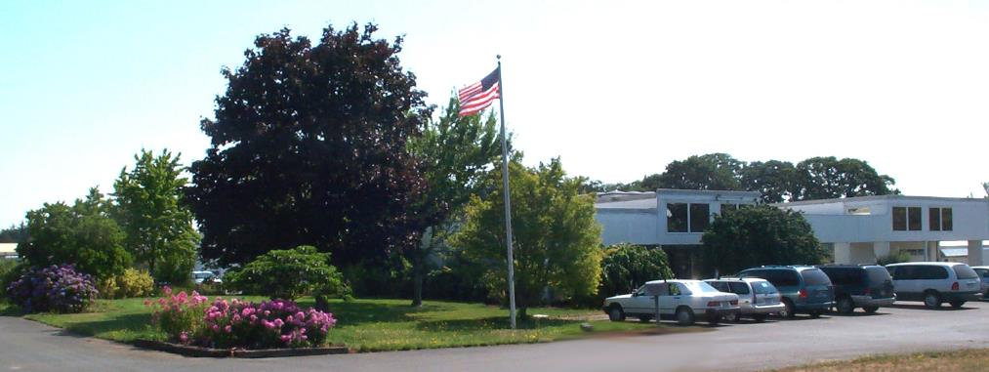
USDA National Clonal Germplasm Repository in Corvallis, Oregon.

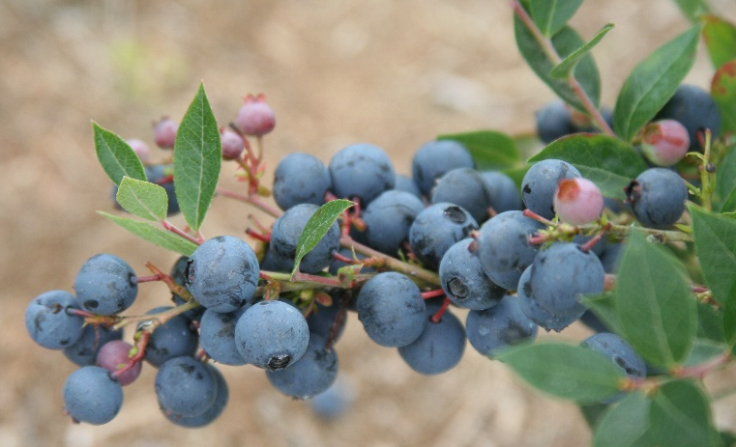
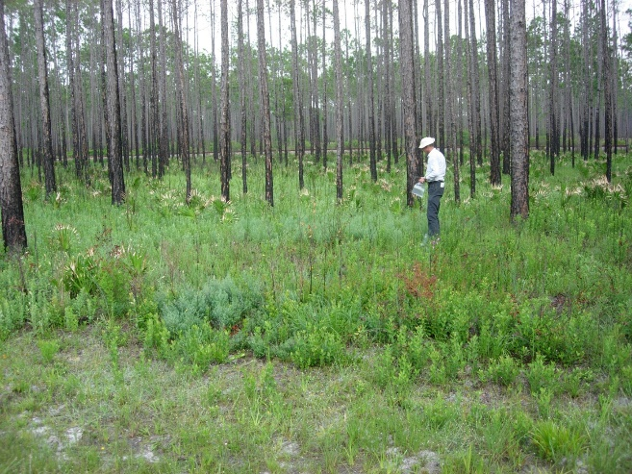
Vaccinium corymbosum hybrid US 612. One of the many hybrids made by Dr. Arlen Draper demonstrating the species crossing range within Cyanococcus. Pedigree: [Ivanhoe x Earliblue) x Collins] x (V. myrsinites x V. angustifolium).

Dr. Paul Lyrene, Geneticist emeritus, University of Florida, collects V. darrowii from western Florida in 2006.

Executive Summary
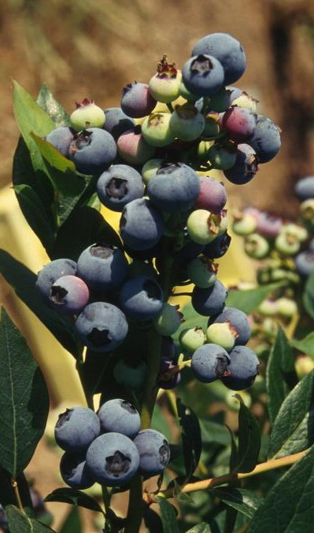
V. corymbosum ‘Reveille’

Blueberries, Vaccinium corymbosum L. and hybrids, are native to North America. The United States is the world’s largest producer of blueberries. In 2014, a total of 303.272 MT or 667.6 million pounds of cultivated and wild blueberries were produced and utilized.
Michigan was the nation's leading state producer of cultivated blueberries. The three following top producers were Washington, Georgia, and Oregon. Maine was the leading producer of lowbush, or "wild" blueberries. In total, fresh and processed wild blueberries were valued at $63.5 million. The United States is a net importer of fresh and frozen blueberries.
The US national blueberry genebank is located at the US Department of Agriculture, Agricultural Research Service, National Clonal Germplasm Repository at Corvallis, Oregon. The NCGR genebank collection includes 81 Vaccinium taxa and about 1714 accessions. The NCGR genebank includes a primary collection of living blueberry plants and their wild relatives, protected in containers in protected enclosed environments such as screenhouses and greenhouses. Aphids, which vector viruses, are excluded from these houses. Integrated pest management techniques minimize powdery mildew, spider mites and other key pests. A core collection representing world species and heritage cultivars has been defined. A secondary backup partial core collection is maintained in vitro under refrigerated temperatures. A long-term backup core collection of meristems has been placed in cryogenic storage on site, and at the remote base location, National Center for Genetic Resource Preservation, Ft. Collins, Colorado.
‘Reveille’ is an early ripening blueberry designed for mechanical harvesting. It is a southern highbush blueberry well suited for low chilling areas. Fruit is medium in size, mid-blue, firm, with a pleasing crunchy texture and excellent tart flavor. This cultivar was released by Dr. James Ballington, plant breeder at North Carolina State University, College of Agriculture and Life Sciences in 2003.
At Corvallis, species diversity is represented by seed lots stored in envelops at -18 C, as single/double plants in containers or in the field, or backed up in cryogenics. In addition, living plant representatives of major taxa are maintained in pots in screenhouses. Plants are tested for common viruses, viroids, and phytoplasmas as resources allow. Plant identity is checked by comparison with written description, review by botanical and horticultural taxonomic experts, and evaluation by molecular markers, such as simple sequence repeat markers. Single nucleotide polymorphism (SNP) markers and genotyping by sequencing (GBS) approaches are under development.
The collection has been documented for accession, inventory, voucher images, morphological and genetic observations on the Germplasm Resources Information Network (GRIN-Global) in Beltsville, Maryland. More than 9,600 blueberry accessions have been distributed to international and domestic requestors during the past 30 years.
As of 2016, the collection has > 300 cultivars. Other heritage cultivars from the US or Europe not presently in the collection are being sought to broaden representation of historical cultivars. Species representatives are especially needed from Southeast Asia including Vietnam, South Pacific Islands, Russia (Kurile Islands, Kamchatka, and Amur), Japan, Oceania, Scandinavia, Canada, Mexico, Alaska, Hawaii, and the Western United States (including Idaho, Oregon, Montana, and Washington) and northeastern North America including New England and Northeastern Canadian Provinces.

1. Introduction to the crop

1.1 Biological features and ecogeographical distribution
Vaccinium L. in the Ericaceae, the Heath Family. This genus as presently described contains more than 400 species of vines, epiphytes, shrubs or small trees (Galletta and Ballington, 1996). About 260 of these species occur in Malaysia, 70 in Southeast Asia, 19 in Japan, 5 in the Pacific, 5 in Africa, 6 in Europe, 25 in South America, and 26 in North America (Vander Kloet, 1988).
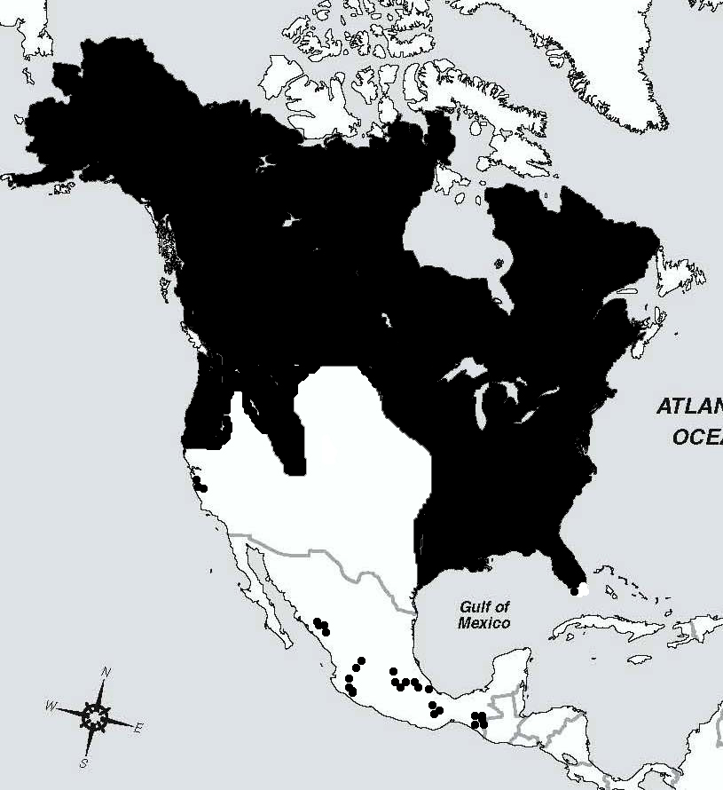
The plants may be terrestrial, epipetric, or epiphytic and are found on acidic, sandy, peaty, organic soils, or in some cases on limestone. Terrestrial Vaccinium tend to be pioneer species in disturbed or exposed areas. Subtropical species may be epiphytic or epipetric. Blueberries (Vaccinium) and huckleberries (Gaylussacia) are members of the Ericaceae (heath family). This genus has a circumboreal distribution but also has many named species native in the South Pacific Islands South America, and Africa (Vander Kloet, 1988; GRIN, 2015). Note that the range map covers eastern Kansas, Missouri, Oklahoma and Texas to College Station.

Fig. 1. Distribution of Vaccinium in North America. Compiled by Hummer (2013) from Vander Kloet (1988).
Most of the North American species have tasty edible fruit. The US Germplasm Resources Information Network (GRIN, 2015) includes slightly less than 200 species (Table 1.).
Vaccinium is polyphyletic (Kron et al, 2002) so a global taxonomic reassessment of the definition of the genus is needed (Vander Kloet, 2011)
Section Cyanococcus, which included the highbush blueberries and relatives, are perennial, long-lived, deciduous, woody shrubs. They belong to the family Ericaceae, which also includes such plants as cranberry, azalea, rhododendron, and heather. Like the other ericaceous plants, blueberries thrive in acid soils and do best in soils with a pH between 4 and 5. Highbush cultivars require from 120 to 160 growing degree days to ripen fruit. While northern species and cultivars can require as many as 1000 hours of chilling for dormant buds to mature, southern species and cultivars may require much less or no chilling. A spectrum of cultivars with varying chilling requirements has been developed for uses in different microclimates.
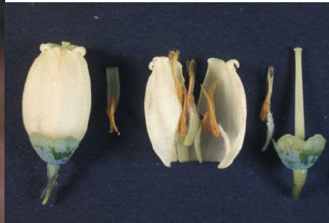
Blueberries (family Ericaceae, section Cyanococcus) are a diverse taxonomic group. Blueberries currently in commercial production represent several Vaccinium species with multiple ploidies: Vaccinium angustifolium Aiton (4x; lowbush blueberry), Vaccinium corymbosum L. (4x; highbush blueberry), and Vaccinium virgatum (synonym = V. ashei (6x; rabbiteye blueberry). These three types are considered within the primary gene pool for the cultivated form. Two other commercial types of blueberry are mixtures of species: half-highbush blueberry cultivars have been produced by hybridization of V. corymbosum (4x) and V. angustifolium (4x) and retain a significant but variable percentage
Blueberry flower morphology and structure. (L-R): urceolate flower, anther, stamen attached to petals, stamen, style and calyx. Courtesy of Dr. Jim Ballington, NCSU, retired.
C

The highbush blueberry is an acid-loving shallow-rooted plant, characterized by a lack of root hairs. The fine, fibrous roots of the blueberry require an open, porous soil for ease of growth. Blueberry roots are associated with mycorrhizal fungi in the soil. These fungi aid the blueberry plant in nutrient absorption. Many of the soil management practices recommended for blueberries may actually benefit the fungus, not the plant.
Root growth begins in spring when soil temperatures reach about 43 F; often this coincides with bud swell. Root growth continues through late spring, but slows during fruit development and maturation. Most root growth occurs from after harvest through fall, until soil temperatures fall below 43 F. Most blueberry roots are found within the dripline of the bush and in the upper 18 inches of soil.
Vaccinium, the genus in which blueberries reside is botanically classified in the blueberry tribe, Vaccinieae, of the subfamily Vaccinioideae of the Ericaceae, the heath family (Stevens, 1969). The Vaccinieae includes those Vaccinioideae with inferior ovaries and more or less fleshy fruits. While the blueberry tribe is monophyletic (Kron et al., 2002; Vander Kloet, 2004), researchers have observed that the genus Vaccinium L. is polyphyletic, through morphological (Stevens, 1985; Vander Kloet 2004) and molecular analyses (Kron et al., 2002).
Kron et al. (2002) performed a phylogenetic analysis of the Vaccinieae using strict consensus trees produced through parsimony analysis of the ribosomal internally transcribed spacer region (nr-ITS) and chloroplast matK genes. Through this analysis they defined an Agapetes clade where both Agapetes species and Vaccinium were grouped (Fig. 1).
Kron et al. (2002) concluded that Vaccinieae were monophyletic based on matK data. However, within the tribe, generic limits were in “disarray and need revision.” Interestingly, some Old World taxa, possibly Vaccinium, appear to have close relatives in the neotropics. Terminal branch lengths were relatively long for all Vaccinieae and more intensive taxonomic analysis within the tribe is warranted. Vander Kloet (2004).

1.2 Genetic base of crop production

Several crops of agricultural importance have been cultivated or gathered from the wild:
- Blueberries - primarily from hybrid selections of species in section Cyanococcus. The initial type was selected from V. corymbosum native to northern North America; named clonal cultivars are planted and cultivated in field plantations. There are several major classes of blueberries grown in the US and expanding globally, marketed to consumers:
  - Northern highbush blueberries: These plants are primarily selected from tetraploid V. corymbosum from elite plants native to northern North America or crosses between them. These plants tend to be cold hardy and have a dormancy requirement of as many as 1,000 hours (6 weeks at 40 ºC of chilling to induce bud growth and flower development after winter dormancy. These blueberries include the initial types that Dr. Fredrick Coville, first blueberry breeder in the USDA developed in the early 1900s. After Dr. Coville, wide crosses of highbush with many other species within Section Cyanococcus were made by Dr. Arlen Draper, USDA Beltsville, Dr. Sharpe, University of Florida, Dr. Gene Galletta, USDA Beltsville, Dr. Jim Ballington, North Carolina State University. Now many public and private companies throughout the world have blueberry breeding and development programs.
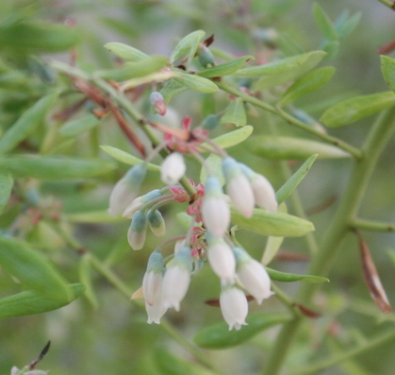
  - Southern highbush blueberries – These plants have similar plan habit to that of northern highbush blueberries but are adapted to mild climatic regions, such as those in the southern United States and the central Mexican highlands. These plants have a range of chilling requirements from 400 to 0 hours. They are hybrids of the northern V. corymbosum crossed with a combination of southern species including: V. darrowii (2n = 2x = 24) distributed in extreme Southern Georgia., Florida and along the Gulf Coast to Texas (most important.); V. virgatum (V. ashei) (2n = 6x = 72) southeastern US (2nd in importance); V. tenellum (2n = 2x = 24) southeastern US low growing stoloniferous species (ancestral to V. virgatum). The southern highbush blueberries are now being grown in subtropical areas using a cultivation technique called “evergreening.” This has allowed production in Mexico, Central and South America to supply northern markets during the off season.
Flowers of Vaccinium darrowii Florida 4B, a founding clone in the pedigree of many of the southern highbush blueberries.
  - Half-high blueberries – cultivars from hybrid species cross of V. corymbosum with V. angustifolium. These hybrids were developed in northern climates, such as Minnesota, where plant stature was designed to be lower than the snow level in winter. The snow being an insulator could protect the dormant buds of blueberry plants from the drying winds and minimum temperatures of winter.
  - Rabbiteye blueberries - selections of V. virgatum (synonym = V. ashei) bred and cultivated in southern North America. Derived from the vigorous southeastern US hexaploid species (2n=6x=72) (formerly V. ashei). The “species” is extremely variable in habit, but cultivars are generally crown forming with suckering stems 2.0 M tall. These plants have fruit tend to have a thicker or firmer skin than the northern highbush blueberry. Rabbiteye blueberries are most important in the “deep south” states of Georgia, Florida, and Mississippi, where their superior adaptation to heat and droughty limited organic matter is important. Some rabbiteye cultivars are tolerant to soils, i.e., 6.5+ pH. Current rabbiteye cultivars have a long fruit development period. (Early rabbiteye ripen 4 weeks later than early std. and southern highbush.)
  - Lowbush blueberries – selections of V. angustifolium and V. myrtilloides gathered from managed wild stands throughout Northeastern North America. These berries are marketed as “wild” blueberries. They tend to have smaller diameters and are used in baking, pastries, and many processed products.
- Cranberries – selections of V. macrocarpon, bred cultivars, propagated by cuttings, with red skinned berries produced in cultivated bogs.
- Lingonberries – selections of V. vitis-idaea, primarily gathered from the wild in Scandinavia, although cultivars have been selected and bred. Fruits ripen red. These fruits are used in processed products such as jams or conserves.

Use of Primitive Forms

Berries of native Vaccinium species are gathered from the wild in many locations throughout the world including Andean South America, Europe, China, Japan, Portugal, Russia, Scandinavia, Eastern and Pacific Northwestern United States, Alaska, and Hawaii. These fruits are gathered directly from the wild, or from areas or regions that are managed for fruit production. The fruits can be consumed fresh or processed into juices, jellies, jams, or frozen.

1.3 Economics of blueberries in the United States
Blueberries were first marketed in the United States in Whitesbog, New Jersey, in 1913 (Darrow, 1937). The United States is the world’s largest producer of blueberries (FAOSTAT, 2013). In 2014, a total of 303.272 MT or 667.6 million pounds of cultivated and wild blueberries (valued at $824.9 million) were produced and utilized (NASS, 2015). This is a slight decline compared to 2011, when about 368,804 MT of blueberries, (valued at $850.9 million) were produced in about 28 countries.
The US is the leading producing nation with approximately 55% of the world’s crop. Blueberries rank as the second most important commercial berry crop in the United States. In 2014, the United States exported 79 million pounds of fresh blueberries (cultivated and wild) valued at $138 million. Canada was the number one buyer, by far, followed by Japan. Exports of U.S. frozen blueberries were almost 56 million pounds, valued at $72 million (ERS, 2015).

1.4 Domestic and international crop production
More than 473.3 million pounds of cultivated blueberries, which included highbush and rabbiteye cultivars, were harvested in 2012. Of that amount, 280.8 million pounds, or around 60 percent, were sold as fresh blueberries. In total, fresh and processed cultivated blueberries were valued at $781.8 million. (NASS 2013). In 2014, the United States produced and processed 563.2 million pounds of cultivated blueberries (including highbush and rabbiteye). Of that amount, 333.8 million pounds were sold as fresh blueberries, and 229.4 million pounds were processed.
In the United States, while blueberries are produced in most states, at least 14 states had crops sufficiently large to be reported to USDA-ERS. Michigan is the nation’s leading producer of cultivated blueberries. In 2012, the state harvested 87 million pounds, valued at $122.7 million (NASS 2013). Other top producers included Georgia, Oregon, Washington and New Jersey. Cultivated blueberries are also grown in Alabama, Arkansas, California, Florida, Indiana, Mississippi, New York, and North Carolina. Maine is the leading producer of lowbush blueberries. In 2012, a total of 91.1 million pounds of wild blueberries were harvested, up 14 percent from 2011. Nearly all were sold for use in the processed market. The 2012 value of fresh and processed wild Maine lowbush blueberries was nearly $69.1 million (NASS 2013).
Plantings are usually established with 2-3 year-old container-grown plants. Highbush (northern and southern) and rabbiteye cultivars require warmer growing conditions compared to northern lowbush plants, with both types thriving in well-drained, acidic soils and benefiting from irrigation and pruning. Highbush plants bloom later and produce a larger, juicier fruit with a thinner skin that ripens in early summer. Rabbiteyes are native to the southeastern U.S. and are the largest of the native blueberry plants, producing a slightly sweet fruit with a tougher skin that is tolerant of machine harvesting however many more highbush are Machine harvested than rabbiteye even on a percentage basis. The lowbush species of blueberry is commonly referred to as a “wild blueberry” plant. The lowbush is gathered from wild, intensively managed stands.
According to the Organic Production Survey (USDA 2010), the United States had 526 certified organic farms growing cultivated blueberries. Total production was 5.9 million pounds, with 516 farms representing total sales of $16.4 million. Washington produced more than half (55%) of the U.S. organic cultivated blueberries harvested from certified organic farms, with 2008 sales valued at $8.7 million.

Demand
In 2000, the North American Blueberry Council (NABC) voted to establish a Blueberry Order, a federally mandated marketing and promotion order. The program established a grower assessment program that is administered by the U.S. Highbush Council (USHBC). Resulting funds were invested in medical research trials, which have documented health benefits associated with blueberry consumption. Combined with consumer marketing expenditures, the USHBC efforts appear successful, as USDA-ERS calculations revealed an impressive increase in national per capita consumption of blueberries, rising from 0.26 pounds in 2000 to nearly 1.3 pounds per person in 2011. In a trend initially observed in the early 2000s, average per capita availability of fresh blueberries surpassed frozen annual per capita availability, reaching 0.96 pounds versus 0.54 pounds frozen in 2009.

2012 Outlook
Rising consumption of blueberries prompted new plantings. The majority of these plantings occurred in Washington, Oregon, and California. As a result of continued labor supply limitations and conflicting regulations, the blueberry industry faced added pressure to mechanize harvest, a practice previously limited to blueberries destined for the processing markets. Food safety and traceability issues associated with fresh fruit consumption continue to be a priority area of concern for the industry. Investment in early and late varietal plantings and high tunnel production technologies offer growers the opportunity to improve overall profitability by targeting the lucrative fresh market windows of November through March.

2014 Outlook
The U.S. blueberry total production, at 5.67 million pounds in 2014, was up 5 percent from the 5.40 million pounds the previous year. Bearing acreage, at 82,630, increased 2,000 acres from the 2013 growing season. In 2014 Georgia, North Carolina and Washington increased their acreage, while New Jersey and Michigan remained unchanged from 2013. The average yield in 2014 was 6,700 pounds per acre nationwide, an increase of 230 pounds per acre from the 6,470 pounds in 2013.

Blueberry Harvested Acres, Yield, Production, Price,
& Value of Utilized Production, by State, 2014^{z}

State | Area Harvested | Yield per Acre 1/ | Utilized Production
 | - acres - | - lbs - | - 1,000 lbs -
Alabama | 430 | 1,120 | 480
Arkansas | 200 | 1,800 | 360
California | 5,000 | 10,700 | 53,350
Florida | 4,300 | 3,720 | 16,000
Georgia | 16,600 | 5,540 | 92,000
Indiana | 500 | 4,000 | 2,000
Michigan | 19,000 | 4,840 | 92,000
Mississippi | 2,100 | 4,070 | 8,550
New Jersey | 8,800 | 6,440 | 56,680
New York | 900 | 1,780 | 1,600
North Carolina | 6,400 | 7,580 | 48,500
Oregon | 9,300 | 9,260 | 86,100
Washington | 9,100 | 10,600 | 96,100
US | 82,630 | 6,700 | 553,720
^{z} Yield is based on utilized production.

2014 Value of blueberry production in the United States

State | Value of Utilized Production | Price per Pound
State | Value of Utilized Production | Fresh |  | Processed | All
Alabama Arkansas California Florida Georgia Indiana Michigan Mississippi New Jersey New York North Carolina Oregon Washington  US | - 1,000 dollars - 1,181  619  126,132  69,760  109,800  2,780  114,320  10,065  79,463  4,208  71,808  106,692  120,504  817,332 | 2,460  1,720 (D) 4,360  1,600 (D) 1.900  1.300  1.440  2.630  1.760  1.530  1.840  1.920 | - - - dollars per pound -  *  *  *  * 0.750 (D) 0.640  1.000  1.050  * 0.550  1.020  0.960  0.906 |  | - -  2,460  1,720  2.380  4,360  1.190  1.390  1.240  1.180  1.400  2.630  1.480  1.240  1.250  1.480
* Small quantities of processed blueberries are included in fresh to avoid disclosure of individual operations.

Blueberry production by state
State | Rank | Yield per Acre 1/ (lbs)
California | 1 | 10,700
Washington | 2 | 10,600
Oregon | 3 | 9,260
North Carolina | 4 | 7,580
New Jersey | 5 | 6,440
Georgia | 6 | 5,540
Michigan | 7 | 4,840
Mississippi | 8 | 4,070
Indiana | 9 | 4,000
Florida | 10 | 3,720
Arkansas | 11 | 1,800
New York | 12 | 1,780
Alabama | 13 | 1,120

State |  | Harvested Acres
State | Rank | Harvested Acres
Michigan | 1 | 19,000
Georgia | 2 | 16,600
Oregon | 3 | 9,300
Washington | 4 | 9,100
New Jersey | 5 | 8,800
North Carolina | 6 | 6,400
California | 7 | 5,000
Florida | 8 | 4,300
Mississippi | 9 | 2,100
New York | 10 | 900
Indiana | 11 | 500
Alabama | 12 | 430
Arkansas | 13 | 200

Yield based on utilized production.

State | Rank | Value of Utilized Production ($1,000)
California | 1 | 126,132
Washington | 2 | 120,504
Michigan | 3 | 114,320
Georgia | 4 | 109,800
Oregon | 5 | 106,692
New Jersey | 6 | 79,463
North Carolina | 7 | 71,808
Florida | 8 | 69,760
Mississippi | 9 | 10,065
New York | 10 | 4,208
Indiana | 11 | 2,780
Alabama | 12 | 1,181
Arkansas | 13 | 619

State | Rank | Utilized Production (1,000 lbs)
Washington | 1 | 96,100
Georgia | 2 | 92,000
Michigan | 2 | 92,000
Oregon | 3 | 86,100
New Jersey | 4 | 56,680
California | 5 | 53,350
North Carolina | 6 | 48,500
Florida | 7 | 16,000
Mississippi | 8 | 8,550
New York | 9 | 1,600
Indiana | 10 | 2,000
Alabama | 11 | 480
Arkansas | 12 | 360

1.4.2 International
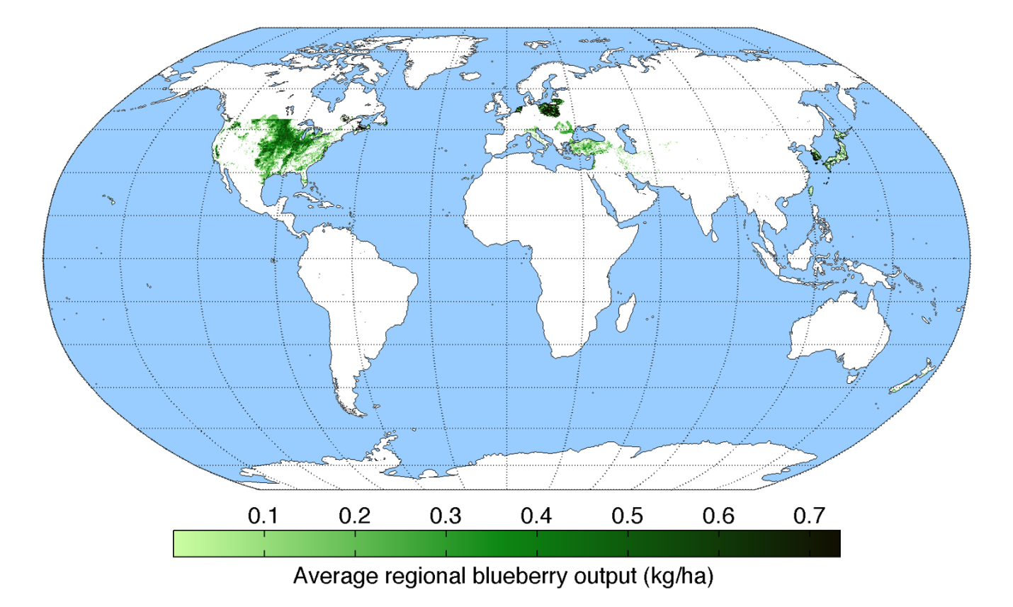
http://faostat.fao.org/site/567/default.aspx#ancor. Accessed 13 August 2013.
The US is the leading producing nation for blueberries with approximately 28% of the world’s crop, followed by Chile, Argentina, and Canada. An additional reference for production can be found at: http://www.oregonblueberry.com/update/USHBC-report.pdf (data through 2010).

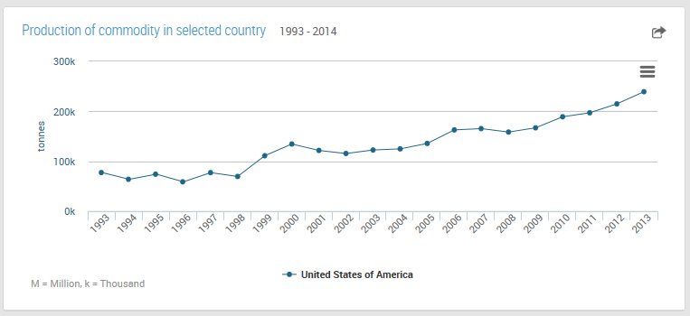
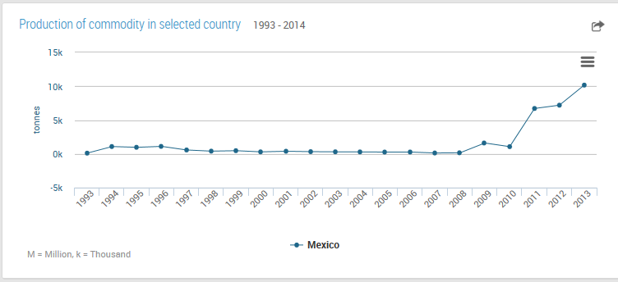
(UNFAO Statistical production database, 2016).

2. Urgency and extent of crop vulnerabilities and threats to food security
Primary collections at national genebanks consisted of living plants, protected in containers greenhouses or screenhouses, or growing in the field. Any plant material grown outdoors cannot be certified as pathogen negative. Secondary backup collections are maintained in vitro under refrigerated temperatures. Long-term backup collections of meristems are placed in cryogenic storage at remote locations to provide decades of security. Species diversity is represented by seed lots stored in -18°C or backed-up in tissue culture. Conservation of clonally propagated material, where genotypes were maintained, is more complicated and expensive than storing seeds, where the objective is to preserve genes. The health status of both forms of storage was of primary importance for plant distribution to meet global plant quarantine regulations.
Blueberries, cranberries, and lingonberries are specialty crops. Limited world resources are available for conservation of these crops and their wild relatives. These limited resources constrain the management of Vaccinium resources. Pathogen testing and elimination procedures critical to maintain pathogen-negative plants to satisfy quarantine requirements. Training on standard protocols for germplasm maintenance is needed for staff of genebanks in developing countries. Coordination of inventory and characterization data between genebanks is also insufficient.
In situ preservation of wild Vaccinium has been limited. The wild species in many regions of the world would be appropriate for such conservation efforts.

2.1 Genetic uniformity in the “standing crops” and cultivar life spans
The highbush blueberry is an outcrossing crop that is sensitive to inbreeding (Ballington, YEAR?). It is asexually propagated by cuttings, so most breeding programs have been based on reciprocal recurrent selection where elite parents are selected for intercrossing each generation. The following table is a list of businesses and institutions supporting blueberry breeding programs, the current breeder and location.
Institution/Business | Breeder name | Breeder email | City/State
Auburn University | Sushan Ru | szr0099@auburn.edu | Auburn, Alabama, USA
Berry Blue, LLC. | (Ed Wheeler retired) | ewheeler@blueberries.com, geneticsofberries@gmail.com | Michigan/Georgia/ Florida/Chile, USA
Driscoll's | James Olmstead | James.Olmstead@driscolls.com | Watsonville, California, USA
Fall Creek | Paul Sandefur | paul.sanedfur@fallcreeknursery.com, pattyr@fallcreeknursery.com | Oregon/Mexico/ Spain, USA
Michigan State University | Patrick Edger | EdgerPat@msu.edu | Lansing, Michigan, USA
North Carolina State University | Hamid Ashrafi | Hamidashrafi@ncsu.edu; hashraf2@ncsu.edu | Raleigh, North Carolina, USA
North Carolina State University | Massimo Iorizzo | MIorizz@ncsu.edu | Kannapolis, North Carolina, USA
North Carolina State University | Jessica Spencer | jaspence@ncsu.edu | Castle Hayne, North Carolina, USA
Oregon Blueberry Farms and Nursery | Adam Wagner | adamw@oblueberry.com | Silverton, Oregon, USA
Plant Sciences | Kendra Blaker | kblaker@plantsciences.com | Watsonville, California/Florida, USA
University of Florida | Patricio Munoz | p.munoz@ufl.edu | Gainesville, Florida, USA
University of Georgia | Ye (Juliet) Chu | ychu@uga.edu | Griffin, Georgia, USA
USDA-ARS Mississippi | Steve Stringer | Stephen.Stringer@usda.gov | Poplarville, Mississippi, USA
USDA-ARS Mississippi | Ebrahiem Babiker | ebrahiem.babiker@usda.gov | Poplarville, Mississippi, USA
USDA-ARS New Jersey | Mark Ehlenfeldt | mark.ehlenfeldt@usda.gov | Chatsworth, New Jersey, USA
USDA-ARS Oregon | vacant |  | Corvallis, Oregon, USA
BC Blueberry Council | Michael Dossett | MDossett@bcberrycultivar.com | Abbotsford, British Columbia, Canada

Cultivar life spans
In most cases, if plant material from the wild is incorporated into blueberry breeding efforts, about 40 years of crossing, selection and testing is required prior to the production of a cultivar-level release. Most breeding programs work under long term objectives, preparing multiple penultimate releases from advanced breeding lines without returning to the incorporation of new wild germplasm. Frequently one breeder will make a cross and his/her successor will evaluate and make the final release. Sometimes breeding programs will share advanced lines with the consideration of mutual benefit when a selection is successful. In some cases, germplasm enhancers work with wild material and breed and select for “germplasm releases,” after which breeders work from that release to develop advanced lines and cultivars.

Some cultivars do not do well after 1 to 5 years after release and are essentially “lost” from production nursery lists. Others survive 40 or 60 years. In the private sector, the life span of a successful blueberry cultivar is longer than the length of a US plant patent, which is 20 years. The ratio of successful releases to total releases seems to be about 1/5 for per breeding program. Some older cultivars are tried in another geographic or climatic niche and then have a renewed life span of several decades. The following table includes some examples of “life spans” for a few publicly available blueberry cultivars (C. Finn and J. Olmsted, 2013, personal communication).

Cultivar | Type^{z} | Year | Comment | Origin
Alapaha | RE | 2002 | Still being produced. | USDA-ARS and Univ. of Georgia
Aurora | NHB | 2004 | Still being produced. | Michigan St. Univ.
Berkeley | NHB | 1949 | Still being produced but no new plantings. | New Jersey Ag. Expt. Stat. & USDA-ARS Beltsville, MD
Bluecrop | NHB | 1952 | Still being produced but few new plantings. | New Jersey Ag. Expt. Stat. & USDA-ARS Beltsville, MD
Biloxi | SHB | 1998 | Still being produced worldwide, but no new plantings in U.S. | USDA-ARS Poplarville, MS
Bluejay | NHB | 1978 | Still being produced, particularly in B.C. | Michigan State Univ.
Blueray | NHB | 1956 | Still being produced, particularly in the lower Midwest. | New Jersey Ag. Expt. Stat. & USDA-ARS Beltsville, MD
Brightwell | RE | 1981 | Still being produced. | USDA-ARS and Univ. of Georgia
Collins | NHB | 1959 | Still being produced but no new plantings. | New Jersey Ag. Expt. Stat. & USDA-ARS Beltsville, MD
Croatan | NHB | 1954 | No longer grown. | North Carolina State Univ. & USDA-ARS Beltsville, MD
Darrow | NHB | 1974 | Still being produced but no new plantings. | USDA-ARS Beltsville, MD
Draper | NHB | 2004 | Still being produced. | Michigan St. Univ.
Duke | NHB | 1987 | Still being produced. | New Jersey Ag. Expt. Stat. & USDA-ARS Beltsville, MD
Earliblue | NHB | 1952 | Still being produced but no new plantings. | New Jersey Ag. Expt. Stat. & USDA-ARS Beltsville, MD
Elliott | NHB | 1973 | Still being produced but few new plantings. | USDA-ARS Beltsville, MD
Emerald | SHB | 2008 | Still being produced. | Univ. of Florida
Gulfcoast | SHB | 1987 | Still being produced but no new plantings. | USDA-ARS, MS
Jersey | NHB | 1928 | Still being produced but no new plantings. | USDA-ARS, New Jersey
Legacy | SHB | 1993 | Still being produced. | New Jersey Ag. Expt. Stat. & USDA-ARS Beltsville, MD
Liberty | NHB | 2003 | Still being produced | Michigan St. Univ.
Misty | SHB | 1990 | Still being produced in CA and worldwide, but no new plantings. | Univ. of Florida
Northblue | HH | 1983 | Still being produced | Univ. of Minnesota
Northcountry | HH | 1986 | Still being produced | Univ. of Minnesota
Ochlockonee | RE | 2002 | Still being produced. | USDA-ARS and Univ. of Georgia
O’Neal | SHB | 1987 | Still being produced. | North Carolina State Univ. & USDA-ARS Beltsville, MD
Ozarkblue
Polaris | HH | 1996 | Still being produced. | Univ. of Minnesota
Powderblue | RE | 1978 | Still being produced. | North Carolina State Univ.. & USDA-ARS Beltsville, MD
Premier | RE | 1965 | Still being produced. | North Carolina State Univ.. & USDA-ARS Beltsville, MD
Rebel | SHB | 2008 | Still being produced. | Univ. of Georgia
Reveille | SHB | 1990 | Still being produced but few new plantings. | North Carolina State Univ.
Rubel | NHB | 1911 | Still being produced but no new plantings. | E. White New Jersey, USDA-ARS, MD
Sharpblue | SHB | 1975 | Still being produced but no new plantings. | Univ. of Florida
Star | SHB | 1996 | Still being produced. | Univ. of Florida
^{z}NHB = northern highbush; SHB = southern highbush; HH = half high; RE = rabbiteye

Biotechnology in blueberry breeding
If transgenes were accepted for blueberry cultivar development, many advances could potential be made efficiently. Presently traditional breeding is looking at the following traits:
- Improved viral disease resistance
- Improved root rot resistance
- Enhanced flowering and fruiting
- Quality – maturation genes
- Carbohydrate development for flavor and processing quality
- Disease and pest resistances
- Cold hardiness,
- Heat tolerance and low chilling
- Mineral soil adaptation

Several obstacles work against the acceptance of transgenic blueberries. The global economic value of this fruit crop (while high per acre) is small in total because much fewer acres are planted than that of agronomic crops. As a result governments are not flocking to support this technology, and private stimulus is modest. The fruit industry has been reluctant to introduce products with potential negative backlash from people leery of consuming transgenic crops.
A strong influx of funds for thorough testing and environmental examination is needed before transgenic blueberries could be commercialized. Careful analysis of public perceptions regarding transgenic fruit is also required. Until this happens, transgenic blueberries will remain as a research tool without commercialization. Using marker-free transformation systems and targeted expression of transgenes will minimize public concern, but the fear of technology must be abated before transgenic blueberries will be commonly accepted.

2.2 Threats of genetic erosion in situ

Many species of the primary and secondary gene pool for blueberries reside in eastern North America. Much of this land has become valuable for human habitation and what were rural forests have become urban or suburban. Wild land is vanishing at an alarming rate. Invasive weeds have escaped into the wild throughout and are displacing North American blueberries from their native habitats. Although most blueberry species in North America remain abundant and widespread, this process will continue strongly for the next 50 to 100 years.
According to Lyrene (in press, 2017) diploid V. fuscatum is currently the most highly endangered species particularly in the south end of its range from Fort Myers to Orlando, Florida. Plants of these diploid V. fuscatum grow tall (2-4 m), are evergreen, have little or no chilling requirement, and make extremely vigorous hybrids (via unreduced gamete production) with cultivated highbush blueberry. Urbanization, agriculture, and invasive weeds are major threats to this species in this area of Florida.
The best method of preserving blueberry species in eastern North America would be in situ conservation on public and private lands. This would require control of invasive weeds, management of grazing (deer and cattle), burning practices favorable to highbush blueberry survival and reproduction, and trained, interested, and empowered land managers. If in situ conservation is not possible, large, diverse seed collections from these plants should be placed in long-term storage for future use.

2.3 Biotic (diseases, pests)
Virus diseases are very important in blueberry cultivation motivating extensive testing and certification programs in the nursery industry. Martin et al. (2012) has recommended procedures for detection of blueberry viruses. These tests include bioassays on indicator plants, sap and graft inoculation, enzyme linked immunosorbent assay, double-stranded RNA detection and polymerase chain reaction (PCR).

Viruses of blueberry and cranberry (Martin et al., 2012)
Virus name | Acronym | Transmission
Blueberry fruit drop associated virus | BFDaV | ?
Blueberry latent spherical virus | BLSV | nematodes/persistent □◊/?
Blueberry latent virus | BlLV | pollen/seed ◊
Blueberry leaf mottle virus | BLMoV | nematodes/persistent? □◊
Blueberry mosaic associated virus | BlMaV | Olpidium/?
Blueberry necrotic ring blotch virus | BNLBV | ?
Blueberry red ringspot virus | BRRV | ?
Blueberry scorch virus | BlScV | aphids/non-persistent
Blueberry shock virus | BlShV | pollen/seed ◊
Blueberry shoestring virus | BlSSV | aphids/non-persistent
Blueberry virus A | BVA | aphids/Semi-persistent?
Cherry leaf roll virus | CLRV | pollen/seed (nematodes?) □◊
Peach rosette mosaic virus | PRMV | nematodes/persistent □◊
Strawberry latent ringspot virus | SLRSV | nematodes/persistent □◊
Tobacco ringspot virus | TRSV | nematodes/persistent □◊
Tobacco streak virus | TSV | pollen/seed □◊
Tomato ringspot virus | ToRSV | nematodes/persistent □◊
◊ Also transmitted by pollen feeding arthropods
□ Pollen and seed transmitted

Plant material should be obtained from certified sources with the lowest risk of virus contamination, preferably derived from pathogen-tested sources. Frequently, this is not possible in germplasm exploration or exchange activities, particularly if plant material is collected from the wild, or the source has no resources for pathogen testing. If certified pathogen-negative germplasm is unavailable, the germplasm should be obtained and subjected to virus-elimination procedures upon arrival at the recipient country. Virus elimination techniques are described by Diekmann et al. (1994).
Clonal virus-negative collections should be protected from access by virus vectors, i.e., aphids, bees (pollen transmission). New plant accessions should be grown in a location isolated from the foundation collection and fumigated or observed to prevent the introduction of exotic insects or diseases into the protected collection.

The following lists include pathogen difficulties that could be addressed by breeding programs.

Fungal and bacterial diseases
Algal stem blotch
Alternaria fruit rot
Anthracnose fruit rot
Armillaria root rot
Bacterial blight (Pseudomonas)
Bacterial blight/Canker
Bacterial leaf scorch (Xylella)
Botryosphaeria stem blight
Botrytis flower blight
Cane canker (Godronia)
Exobasidium leaf and fruit spot
Macrophomina (charcoal rot)
Mummy berry
Phomopsis twig blight
Phytophthora root rot
Silver leaf

Insect and arthropod pests
Aphids
Blueberry maggot
Brown marmorated stink bug
Bud mite
Cherry fruitworm
Cranberry fruitworm
Flower thrips
Gall midge
Plum curculio
Root weevil
Scale insects
Leafhoppers
Drosophila
Stem borers
Stem gall wasp
White grubs (roots)
Winter moth

2.3.2 Abiotic (environmental extremes, climate change)

Low temperature adaptation
Frost tolerance or avoidance is important to blueberries growing in temperate climates. During the onset of floral development in spring the buds must avoid or tolerate frost events. This is critical even in areas without severe winter temperatures. Spiers (1978), Hancock et al. (1987) reported on frost tolerance among rabbiteye blueberries. Ehlenfeldt et al. (2006) evaluated mid-winter cold hardiness of 25 rabbiteye blueberry cultivars.

High temperature adaptation

Lower water use

Mineral soil adaptation

High pH adaptation

2.3.3 Production/demand (inability to meet market and population growth demands)

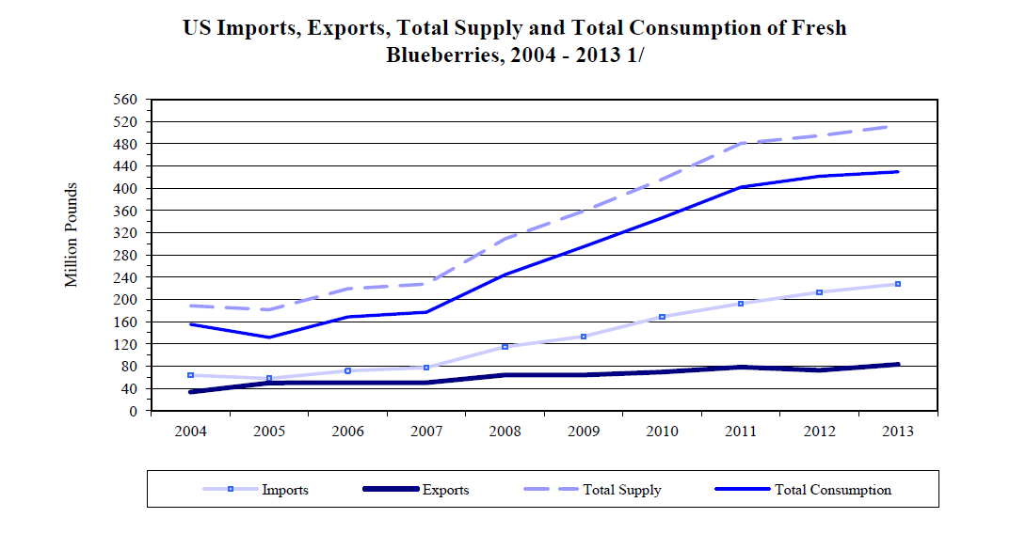
The United States is a net importer of fresh and frozen blueberries. Despite the production and export figures for blueberries, the United States is a net importer of fresh and frozen blueberries. In 2014, the nation imported 234.7 million pounds of fresh blueberries valued at nearly $530.5 million. Over 60 percent of the fresh blueberries originated from Chile, which provides fresh blueberries to U.S. markets during the winter months of mid-November through January. Canada provided almost 20 percent of the fresh blueberries coming into the country (USDA-ERS, 2015). Mexican blueberry production is increasing and will be reported in subsequent years.

2.3.4 Dietary key nutritional requirements

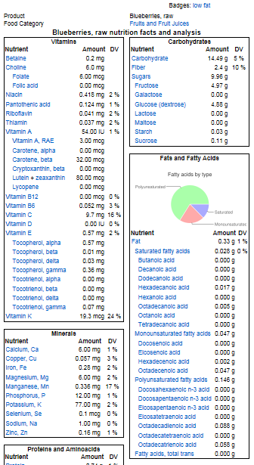
Blueberry fruit have high nutritional value. Blueberries are a source of vitamin A and C, protein, fat, carbohydrate, calories, and calcium, iron, and other minerals. The berry contains about 85% water.

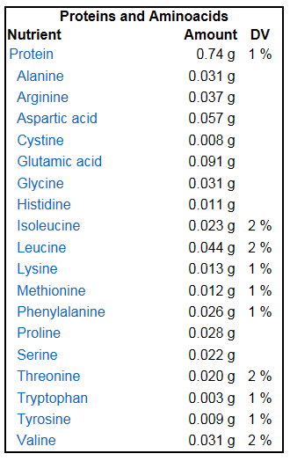

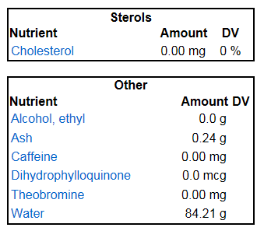

2.3.5 Accessibility (inability to gain access to needed plant genetic resources because of phytosanitary/quarantine issues, inadequate budgets, management capacities or legal restrictions)
Secondary and tertiary gene pools of blueberry crop wild relatives may be difficult to obtain presently from China and from several South American countries. Germplasm from the United States is available for distribution and exchange.
Universities and private companies have systems that demand that new releases are patented with returns or propagation royalties are returned to administrations. This has reduced accessibility and exchange of enhanced or developed genetic resources unless elaborate collaborative agreements are established.
The USDA NCGR provides plant material and information

3. Status of plant genetic resources in the NPGS available for reducing genetic vulnerabilities
The US national blueberry genebank is located at the US Department of Agriculture, Agricultural Research Service, National Clonal Germplasm Repository at Corvallis, Oregon. The NCGR genebank collection includes 81 Vaccinium taxa and about 1714 accessions. The NCGR genebank includes a primary collection of living blueberry plants and their wild relatives, protected in containers in protected enclosed environments such as screenhouses and greenhouses. Aphids, which vector viruses, are excluded from these houses. Integrated pest management techniques minimize powdery mildew, spider mites and other key pests. A core collection representing world species and heritage cultivars has been defined. A secondary backup partial core collection is maintained in vitro under refrigerated temperatures. A long-term backup core collection of meristems has been placed in cryogenic storage on site, and at the remote base location, National Center for Genetic Resource Preservation, Ft. Collins, Colorado.

3.1 Germplasm collections and in situ reserves

The US National Vaccinium genebank collection is kept ex situ in Corvallis, Oregon. Back-up seed of species are maintained in Corvallis and have been sent to NCGRP in Ft. Collins, Colorado, and to the Global Seed Vault in Svalbard, Norway.

In situ reserve agreements between the USDA ARS and the US Forest Service have been established for cranberry in the Eastern United States. This genus would be a good candidate to consider for additional in situ conservation within the United States, including Alaska and Hawaii.

3.1.1 Holdings

The NCGR-Corvallis holdings include two types of accessions: clonal and species
1) Clonal plants (living collections) that are propagated vegetatively and represent specific genotypes. These include heritage cultivars, newer cultivars, selections which contain specific traits of interest and elite wild accessions.
2) Broader species collections are represented by seed lots or additionally by plant representatives of certain populations.

The available Vaccinium clonal collection at the NCGR-Corvallis is listed in Appendix Table 3 or can be obtained by searching GRIN accession text query entering: “Vaccinium cultivar”.
The Vaccinium species collection at the NCGR-Corvallis is listed in Appendix Table x).
The collection includes representatives of international Vaccinium taxa (found in Appendix table 1).

3.1.2 Genetic coverage and gaps

Clonal holdings
The collection presently has about 375 cultivars. Other major heritage cultivars from the US or Europe not in the collection are being sought to broaden representation of historical cultivars.

A list of clones that the Repository would like to obtain include:
Vaccinium angustifolium
Chignecto
Cumberland
North Sedgewick
Michigan Lowbush selection numbers
Russell
Half-high blueberries
Friendship (Wisconsin)

Highbush hybrid blueberries
Heritage:
Brooks (if in existence)
Other original releases from Coville
Southern highbush blueberries
Cultivars from breeding program as they come out of patent

Domestic Collection Gaps.
- Hawaii – on Big Island – would be good to work out agreement for in situ/ex situ preservation with US National Park Service. Plants are on Park Service land.
- V. stamineum from eastern United States
- V. fuscatum from Florida, Louisiana, east Texas, southeastern Arkansas, middle and east Tennessee, Kentucky, Mississippi, and Alabama.
- V. staminuem should include mid-south states
- More species rootstock possibilities for high pH adaptability

Foreign Collection Gaps
- Additional crop wild relatives from Vietnam, China, and Southeast Asia
- High pH adaptability for direct production and rootstock potential
- Vaccinium floribundum and other high ploidy crop wild relatives from Central and South America
- Vaccinium for cold hardiness, cyanococcus from Canada

List of Designates Primary, Secondary, and Tertiary Crop Wild Relatives

Primary genetic relative: taxa that cross readily with the crop (or can be predicted to do so based on their taxonomic or phylogenetic relationships), yielding (or being expected to yield) fertile hybrids with good chromosome pairing, making gene transfer through hybridization simple.
Secondary genetic relative: taxa that will successfully cross with the crop (or can be predicted to do so based on their taxonomic or phylogenetic relationships), but yield (or would be expected to yield) partially or mostly sterile hybrids with poor chromosome pairing, making gene transfer through hybridization difficult.
Tertiary genetic relative: taxa that can be crossed with the crop (or can be predicted to do so based on their taxonomic or phylogenetic relationships), but hybrids are (or are expected to be) lethal or completely sterile. Special breeding techniques, some yet to be developed, are required for gene transfer.

Crop: BLUEBERRY, HIGHBUSH
(compiled by Dr. Blanca León)
Crop taxon:
- Vaccinium corymbosum L. – highbush blueberry
Crop wild relatives:
Primary
- Vaccinium angustifolium Aiton — [References]
- Vaccinium corymbosum L. [wild types] — [References]
- V. corymbosum cultivated and wild V. corymbosum, i.e., V. fuscatum (4x)
- V. formosum
- Other tetraploid Cyanococcus species that produce fertile vigorous hybrids in large numbers when crossed with cultivated and wild highbush including:
- V. hirsutum,
- V. myrsinites, (4X)
- V. pallidum
- V. simulatum.

Secondary
- Vaccinium boreale I. V. Hall & Aalders — [References]
- Vaccinium darrowii Camp — [References]
- Vaccinium elliottii Chapm. — [References]
- Vaccinium formosum Andrews — [References]
- Vaccinium fuscatum Aiton — [References]
- Vaccinium hirsutum Buckley — [References]
- Vaccinium myrsinites Lam. — [References]
- Vaccinium myrtilloides Michx. — [References]
- Vaccinium pallidum Aiton — [References]
- Vaccinium simulatum Small — [References]
- Vaccinium tenellum Aiton — [References]
- Vaccinium virgatum Aiton — [References]
Tertiary
- Vaccinium arboreum Marshall — [References]
- Vaccinium ovalifolium Sm. — [References]
- Vaccinium ovatum Pursh — [References]
- Vaccinium stamineum
- Vaccinium uliginosum L. — [References]
Crop: BLUEBERRY, LOWBUSH
(compiled by Dr. Blanca León)
Crop taxon:
- Vaccinium angustifolium Aiton – lowbush blueberry
Crop wild relatives:
Primary
- Vaccinium angustifolium Aiton [wild types] — [References]
Secondary
- Vaccinium corymbosum L. — [References] (cultivated and wild)
- Vaccinium boreale I. V. Hall & Aalders — [References]
- Vaccinium darrowii Camp — [References]
- Vaccinium elliottii Chapm. — [References]
- Vaccinium formosum Andrews — [References]
- Vaccinium fuscatum Aiton — [References]
- Vaccinium hirsutum Buckley — [References]
- Vaccinium myrsinites Lam. — [References]
- Vaccinium myrtilloides Michx. — [References]
- Vaccinium pallidum Aiton — [References]
- Vaccinium simulatum Small — [References]
- Vaccinium tenellum Aiton — [References]
- Vaccinium virgatum Aiton — [References]
Crop: BLUEBERRY, RABBITEYE
(compiled by Dr. Blanca León)
Crop taxon:
- Vaccinium virgatum Aiton – rabbit-eye blueberry
Crop wild relatives:
Primary
- Vaccinium virgatum Aiton [wild types] — [References]
Secondary
- Vaccinium boreale I. V. Hall & Aalders — [References]
- Vaccinium corymbosum L. — [References]
- Vaccinium darrowii Camp — [References]
- Vaccinium elliottii Chapm. — [References]
- Vaccinium formosum Andrews — [References]
- Vaccinium fuscatum Aiton — [References]
- Vaccinium hirsutum Buckley — [References]
- Vaccinium myrsinites Lam. — [References]
- Vaccinium myrtilloides Michx. — [References]
- Vaccinium pallidum Aiton — [References]
- Vaccinium simulatum Small — [References]
- Vaccinium tenellum Aiton — [References]

Crop: CRANBERRY
(compiled by Dr. Blanca León)
Crop taxon:
- Vaccinium macrocarpon Aiton – cranberry
Crop wild relatives:
Primary
- Vaccinium macrocarpon Aiton [wild types] — [References]
Secondary
- Vaccinium oxycoccos L. — [References]
Crop: LINGONBERRY
(compiled by Dr. Blanca León)
Crop taxon:
- Vaccinium vitis-idaea L. – lingonberry
Crop wild relatives:
Primary
- Vaccinium vitis-idaea L. [wild types] — [References]
Secondary
- Vaccinium myrtillus L. — [References]
- Vaccinium uliginosum L. — [References]

Gaps in holdings of Foreign Species
The NCGR-Corvallis needs better representation of the following Vaccinium species:
(Canada is a foreign country.)
- Vaccinium ambyandrum F. Muell.
- Vaccinium angustifolium Aiton
- Vaccinium arboreum Marshall
- Vaccinium arctostaphylos L.
- Vaccinium auriculifolium Sleumer
- Vaccinium barandanum S. Vidal
- Vaccinium boreale I. V. Hall & Aalders
- Vaccinium borneense W. W. Sm.
- Vaccinium bracteatum Thunb.
- Vaccinium bracteatum var. bracteatum
- Vaccinium bracteatum var. chinense (Lodd. et al.) Chun ex Sleumer
- Vaccinium bracteatum var. thysanocalyx (Dop) Smitinand & P. H. Ho
- Vaccinium brevipedicellatum C. Y. Wu ex W. P. Fang & Z. H. Pan
- Vaccinium bulleyanum (Diels) Sleumer
- Vaccinium caesariense Mack.
- Vaccinium calycinum Sm.
- Vaccinium cereum G. Forst.
- Vaccinium cespitosum Michx.
- Vaccinium chunii Merr. ex Sleumer
- Vaccinium ciliatum Thunb.
- Vaccinium confertum Kunth
- Vaccinium consanguineum Klotzsch
- Vaccinium coriaceum Hook. f.
- Vaccinium cornigerum Sleumer
- Vaccinium corymbodendron Dunal
- Vaccinium crenatum (G. Don) Sleumer
- Vaccinium cruentum Sleumer
- Vaccinium cyclopense J. J. Sm.
- Vaccinium cylindraceum Sm.
- Vaccinium delavayi Franch.
- Vaccinium dentatum Sm.
- Vaccinium dependens (G. Don) Sleumer
- Vaccinium dunalianum Wight
- Vaccinium dunalianum var. caudatifolium (Hayata) H. L. Li
- Vaccinium dunalianum var. dunalianum
- Vaccinium dunalianum var. megaphyllum Sleumer
- Vaccinium dunalianum var. urophyllum Rehder & E. H. Wilson
- Vaccinium eberhardtii Dop
- Vaccinium emarginatum Hayata
- Vaccinium erythrocarpum Michx.
- Vaccinium erythrocarpum subsp. erythrocarpum
- Vaccinium erythrocarpum subsp. japonicum (Miq.) Vander Kloet
- Vaccinium exul Bolus
- Vaccinium floribundum Kunth
- Vaccinium formosum Andrews
- Vaccinium fragile Franch.
- Vaccinium gaultheriifolium (Griff.) Hook. f. ex C. B. Clarke
- Vaccinium gaultheriifolium var. gaultheriifolium
- Vaccinium gaultheriifolium var. glaucorubrum C. Y. Wu
- Vaccinium glaucoalbum Hook. f. ex C. B. Clarke
- Vaccinium griffithianum Wight
- Vaccinium hiepii Vander Kloet
- Vaccinium hirtum Thunb.
- Vaccinium hooglandii Sleumer
- Vaccinium horizontale Sleumer
- Vaccinium ^{x}intermedium Ruthe
- Vaccinium kachinense Brandis
- Vaccinium laurifolium (Blume) Miq.
- Vaccinium leucobotrys (Nutt.) G. Nicholson
- Vaccinium lobbii (Ridl.) Sleumer
- Vaccinium loranthifolium Ridl.
- Vaccinium lucidum (Blume) Miq.
- Vaccinium macrocarpon Aiton
- Vaccinium mandarinorum Diels
- Vaccinium ^{x}marianum P. Watson
- Vaccinium meridionale Sw.
- Vaccinium moupinense Franch.
- Vaccinium myrtillus L.
- Vaccinium myrtoides (Blume) Miq.
- Vaccinium neilgherrense Wight
- Vaccinium nummularia Hook. f. & Thomson ex C. B. Clarke
- Vaccinium oldhamii Miq.
- Vaccinium oxycoccos L.
- Vaccinium padifolium Sm.
- Vaccinium pallidum Aiton
- Vaccinium parvifolium Sm.
- Vaccinium petelotii Merr.
- Vaccinium phillyreoides Sleumer
- Vaccinium pipolyi Luteyn
- Vaccinium praestans Lamb.
- Vaccinium pseudorobustum Sleumer
- Vaccinium pseudotonkinense Sleumer
- Vaccinium puberulum Klotzsch ex Meisn.
- Vaccinium reticulatovenosum Sleumer
- Vaccinium reticulatum Sm.
- Vaccinium retusum (Griff.) Hook. f. ex C. B. Clarke
- Vaccinium simulatum Small
- Vaccinium smallii A. Gray
- Vaccinium sparsum Sleumer
- Vaccinium stapfianum Sleumer
- Vaccinium tonkinense Dop
- Vaccinium uliginosum L.
- Vaccinium urceolatum Hemsl.
- Vaccinium vacciniaceum (Roxb.) Sleumer
- Vaccinium varingifolium (Blume) Miq.
- Vaccinium viscifolium King & Gamble
- Vaccinium vitis-idaea L.
- Vaccinium wrightii A. Gray
- Vaccinium yakushimense Makino

3.1.3 Acquisitions

Plants
From any country plant material must be obtained from the USDA Animal and Plant Health Inspection Service. Vaccinium plants and plant parts from Canada are prohibited and a permit is required. Permits can be obtained through application the USDA APHIS PPQ website
http://www.aphis.usda.gov/plant_health/permits/

APHIS works with state departments of agricultural, such as the Oregon Department of Agriculture (ODA) to provide inspection of plant material for the Vaccinium genebank in Corvallis.

Seeds
Fruit from foreign countries is prohibited. Seed must be extracted from the fruit prior to importation from foreign sources.

To extract seed, fruit are soaked in solution of 5% pectinase overnight. The solution is put in a blender with the blades masked. The solution and the fruit pulp are decanted. Floating seeds are eliminated. The seeds that sink are air dried on paper towels and then dried in desiccators to about 6 % moisture.
Seeds can be placed in coin envelops and placed in aluminized plastic envelops and stored at -20ºC

Seeds are germinated and plant representatives are chosen from vigorous seedlings.

3.1.4 Maintenance
3.1.4.1 Clonal storage
The pathogen-tested primary Vaccinium collection is maintained under screen. Two containers are preserved for each genotype. The highbush cultivars are alternated with prostrate-growing accessions on benches in the screenhouse to maximize usage of space (Fig. 1).

We apply a pumice topdress (collar) to finished and intermediate sized plant material. The goal is to create a sterile (dry and inorganic) surface that will prevent weed and moss growth. This also can prevent or reduce fungus gnats.
The abrupt change from fine growing medium to coarse pumice breaks the hydraulic conductivity between these materials and prevents capillary movement of water to the pot surface. Water in the medium is lost primarily through transpiration via stomata and not evaporation from the pot surface.
This topdress is a third component to the physical structure of our growing system. The other two are: Pot height (distance of crown to perched water table) and percent free air space. Tall pots with good aeration give healthy growth. The pumice collar reduces maintenance effort (sanitation and watering) and conserves resources (nutrients). The drawback of this system is that it can be difficult to evaluate moisture levels and develop a watering schedule. Scratching the surface to see moisture and pot weight are effective in gauging watering frequency. Overall, for us, the pumice topdress reduces significantly reduces cultural risk to containerized plant material.
The pumice collar is ideal for vigorous or pot bound material that needs frequent water. If you put a pumice collar on weak or poorly rooted material that needs a well aerated medium, you can get saturated conditions and loss of material. In this case, it is better to allow the plants to get established and apply the topdress later. I’m recommending a pumice collar for healthy, typical material. For xeric or high montane material that needs superior drainage, or has a prolonged dry dormancy, a pumice collar should only be used over medium with superior porosity and only after establishment or not at all. For slow growing montane material this is a compromise between control of fungus gnats and root aeration.
3.1.4.2 Seed storage

After extraction, seeds are put into manila seed envelops and then into plastic-aluminum envelops for storage in -20ºC chest freezers.

3.1.4.3 Molecular marker analysis

Species diversity

Clonal cultivar assessment
SSR development
Multiplexed marker set

3.1.5 Distributions and outreach
Vaccinium are distributed as dormant, softwood and semi-hardwood cuttings, tissue cultures, pollen, flowers, or seed. For most plant requests, blueberry cuttings are available for distribution during the dormant season from November through January. Cold stored tissue cultured plants in plastic packets (depending on availability) or seeds can be distributed any time of year.
From 1997 to 30 December 2014, 8,485 Vaccinium accessions have been distributed. The most distributed species was V. corymbosum with 2,688 accessions shipped during that time. The top 10 most requested blueberry accessions were: ‘O’Neal, ‘Duke, ‘Misty’, ‘Sharpblue’, ‘Jersey’, ‘Elliott’, ‘Patriot’, ‘Bluecrop’, ‘Rubel’ and ‘Spartan’. In addition, the blueberry virus positive collection is well requested by pathologists for virus testing procedures. Annual blueberry distribution counts are provided below.

3.2 Associated information
3.2.1 Genebank and/or crop-specific web site(s)
NCGR website: http://www.ars.usda.gov/main/site_main.htm?modecode=53-58-15-00
Blueberry catalog link: https://www.ars.usda.gov/Main/docs.htm?docid=11371
Passport information
Genotypic characterization data
Phenotypic evaluation data

As of 1 October 2013, information will be searchable on the new GRIN-Global database.
http://www.grin-global.org/index.php/Main_Page

3.3 Plant genetic resource research associated with the NPGS

- Project sponsored by USDA NIFA Specialty Crop Research Initiative blueberry genomics

3.3.1 Future Goals and emphases

- Obtain wild blueberries with tolerance to mineral soils
- Obtain wild blueberries with cold hardiness
- Obtain wild blueberries with low chilling, heat, and drought tolerance
- Obtain primary, secondary, tertiary crop wild relatives with high fruit qualities
- Obtain wild blueberries that have repeat blooming
- Obtain heritage cultivars from the US
- Obtain wild blueberry relatives from Asia to Northwestern America that would be available for crossing with North American blueberries
- Analysis of fruit content variability within the genus

3.3.2 Significant accomplishments

- Significant plant collections from the US in multiple collecting trips over 30 years.
- Significant plant collections of blueberry crop wild relatives were obtained from Canada, Japan, China, Russia, and Vietnam
- Conservation of heritage blueberries dating back to the early 1900s.
- Cryopreserved core cultivars and species clones in the NCGR-Corvallis at the NCGRP Ft. Collins.
- Conservation of significant heritage genotypes from Dr. F. Coville, and Dr. A. Draper
3.4 Curatorial, managerial and research capacities and tools
3.4.1 Staffing
0.1 FTE Cat. 4 support scientist Curator
0.1 FTE Cat. 4 plant pathologist/ testing and clean up
0.1 FTE Cat. 4 geneticist for identity confirmation/diversity assessment
0.1 FTE Program Assistant (GS-7)
0.1 FTE Bio Sci Res Tech (GS 9) – greenhouse manager
0.1 FTE Bio Sci Res Tech (GS 9) – tissue culture/cryogenic technician
0.1 FTE Bio Sci Res Tech (GS 9) – distribution
0.5 FTE Bio aid (GS 5) – propagation
0.1 FTE time slip labor- flower removal, plant management
1.3 FTE total labor for Vaccinium efforts
3.4.2 Facilities and equipment ft² m²
1 Screenhouses for blueberry only 6,000 700

(below only 1/10 for blueberry)
Main Office and Laboratory Space 9,830 929
Four Greenhouses 10,229 937
Headhouse 6,500 614
One Shadehouse 1,720 164
Boiler Room 400 38
Shop Work Area 1,704 161
Two Storage Sheds 3,960 374
Two Walk-in coolers 360 36
North Farm Building 2,220 210
Additional facilities and support
Fuel Tanks
Above ground diesel 2 @ 500 gal
Above ground gasoline 1 @ 500 gal
4 wells
Land
Buildings and Grounds 5 acres (2.23 hectares)
(25 year lease from OSU starting January 1, 1978)
(Lease has been signed for additional 25 year extension 2004 through 2029)
Planted (other non-blueberry crops)
20 acres (8.09 hectares) at 33447 Peoria Road, Corvallis, OR 97333
(Agreement with OSU Department of Horticulture on Lewis Brown Farm)
Additional Plantings 42 acres (17 hectares) USDA-ARS owner
33707 S.E. Peoria Road, Corvallis, OR 97333
Staffing for Facilities Management
Location Engineering Technician GS-9 available for consultation and advice
Unit Maintenance Technician WG-5 provides 0.15 FTE of facilities maintenance.
Janitor WG-1, 0.15 FTE

Equipment
Tissue culture laboratory (media prep, culturing, growth room, cryogenic option)
Molecular marker laboratory(molecular marker determination)
Pathogen testing laboratory (bio assays, ELISA, PCR)
Plant propagation equipment (mistbed, propagation houses, quarantine facility)
Field propagation

3.5 Fiscal and operational resources

Federal funding to support federal Vaccinium germplasm management at NCGR- Corvallis: FY 2016 – $153,000.

About $10,000 per biennium to fund small fruit germplasm evaluation proposals from USDA Crop Germplasm Committee evaluation grants. In addition plant exploration/exchange funding can be applied for through the USDA annual granting process.

4. Other goals for genetic resource capacities (germplasm collections, in situ reserves, specialized genetic/genomic stocks, associated information, research and managerial capacities and tools, and industry/technical specialists/organizations) (2 pp. maximum)

- In situ cranberry conservation effort between USDA ARS and Forest Service beginning 2013 for 5 years.
- Establish in situ Vaccinium (blueberry) conservation within the US including lower 48 and Alaska and Hawaii. Work with National Parks, National Forests, Heritage Botanists, State Collections, Private land resources
- Verify each of the genotypes in the collection using molecular markers. (SSR or SNP).
- Establish tissue culture collection of complete cultivar collection.
- Store examples of all Vaccinium species both at NCGRP- Ft. Collins and at Svalbard Global Seed Vault.

5, Prospects and future developments
- Low and no chill blueberries
- Development of resistance to spotted wing drosophila
- Broader soil adaptation (V. arboreum, V. virgatum, V. elliottii, V. pallidum, 5X x 4X)
- Broader climatic adaptation (V. darrowii, V. consanguineum)
- Improved disease and pest resistance (V. virgatum, V. elliottii, V. angustifolium, V. corymbosum)
- Mechanical management (V. corymbosum, V. darrowii, V. elliottii, V. virgatum)
- Extension of the ripening season (V. virgatum late, V. boreale early
- Improved precocity (southern highbush hybrids, V. boreale)
- Reduced time to harvest.
- Improved quality (southern highbush hybrids)
- Improved nutraceutical content (small fruited V. corymbosum, V. angustifolium, V. myrtillus)
- Mechanical handling tolerance for harvesting, pruning
- Increased plant densities,
- Superb and diverse fruit flavors

6. References
Eklund, B. 2016. 2014 Blueberry statistics. www.nass.usda.gov https://www.nass.usda.gov/Statistics_by_State/New_Jersey/Publications/Blueberry_Statistics/2014%20Blueberry%20Statistics.pdf Accessed 5 September 2016.

Galletta, G.J. and J.R. Ballington, 1996. Blueberries, cranberries and lingonberries. Chapter 1, pp. 1 – 109 in: J. Janick and J. N. Moore, (eds.) Fruit Breeding, Vol. II, Vine and Small Fruit Crops. John Wiley and Sons, Inc. New York.

FAS, Foreign Agricultural Service, 2013. USDA. Global Agricultural Trade Statistics,

GRIN-Global. (2016). Taxonomy for the National Plant Germplasm System. https://npgsweb.ars-grin.gov/gringlobal/taxonomybrowse.aspx
Hummer, K.E., N.V. Bassil, H.P. Rodríguez Armenta, and J.W. Olmstead, 2015. Vaccinium Species Ploidy Assessment. Acta Hort. 1101:199-204. DOI 10.17660/ActaHortic.2015.1101.30

Hummer, K., J. Oliphant, N.V. Kien, and T. Hoai. 2016. Wild Vietnamese Relatives of Blueberry. Acta Horticulturae. In press.

Hummer, K., J. Oliphant, N.V. Kien, and T. Hoai. 2016. Agapetes: Jewels of the Himalayas. Acta Horticulturae. In press.
Hummer, K. 2013. Manna in Winter: Indigenous Americans, Huckleberries, and Blueberries. HortScience 48:413-417.
Kron, K.A., A.E. Powell, and J.L. Luteyn. 2002. Phylogenetic relationships within the blueberry tribe (Vaccinieae, Ericaceae) based on sequence data from mat K and nuclear ribosomal ITS regions, with comments on the placement of Satyria. Amer. J. Bot. 89: 327-336
Lyrene, P. 2017. Florida native blueberries and their use in breeding cultivars. Acta Horticulturae. (In press)
Martin, R.R., J. Polashock, and I. Tzanetakis. 2012. New and emerging viruses of blueberry and cranberry. Viruses. 2012 Nov 6;4(11):2831-52. doi: 10.3390/v4112831.
New England Agricultural Statistics (Field office of NASS), USDA. 2013. Maine Wild Blueberries,
National Agricultural Statistics Service (NASS), 2013. USDA. Noncitrus Fruits and Nuts,
Stevens, P.F. 1969. Taxonomic studies in the Ericaceae. Ph. D. Thesis. University of Edinburgh, Edinburgh, Scotland, UK.
Vander Kloet S. P. (2004) Vaccinia gloriosa, Small Fruits Review, 3:3-4,221-227, DOI: 10.1300/J301v03n03_01
USHBC, (2014). US Highbush Blueberry Councilhttp://www.blueberry.org/ accessed 25 September 2016.
Vander Kloet, S. 1988. The genus Vaccinium in North America. Ottawa, Ontario. Research Branch Agriculture Canada.

7. Appendices
Table 1. Vaccinium species and synonyms listed in GRIN, September 2013.
- Vaccinium acrobracteatum K. Schum.
- Vaccinium africanum Britton (=Vaccinium exul Bolus)
- Vaccinium alaskaense Howell (=Vaccinium ovalifolium Sm.)
- Vaccinium alaternoides Kunth (=Disterigma alaternoides (Kunth) Nied.)
- Vaccinium altomontanum Ashe (=Vaccinium pallidum Aiton)
- Vaccinium ambyandrum F. Muell.
- Vaccinium amoenum Aiton (=Vaccinium virgatum Aiton)
- Vaccinium angustifolium Aiton
- Vaccinium angustifolium var. hypolasium Fernald (=Vaccinium angustifolium Aiton)
- Vaccinium angustifolium var. laevifolium House (=Vaccinium angustifolium Aiton)
- Vaccinium angustifolium var. nigrum (Alph. Wood) Dole (=Vaccinium angustifolium Aiton)
- Vaccinium arboreum Marshall
- Vaccinium arctostaphylos L.
- Vaccinium arkansanum Ashe (=Vaccinium fuscatum Aiton)
- Vaccinium ashei J. M. Reade (=Vaccinium virgatum Aiton)
- Vaccinium atlanticum E. P. Bicknell (=Vaccinium corymbosum L.)
- Vaccinium atrococcum (A. Gray) A. Heller (=Vaccinium fuscatum Aiton)
- Vaccinium auriculifolium Sleumer
- Vaccinium australe Small (=Vaccinium formosum Andrews)
- Vaccinium axillare Nakai (=Vaccinium ovalifolium Sm.)
- Vaccinium barandanum S. Vidal
- Vaccinium boreale I. V. Hall & Aalders
- Vaccinium brachycerum Michx. (=Gaylussacia brachycera (Michx.) A. Gray)
- Vaccinium bracteatum Thunb.
- Vaccinium brittonii Porter ex E. P. Bicknell (=Vaccinium angustifolium Aiton)
- Vaccinium buergeri Miq. (=Vaccinium bracteatum Thunb.)
- Vaccinium bulleyanum (Diels) Sleumer
- Vaccinium caesariense Mack.
- Vaccinium calycinum Sm.
- Vaccinium canadense Kalm ex Richardson (=Vaccinium myrtilloides Michx.)
- Vaccinium cantabricum Huds. (=Daboecia cantabrica (Huds.) K. Koch)
- Vaccinium cereum G. Forst.
- Vaccinium cespitosum Michx.
- Vaccinium chaetothrix Sleumer
- Vaccinium chamissonis Bong. (=Vaccinium ovalifolium Sm.)
- Vaccinium chamissonis var. alpinum Tatew. (=Vaccinium ovalifolium var. alpinum (Tatew.) T. Yamaz.)
- Vaccinium chapaense Merr. (=Agapetes rubrobracteata R. C. Fang & S. H. Huang)
- Vaccinium chunii Merr. ex Sleumer
- Vaccinium ciliatum Thunb.
- Vaccinium coccineum Piper (=Vaccinium deliciosum Piper)
- Vaccinium consanguineum Klotzsch
- Vaccinium constablaei A. Gray (=Vaccinium corymbosum L.) (will be demarcated as a form until taxonomy is reconsidered)
- Vaccinium coriaceum Hook. f.
- Vaccinium cornigerum Sleumer
- Vaccinium corymbodendron Dunal
- Vaccinium corymbosum L.
- Vaccinium corymbosum var. atrococcum A. Gray (=Vaccinium fuscatum Aiton)
- Vaccinium crassifolium Andrews
- Vaccinium crassifolium subsp. crassifolium
- Vaccinium crassifolium subsp. sempervirens (D. A. Rayner & J. Hend.) W. B. Kirkman & Ballington
- Vaccinium crenatum (G. Don) Sleumer
- Vaccinium cruentum Sleumer
- Vaccinium cyclopense J. J. Sm.
- Vaccinium cylindraceum Sm.
- Vaccinium darrowii Camp
- Vaccinium delavayi Franch.
- Vaccinium delavayi subsp. delavayi
- Vaccinium delavayi subsp. merrillianum (Hayata) R. C. Fang
- Vaccinium deliciosum Piper
- Vaccinium dentatum Sm.
- Vaccinium dependens (G. Don) Sleumer
- Vaccinium dumosum Andrews (=Gaylussacia dumosa (Andrews) A. Gray)
- Vaccinium dunalianum Wight
- Vaccinium elliottii Chapm.
- Vaccinium emarginatum Hayata
- Vaccinium empetrifolium Kunth (=Disterigma empetrifolium (Kunth) Drude)
- Vaccinium erythrinum Hook. (=Vaccinium varingifolium (Blume) Miq.)
- Vaccinium erythrocarpum Michx.
- Vaccinium erythrocarpum subsp. erythrocarpum
- Vaccinium erythrocarpum subsp. japonicum (Miq.) Vander Kloet
- Vaccinium exul Bolus
- Vaccinium fissiflorum Sleumer (=Dimorphanthera fissiflora (Sleumer) P. F. Stevens)
- Vaccinium floribundum Kunth
- Vaccinium formosum Andrews
- Vaccinium fragile Franch.
- Vaccinium frondosum L. (=Gaylussacia frondosa var. frondosa)
- Vaccinium fuscatum Aiton
- Vaccinium gaultheriifolium (Griff.) Hook. f. ex C. B. Clarke
- Vaccinium gaultherioides Bigelow (=Vaccinium uliginosum L.)
- Vaccinium geminiflorum Kunth (=Vaccinium cespitosum Michx.)
- Vaccinium glaucoalbum Hook. f. ex C. B. Clarke
- Vaccinium globulare Rydb. (=Vaccinium membranaceum Douglas ex Torr.)
- Vaccinium griffithianum Wight
- Vaccinium hagerupii (A. Love & D. Love) Ahokas (=Vaccinium oxycoccos L.)
- Vaccinium hiepii Vander Kloet
- Vaccinium hirsutum Buckley
- Vaccinium hirtum Thunb.
- Vaccinium hooglandii Sleumer
- Vaccinium horizontale Sleumer
- Vaccinium humifusum Graham (=Gaultheria humifusa (Graham) Rydb.)
- Vaccinium hybr.
- Vaccinium ×intermedium Ruthe
- Vaccinium japonicum Miq. (=Vaccinium erythrocarpum subsp. japonicum (Miq.) Vander Kloet)
- Vaccinium kachinense Brandis
- Vaccinium koreanum Nakai (=Vaccinium hirtum Thunb.)
- Vaccinium lamarckii Camp (=Vaccinium angustifolium Aiton)
- Vaccinium laurifolium (Blume) Miq.
- Vaccinium leucobotrys (Nutt.) G. Nicholson
- Vaccinium ligustrinum L. (=Lyonia ligustrina (L.) DC.)
- Vaccinium loranthifolium Ridl.
- Vaccinium lucidum (Blume) Miq.
- Vaccinium macrocarpon Aiton
- Vaccinium maderense Link (=Vaccinium padifolium Sm.)
- Vaccinium malaccense Wight (=Vaccinium bracteatum Thunb.)
- Vaccinium ×marianum P. Watson
- Vaccinium membranaceum Douglas ex Torr.
- Vaccinium meridionale Sw.
- Vaccinium merrillianum Hayata (=Vaccinium delavayi subsp. merrillianum (Hayata) R. C. Fang)
- Vaccinium meyenianum Klotzsch (=Vaccinium calycinum Sm.)
- Vaccinium microcarpum (Turcz. ex Rupr.) Schmalh. (=Vaccinium oxycoccos L.)
- Vaccinium mortinia Benth. (=Vaccinium floribundum Kunth)
- Vaccinium moupinense Franch.
- Vaccinium mucronatum L. (=Ilex mucronata (L.) M. Powell et al.)
- Vaccinium myrsinites Lam.
- Vaccinium myrtilloides Michx.
- Vaccinium myrtillus L.
- Vaccinium myrtoides (Blume) Miq.
- Vaccinium neilgherrense Wight
- Vaccinium nummularia Hook. f. & Thomson ex C. B. Clarke
- Vaccinium occidentale A. Gray (=Vaccinium uliginosum L.)
- Vaccinium oldhamii Miq.
- Vaccinium ovalifolium Sm.
- Vaccinium ovalifolium var. alpinum (Tatew.) T. Yamaz.
- Vaccinium ovalifolium var. coriaceum Boiss. (=Vaccinium ovalifolium var. ovalifolium)
- Vaccinium ovalifolium var. ovalifolium
- Vaccinium ovalifolium var. sachalinense T. Yamaz.
- Vaccinium ovatum Pursh
- Vaccinium oxycoccos L.
- Vaccinium padifolium Sm.
- Vaccinium ×pahalae Skottsb.
- Vaccinium pallidum Aiton (= V. vacillans)
- Vaccinium palustre Salisb. (=Vaccinium oxycoccos L.)
- Vaccinium parvifolium Sm.
- Vaccinium peleanum Skottsb. (=Vaccinium reticulatum Sm.)
- Vaccinium pensylvanicum Lam. (=Vaccinium angustifolium Aiton)
- Vaccinium pensylvanicum var. nigrum Alph. Wood (=Vaccinium angustifolium Aiton)
- Vaccinium pernettyoides Griseb. ex Wedd. (=Disterigma pernettyoides (Griseb. ex Wedd.) Nied.)
- Vaccinium phillyreoides Sleumer
- Vaccinium pipolyi Luteyn
- Vaccinium poasanum Donn. Sm. (=Symphysia poasana (Donn. Sm.) Vander Kloet)
- Vaccinium praestans Lamb.
- Vaccinium pseudotonkinense Sleumer
- Vaccinium puberulum Klotzsch ex Meisn.
- Vaccinium reticulatovenosum Sleumer
- Vaccinium reticulatum Sm.
- Vaccinium retusum (Griff.) Hook. f. ex C. B. Clarke
- Vaccinium scoparium Leiberg
- Vaccinium sempervirens D. A. Rayner & J. Hend. (=Vaccinium crassifolium subsp. sempervirens (D. A. Rayner & J. Hend.) W. B. Kirkman & Ballington)
- Vaccinium serpens Wight (=Pentapterygium serpens (Wight) Klotzsch)
- Vaccinium serratum (G. Don) Wight (=Vaccinium vacciniaceum (Roxb.) Sleumer)
- Vaccinium sikkimense C. B. Clarke
- Vaccinium simulatum Small
- Vaccinium sintenisii Urb. (=Ilex sintenisii (Urb.) Britton)
- Vaccinium smallii A. Gray
- Vaccinium sparsum Sleumer
- Vaccinium spp.
- Vaccinium stamineum L.
- Vaccinium tenellum Aiton
- Vaccinium tonkinense Dop
- Vaccinium uliginosum L.
- Vaccinium uliginosum var. alpinum Bigelow (=Vaccinium uliginosum L.)
- Vaccinium uliginosum subsp. gaultherioides (Bigelow) S. B. Young (=Vaccinium uliginosum L.)
- Vaccinium uliginosum var. microphyllum Lange (=Vaccinium uliginosum L.)
- Vaccinium uliginosum subsp. occidentale (A. Gray) Hulten (=Vaccinium uliginosum L.)
- Vaccinium urceolatum Hemsl.
- Vaccinium ursinum M. A. Curtis (=Gaylussacia ursina (M. A. Curtis) Torr. & A. Gray)
- Vaccinium usunoki Nakai (=Vaccinium hirtum Thunb.)
- Vaccinium vacciniaceum (Roxb.) Sleumer
- Vaccinium vacillans Kalm ex Torr. (=Vaccinium pallidum Aiton)
- Vaccinium valeri Standl. (=Sphyrospermum cordifolium Benth.)
- Vaccinium varingifolium (Blume) Miq.
- Vaccinium virgatum Aiton
- Vaccinium vitis-idaea L.
- Vaccinium vitis-idaea subsp. minus (Lodd. et al.) Hulten (=Vaccinium vitis-idaea L.)
- Vaccinium vitis-idaea var. minus Lodd. et al. (=Vaccinium vitis-idaea L.)
- Vaccinium yakushimense Makino
- Vaccinium yatabei Makino (=Vaccinium myrtillus L.)
- Vaccinium yunnanense Franch. (=Gaultheria leucocarpa var. yunnanensis (Franch.) T. Z. Hsu & R. C. Fang)

Appendix Table 3. Available Vaccinium cultivars in the NCGR-Corvallis collection.
IVP | IVNO | IVS | ACP | ACNO | STATE | COUNTRY | TAXON | PLANTID
CVAC | 222 | 0.002 | PI | 554666 | Nova Scotia | Canada | Vaccinium angustifolium | Augusta
CVAC | 219 | 0.001 | PI | 554664 | Nova Scotia | Canada | Vaccinium angustifolium | Blomidon
CVAC | 220 | 0.001 | PI | 554665 | Nova Scotia | Canada | Vaccinium angustifolium | Brunswick
CVAC | 1518 | 0.001 | PI | 638380 |  |  | Vaccinium angustifolium | Fundy
CVAC | 2005 | 0.001 | PI | 666841 | Michigan | United States | Vaccinium angustifolium | Joselyn
CVAC | 2006 | 0.001 | PI | 666842 | Michigan | United States | Vaccinium angustifolium | Leslie
CVAC | 2007 | 0.001 | PI | 666843 | Maine | United States | Vaccinium angustifolium | Ruby Carpet
CVAC | 284 | 0.001 | PI | 554850 | North Carolina | United States | Vaccinium corymbosum | Angola
CVAC | 516 | 0.001 | PI | 554865 |  | Finland | Vaccinium corymbosum | Aron
CVAC | 3 | 0.001 | PI | 554789 | New York | United States | Vaccinium corymbosum | Ashworth
CVAC | 47 | 0.001 | PI | 554798 | New Jersey | United States | Vaccinium corymbosum | Atlantic
CVAC | 849 | 0.001 | PI | 554883 | New Jersey | United States | Vaccinium corymbosum | Berkeley
CVAC | 1016 | 0.002 | PI | 618033 |  |  | Vaccinium corymbosum | Bladen
CVAC | 314 | 0.001 | PI | 554869 | North Carolina | United States | Vaccinium corymbosum | Blue Ridge
CVAC | 280 | 0.001 | PI | 554860 | North Carolina | United States | Vaccinium corymbosum | Bluechip
CVAC | 851 | 0.001 | PI | 554885 | New Jersey | United States | Vaccinium corymbosum | Bluecrop
CVAC | 1019 | 0.001 | PI | 618034 | New Jersey | United States | Vaccinium corymbosum | Bluegold
CVAC | 227 | 0.001 | PI | 554847 | Michigan | United States | Vaccinium corymbosum | Bluehaven
CVAC | 226 | 0.001 | PI | 554846 | Michigan | United States | Vaccinium corymbosum | Bluejay
CVAC | 853 | 0.001 | PI | 554887 | New Jersey | United States | Vaccinium corymbosum | Blueray
CVAC | 225 | 0.001 | PI | 554837 | New Jersey | United States | Vaccinium corymbosum | Bluetta
CVAC | 320 | 0.001 | PI | 554859 | North Carolina | United States | Vaccinium corymbosum | Bounty
CVAC | 1312 | 0.001 | PI | 618166 | Victoria | Australia | Vaccinium corymbosum | Brigitta Blue
CVAC | 51 | 0.001 | PI | 554800 | New Jersey | United States | Vaccinium corymbosum | Burlington
CVAC | 78 | 0.001 | PI | 554826 | New Jersey | United States | Vaccinium corymbosum | Cabot
CVAC | 1055 | 0.001 | PI | 618065 | Washington | United States | Vaccinium corymbosum | Canada Blue x Early Blue
CVAC | 610 | 0.001 | PI | 554951 | North Carolina | United States | Vaccinium corymbosum | Cape Fear
CVAC | 1417 | 0.001 | PI | 618262 |  | Australia | Vaccinium corymbosum | Caroline Blue
CVAC | 1811 | 0.001 | PI | 657260 | Arizona | United States | Vaccinium corymbosum | Chandler
CVAC | 1304 | 0.002 | PI | 638765 |  |  | Vaccinium corymbosum | Chanticleer
CVAC | 281 | 0.001 | PI | 554842 | New Jersey | United States | Vaccinium corymbosum | Collins
CVAC | 52 | 0.001 | PI | 554801 | New Jersey | United States | Vaccinium corymbosum | Concord
CVAC | 53 | 0.001 | PI | 554829 | New Jersey | United States | Vaccinium corymbosum | Coville
CVAC | 319 | 0.001 | PI | 554852 | North Carolina | United States | Vaccinium corymbosum | Croatan
CVAC | 1020 | 0.002 | PI | 618035 | New Jersey | United States | Vaccinium corymbosum | Darrow
CVAC | 89 | 0.001 | PI | 554802 | New Jersey | United States | Vaccinium corymbosum | Dixi
CVAC | 1689 | 0.001 | PI | 641331 | Mississippi | United States | Vaccinium corymbosum | Dixieblue
CVAC | 2004 | 0.001 | PI | 666840 | Michigan | United States | Vaccinium corymbosum | Draper
CVAC | 703 | 0.001 | PI | 554872 | New Jersey | United States | Vaccinium corymbosum | Duke
CVAC | 1757 | 0.001 | PI | 657220 | Arizona | United States | Vaccinium corymbosum | Duplin
CVAC | 859 | 0.001 | PI | 554893 | New Jersey | United States | Vaccinium corymbosum | Earliblue
CVAC | 318 | 0.001 | PI | 554858 | North Carolina | United States | Vaccinium corymbosum | Echota
CVAC | 521 | 0.001 | PI | 554866 | New Jersey | United States | Vaccinium corymbosum | Elizabeth
CVAC | 701 | 0.001 | PI | 554871 | Michigan | United States | Vaccinium corymbosum | Elliott
CVAC | 56 | 0.001 | PI | 554803 | Washington | United States | Vaccinium corymbosum | Evelyn
CVAC | 102 | 0.008 | PI | 554838 | Washington | United States | Vaccinium corymbosum | Gem
CVAC | 721 | 0.001 | PI | 554873 | Georgia | United States | Vaccinium corymbosum | Georgiagem
CVAC | 57 | 0.001 | PI | 554804 | New Jersey | United States | Vaccinium corymbosum | Grover
CVAC | 1691 | 0.001 | PI | 641333 | Mississippi | United States | Vaccinium corymbosum | Gupton
CVAC | 1810 | 0.001 | PI | 657259 | Arizona | United States | Vaccinium corymbosum | Hannah s Choice
CVAC | 79 | 0.001 | PI | 554831 | New Jersey | United States | Vaccinium corymbosum | Harding
CVAC | 1190 | 0.001 | PI | 618147 | New Jersey | United States | Vaccinium corymbosum | Hardyblue
CVAC | 283 | 0.001 | PI | 554849 | North Carolina | United States | Vaccinium corymbosum | Harrison
CVAC | 91 | 0.001 | PI | 554805 | New Jersey | United States | Vaccinium corymbosum | Herbert
CVAC | 92 | 0.001 | PI | 554807 | North Carolina | United States | Vaccinium corymbosum | Ivanhoe
CVAC | 90 | 0.001 | PI | 554808 | New Jersey | United States | Vaccinium corymbosum | Jersey
CVAC | 63 | 0.001 | PI | 554810 | New Jersey | United States | Vaccinium corymbosum | June
CVAC | 1876 | 0.001 | PI | 666717 | Mississippi | United States | Vaccinium corymbosum | Ka-Bluey
CVAC | 64 | 0.001 | PI | 554811 | New Jersey | United States | Vaccinium corymbosum | Kathrine
CVAC | 282 | 0.001 | PI | 554836 | Washington | United States | Vaccinium corymbosum | Laniera
CVAC | 105 | 0.002 | PI | 554840 |  |  | Vaccinium corymbosum | Lateblue
CVAC | 1516 | 0.001 | PI | 666667 | North Carolina | United States | Vaccinium corymbosum | Lenoir
CVAC | 82 | 0.001 | PI | 554832 | New Hampshire | United States | Vaccinium corymbosum | Meader
CVAC | 718 | 0.001 | PI | 555317 |  | United States | Vaccinium corymbosum | Misty
CVAC | 512 | 0.001 | PI | 554863 | North Carolina | United States | Vaccinium corymbosum | Morrow
CVAC | 285 | 0.001 | PI | 554851 | North Carolina | United States | Vaccinium corymbosum | Murphy
CVAC | 1805 | 0.001 | PI | 657254 | North Carolina | United States | Vaccinium corymbosum | NC 2140
CVAC | 1800 | 0.001 | PI | 657249 | North Carolina | United States | Vaccinium corymbosum | NC 2426
CVAC | 1801 | 0.001 | PI | 657250 | North Carolina | United States | Vaccinium corymbosum | NC 2492
CVAC | 1808 | 0.001 | PI | 657257 | North Carolina | United States | Vaccinium corymbosum | NC 3311
CVAC | 1807 | 0.001 | PI | 657256 | North Carolina | United States | Vaccinium corymbosum | NC 3317
CVAC | 1804 | 0.001 | PI | 657253 | North Carolina | United States | Vaccinium corymbosum | NC 3408
CVAC | 1799 | 0.001 | PI | 657248 | North Carolina | United States | Vaccinium corymbosum | NC 3660
CVAC | 1809 | 0.001 | PI | 657258 | North Carolina | United States | Vaccinium corymbosum | NC 3660
CVAC | 1115 | 0.001 | PI | 618100 |  | United States | Vaccinium corymbosum | Nelson
CVAC | 1308 | 0.001 | PI | 666655 | North Island | New Zealand | Vaccinium corymbosum | Nui
CVAC | 228 | 0.001 | PI | 554812 | Washington | United States | Vaccinium corymbosum | Olympia
CVAC | 312 | 0.001 | PI | 554944 | North Carolina | United States | Vaccinium corymbosum | O'Neal
CVAC | 1321 | 0.001 | PI | 666656 |  |  | Vaccinium corymbosum | Ozarkblue
CVAC | 66 | 0.001 | PI | 554813 | Washington | United States | Vaccinium corymbosum | Pacific
CVAC | 744 | 0.001 | PI | 554878 | South Island | New Zealand | Vaccinium corymbosum | Pacific Blue
CVAC | 1517 | 0.001 | PI | 641328 | North Carolina | United States | Vaccinium corymbosum | Pamlico
CVAC | 864 | 0.001 | PI | 554843 | Maine | United States | Vaccinium corymbosum | Patriot
CVAC | 865 | 0.001 | PI | 554898 | New Jersey | United States | Vaccinium corymbosum | Pemberton
CVAC | 1755 | 0.001 | PI | 657218 | North Carolina | United States | Vaccinium corymbosum | Pender
CVAC | 1687 | 0.001 | PI | 641329 | New Jersey | United States | Vaccinium corymbosum | Pink Champagne
CVAC | 68 | 0.001 | PI | 554815 | New Jersey | United States | Vaccinium corymbosum | Pioneer
CVAC | 1309 | 0.001 | PI | 618163 | Minnesota | United States | Vaccinium corymbosum | Polaris
CVAC | 59 | 0.001 | PI | 554806 | Maryland | United States | Vaccinium corymbosum | R-86 (Improved Stanley)
CVAC | 69 | 0.001 | PI | 554816 | New Jersey | United States | Vaccinium corymbosum | Rancocas
CVAC | 125 | 0.001 | PI | 554841 | New Jersey | United States | Vaccinium corymbosum | Razz
CVAC | 1314 | 0.001 | PI | 618168 |  | New Zealand | Vaccinium corymbosum | Reka
CVAC | 754 | 0.001 | PI | 554879 | North Carolina | United States | Vaccinium corymbosum | Reveille
CVAC | 70 | 0.001 | PI | 554817 | New Jersey | United States | Vaccinium corymbosum | Rubel
CVAC | 1753 | 0.001 | PI | 666673 | North Carolina | United States | Vaccinium corymbosum | Sampson
CVAC | 71 | 0.002 | PI | 554818 | New Jersey | United States | Vaccinium corymbosum | Scammell
CVAC | 514 | 0.001 | PI | 554948 | Florida | United States | Vaccinium corymbosum | Sharpblue
CVAC | 1114 | 0.001 | PI | 618099 |  | United States | Vaccinium corymbosum | Sierra
CVAC | 223 | 0.001 | PI | 554845 | Maryland | United States | Vaccinium corymbosum | Spartan
CVAC | 73 | 0.001 | PI | 554820 | New Jersey | United States | Vaccinium corymbosum | Stanley
CVAC | 1329 | 0.001 | PI | 618181 | Maryland | United States | Vaccinium corymbosum | Summit
CVAC | 924 | 0.001 | PI | 618024 | New Jersey | United States | Vaccinium corymbosum | Sunrise
CVAC | 923 | 0.001 | PI | 618023 |  | United States | Vaccinium corymbosum | Toro
CVAC | 140 | 0.001 | PI | 554825 | Maryland | United States | Vaccinium corymbosum | USDA F-72
CVAC | 74 | 0.001 | PI | 554821 | Massachusetts | United States | Vaccinium corymbosum | Wareham
CVAC | 75 | 0.001 | PI | 554822 | Washington | United States | Vaccinium corymbosum | Washington
CVAC | 76 | 0.001 | PI | 554823 | New Jersey | United States | Vaccinium corymbosum | Weymouth
CVAC | 1302 | 0.001 | PI | 614082 | North Carolina | United States | Vaccinium corymbosum | Wolcott
CVAC | 1356 | 0.001 | PI | 638326 | Maryland | United States | Vaccinium darrowii | Everblue
CVAC | 1790 | 0.001 | PI | 554904 | Florida | United States | Vaccinium darrowii | Florida 4B
CVAC | 1327 | 0.002 | PI | 638325 | North Carolina | United States | Vaccinium darrowii | Johnblue
CVAC | 656 | 0.001 | PI | 554912 | Florida | United States | Vaccinium elliottii | Oleno Yellow (V. elliottii)
CVAC | 1415 | 0.001 | PI | 618260 | New Jersey | United States | Vaccinium hybr. | Ascorba
CVAC | 515 | 0.001 | PI | 554949 | Florida | United States | Vaccinium hybr. | Avonblue
CVAC | 1344 | 0.001 | PI | 618193 | Mississippi | United States | Vaccinium hybr. | Biloxi
CVAC | 2003 | 0.001 | PI | 666839 | Michigan | United States | Vaccinium hybr. | Bonus
CVAC | 1307 | 0.001 | PI | 618162 | Minnesota | United States | Vaccinium hybr. | Chippewa
CVAC | 1388 | 0.001 | PI | 618235 | Mississippi | United States | Vaccinium hybr. | Cooper
CVAC | 720 | 0.001 | PI | 554957 | Florida | United States | Vaccinium hybr. | Flordablue
CVAC | 2002 | 0.001 | PI | 666838 | Wisconsin | United States | Vaccinium hybr. | Friendship
CVAC | 1414 | 0.001 | PI | 618259 | New Jersey | United States | Vaccinium hybr. | Goldtraube 74
CVAC | 1386 | 0.001 | PI | 618233 | Mississippi | United States | Vaccinium hybr. | Gulfcoast
CVAC | 1346 | 0.001 | PI | 618195 | Mississippi | United States | Vaccinium hybr. | Jubilee
CVAC | 1310 | 0.001 | PI | 618164 | New Jersey | United States | Vaccinium hybr. | Legacy
CVAC | 1306 | 0.001 | PI | 618161 | Maryland | United States | Vaccinium hybr. | Little Giant
CVAC | 1345 | 0.001 | PI | 618194 | Florida | United States | Vaccinium hybr. | Magnolia
CVAC | 1313 | 0.001 | PI | 618167 | Oregon | United States | Vaccinium hybr. | Marimba
CVAC | 216 | 0.001 | PI | 554942 | Minnesota | United States | Vaccinium hybr. | Northblue
CVAC | 710 | 0.001 | PI | 554953 | Minnesota | United States | Vaccinium hybr. | Northcountry
CVAC | 702 | 0.001 | PI | 554952 | Michigan | United States | Vaccinium hybr. | Northland
CVAC | 217 | 0.001 | PI | 554943 | Minnesota | United States | Vaccinium hybr. | Northsky
CVAC | 711 | 0.001 | PI | 554954 | West Virginia | United States | Vaccinium hybr. | Ornablue
CVAC | 1343 | 0.001 | PI | 618192 | Mississippi | United States | Vaccinium hybr. | Pearl River
CVAC | 1688 | 0.001 | PI | 641330 | New Jersey | United States | Vaccinium hybr. | Pink Lemonade
CVAC | 1416 | 0.001 | PI | 618261 | New Jersey | United States | Vaccinium hybr. | Polen 38
CVAC | 2001 | 0.001 | PI | 666837 | Minnesota | United States | Vaccinium hybr. | St. Cloud
CVAC | 713 | 0.001 | PI | 555316 | Michigan | United States | Vaccinium hybr. | Sunshine Blue
CVAC | 1360 | 0.001 | PI | 618207 | Oregon | United States | Vaccinium hybr. | Tinytop
CVAC | 714 | 0.001 | PI | 554955 | Michigan | United States | Vaccinium hybr. | Tophat
CVAC | 1765 | 0.001 | PI | 666677 | Mississippi | United States | Vaccinium hybr. | US 508
CVAC | 1425 | 0.002 | PI | 618270 |  |  | Vaccinium hybr. | US 612
CVAC | 1436 | 0.001 | PI | 638333 |  |  | Vaccinium hybr. | US 645
CVAC | 1437 | 0.001 | PI | 638334 |  |  | Vaccinium hybr. | US 673
CVAC | 1438 | 0.001 | PI | 638335 |  |  | Vaccinium hybr. | US 676
CVAC | 1430 | 0.002 | PI | 638328 |  |  | Vaccinium hybr. | US 693
CVAC | 1440 | 0.001 | PI | 638336 |  |  | Vaccinium hybr. | US 714
CVAC | 1426 | 0.002 | PI | 618271 |  |  | Vaccinium hybr. | US 717
CVAC | 1431 | 0.002 | PI | 638329 |  |  | Vaccinium hybr. | US 720
CVAC | 1761 | 0.001 | PI | 666676 | Mississippi | United States | Vaccinium hybr. | US 74
CVAC | 1760 | 0.001 | PI | 666675 | Mississippi | United States | Vaccinium hybr. | US 75
CVAC | 1432 | 0.002 | PI | 638330 |  |  | Vaccinium hybr. | US 845
CVAC | 1433 | 0.002 | PI | 638331 |  |  | Vaccinium hybr. | US 847
CVAC | 1434 | 0.002 | PI | 638332 |  |  | Vaccinium hybr. | US 848
CVAC | 1442 | 0.001 | PI | 638337 |  |  | Vaccinium hybr. | US 851
CVAC | 1026 | 0.001 | PI | 618039 |  | United States | Vaccinium macrocarpon | AA 4 Boone cranberry
CVAC | 492 | 0.001 | PI | 554979 | New Jersey | United States | Vaccinium macrocarpon | AJ
CVAC | 1027 | 0.001 | PI | 618040 |  | United States | Vaccinium macrocarpon | AR 2 Boone cranberry
CVAC | 1037 | 0.001 | PI | 618050 | Wisconsin | United States | Vaccinium macrocarpon | Bain 10
CVAC | 1029 | 0.001 | PI | 618042 | Wisconsin | United States | Vaccinium macrocarpon | Bain 2
CVAC | 1030 | 0.001 | PI | 618043 | Wisconsin | United States | Vaccinium macrocarpon | Bain 3
CVAC | 1031 | 0.001 | PI | 618044 | Wisconsin | United States | Vaccinium macrocarpon | Bain 4
CVAC | 1032 | 0.001 | PI | 618045 | Wisconsin | United States | Vaccinium macrocarpon | Bain 5
CVAC | 1033 | 0.001 | PI | 618046 | Wisconsin | United States | Vaccinium macrocarpon | Bain 6
CVAC | 1034 | 0.001 | PI | 618047 | Wisconsin | United States | Vaccinium macrocarpon | Bain 7
CVAC | 1035 | 0.001 | PI | 618048 | Wisconsin | United States | Vaccinium macrocarpon | Bain 8
CVAC | 1036 | 0.001 | PI | 618049 | Wisconsin | United States | Vaccinium macrocarpon | Bain 9
CVAC | 1028 | 0.001 | PI | 618041 | Wisconsin | United States | Vaccinium macrocarpon | Bain Favorite No. 1
CVAC | 1038 | 0.001 | PI | 618051 | Wisconsin | United States | Vaccinium macrocarpon | Bain Favorite No. 2
CVAC | 1039 | 0.001 | PI | 618052 | Wisconsin | United States | Vaccinium macrocarpon | Bain McFarlin
CVAC | 1825 | 0.001 | PI | 657266 | Washington | United States | Vaccinium macrocarpon | BE 4 cranberry
CVAC | 496 | 0.001 | PI | 554990 | Maryland | United States | Vaccinium macrocarpon | Beckwith
CVAC | 503 | 0.001 | PI | 554983 | Wisconsin | United States | Vaccinium macrocarpon | Ben Lear
CVAC | 112 | 0.002 | PI | 554973 | Wisconsin | United States | Vaccinium macrocarpon | Bennett
CVAC | 1677 | 0.002 | PI | 657166 | Oregon | United States | Vaccinium macrocarpon | Bennett - Floyd Brown's Bog - Bandon
CVAC | 662 | 0.002 | PI | 554982 | New Jersey | United States | Vaccinium macrocarpon | Bergman
CVAC | 1040 | 0.001 | PI | 618053 |  | United States | Vaccinium macrocarpon | Biron Selection
CVAC | 770 | 0.001 | PI | 555008 | Massachusetts | United States | Vaccinium macrocarpon | Black Veil
CVAC | 827 | 0.001 | PI | 555024 | Massachusetts | United States | Vaccinium macrocarpon | Bugle: Mashpee type
CVAC | 826 | 0.001 | PI | 555023 | Massachusetts | United States | Vaccinium macrocarpon | Bugle: Wareham type
CVAC | 771 | 0.001 | PI | 555009 | Massachusetts | United States | Vaccinium macrocarpon | Centennial
CVAC | 745 | 0.001 | PI | 554999 | Massachusetts | United States | Vaccinium macrocarpon | Centerville
CVAC | 746 | 0.001 | PI | 555000 | Massachusetts | United States | Vaccinium macrocarpon | Champion
CVAC | 493 | 0.001 | PI | 554980 | New Jersey | United States | Vaccinium macrocarpon | Cropper
CVAC | 111 | 0.001 | PI | 554976 | Washington | United States | Vaccinium macrocarpon | Crowley
CVAC | 1678 | 0.002 | PI | 657167 | Oregon | United States | Vaccinium macrocarpon | Crowley - Floyd Brown - Bandon
CVAC | 1681 | 0.002 | PI | 657170 | Oregon | United States | Vaccinium macrocarpon | Crowley - Ray Gardner - Bandon
CVAC | 1041 | 0.001 | PI | 618054 |  | United States | Vaccinium macrocarpon | Drever
CVAC | 741 | 0.002 | PI | 554986 | Massachusetts | United States | Vaccinium macrocarpon | Early Black
CVAC | 747 | 0.002 | PI | 555001 | Massachusetts | United States | Vaccinium macrocarpon | Foxboro Howes
CVAC | 743 | 0.001 | PI | 554998 | New Jersey | United States | Vaccinium macrocarpon | Franklin
CVAC | 772 | 0.001 | PI | 555010 | New Jersey | United States | Vaccinium macrocarpon | Garwood Bell
CVAC | 773 | 0.001 | PI | 555011 | Wisconsin | United States | Vaccinium macrocarpon | Gebhardt Beauty
CVAC | 1042 | 0.001 | PI | 618055 | Wisconsin | United States | Vaccinium macrocarpon | Habelman 2
CVAC | 708 | 0.002 | PI | 554995 | Massachusetts | United States | Vaccinium macrocarpon | Hamilton
CVAC | 1043 | 0.001 | PI | 618056 | Massachusetts | United States | Vaccinium macrocarpon | Hollison
CVAC | 1296 | 0.001 | PI | 614076 | Massachusetts | United States | Vaccinium macrocarpon | Howes
CVAC | 709 | 0.001 | PI | 554996 | Oregon | United States | Vaccinium macrocarpon | Langlois Form
CVAC | 499 | 0.001 | PI | 554985 |  | United States | Vaccinium macrocarpon | Le Munyon
CVAC | 1044 | 0.002 | PI | 618057 | Massachusetts | United States | Vaccinium macrocarpon | Matthews
CVAC | 1295 | 0.001 | PI | 614075 | Massachusetts | United States | Vaccinium macrocarpon | McFarlin
CVAC | 1676 | 0.002 | PI | 657165 | Oregon | United States | Vaccinium macrocarpon | McFarlin - Frasier - Bandon
CVAC | 1045 | 0.001 | PI | 618058 | Massachusetts | United States | Vaccinium macrocarpon | Middleboro
CVAC | 491 | 0.001 | PI | 554978 | New Jersey | United States | Vaccinium macrocarpon | No. 35 (cranberry)
CVAC | 1758 | 0.001 | PI | 666674 | Oregon | United States | Vaccinium macrocarpon | No. 41 cranberry
CVAC | 505 | 0.001 | PI | 554987 | Oregon | United States | Vaccinium macrocarpon | Olson's Honkers
CVAC | 1680 | 0.002 | PI | 657169 | Oregon | United States | Vaccinium macrocarpon | Olson's Honkers - Ray Gardner - Bandon
CVAC | 749 | 0.001 | PI | 555003 | Massachusetts | United States | Vaccinium macrocarpon | Paradise Meadow
CVAC | 751 | 0.001 | PI | 555005 | Massachusetts | United States | Vaccinium macrocarpon | Perry Red
CVAC | 1297 | 0.001 | PI | 614077 | New Jersey | United States | Vaccinium macrocarpon | Pilgrim
CVAC | 1679 | 0.002 | PI | 657168 | Oregon | United States | Vaccinium macrocarpon | Pilgrim - Floyd Brown - Bandon
CVAC | 774 | 0.001 | PI | 555012 | Wisconsin | United States | Vaccinium macrocarpon | Potter's Favorite
CVAC | 750 | 0.001 | PI | 555004 | Massachusetts | United States | Vaccinium macrocarpon | Pride
CVAC | 666 | 0.001 | PI | 554993 | Michigan | United States | Vaccinium macrocarpon | Prolific
CVAC | 1047 | 0.001 | PI | 618060 | Wisconsin | United States | Vaccinium macrocarpon | Rezin McFarlin
CVAC | 1048 | 0.001 | PI | 618061 | Wisconsin | United States | Vaccinium macrocarpon | Rezin Native
CVAC | 748 | 0.002 | PI | 555002 | Massachusetts | United States | Vaccinium macrocarpon | Round Howes
CVAC | 775 | 0.002 | PI | 555013 | Wisconsin | United States | Vaccinium macrocarpon | Searles
CVAC | 775 | 0.003 | PI | 555013 | Wisconsin | United States | Vaccinium macrocarpon | Searles
CVAC | 776 | 0.001 | PI | 555014 | Massachusetts | United States | Vaccinium macrocarpon | Shaw's Success
CVAC | 110 | 0.001 | PI | 554972 | Oregon | United States | Vaccinium macrocarpon | Stankovich
CVAC | 1046 | 0.001 | PI | 618059 | Massachusetts | United States | Vaccinium macrocarpon | Stanley
CVAC | 1298 | 0.001 | PI | 614078 | Maryland | United States | Vaccinium macrocarpon | Stevens
CVAC | 1682 | 0.002 | PI | 657171 | Oregon | United States | Vaccinium macrocarpon | Stevens - Bob Donaldson - Floras Lake
CVAC | 1673 | 0.002 | PI | 657162 | Oregon | United States | Vaccinium macrocarpon | Stevens - Manicke - Bandon
CVAC | 1674 | 0.002 | PI | 657163 | Oregon | United States | Vaccinium macrocarpon | Stevens - Northside - Bandon
CVAC | 1675 | 0.002 | PI | 657164 | Oregon | United States | Vaccinium macrocarpon | Stevens - Southside - Bandon
CVAC | 1683 | 0.002 | PI | 657172 | Oregon | United States | Vaccinium macrocarpon | Stevens - Stu Peterson - George Bushman
CVAC | 1672 | 0.002 | PI | 657161 | Oregon | United States | Vaccinium macrocarpon | Stevens - Yellow River
CVAC | 752 | 0.001 | PI | 555006 | Massachusetts | United States | Vaccinium macrocarpon | Wales Henry
CVAC | 753 | 0.001 | PI | 555007 | Massachusetts | United States | Vaccinium macrocarpon | Whiting Randall
CVAC | 1299 | 0.001 | PI | 614079 | Maryland | United States | Vaccinium macrocarpon | Wilcox
CVAC | 1051 | 0.001 | PI | 618064 | Washington | United States | Vaccinium macrocarpon | WSU 108 cranberry
CVAC | 1050 | 0.001 | PI | 618063 | Washington | United States | Vaccinium macrocarpon | WSU 77 cranberry
CVAC | 832 | 0.001 | PI | 555028 | Maine | United States | Vaccinium macrocarpon | Yellow Bell Open Pollinated
CVAC | 1880 | 0.001 | PI | 660969 | Louisiana | United States | Vaccinium ovatum | Trentberry
CVAC | 848 | 0.001 | PI | 554959 | Florida | United States | Vaccinium virgatum | Aliceblue
CVAC | 1315 | 0.001 | PI | 618169 | Maryland | United States | Vaccinium virgatum | Austin
CVAC | 715 | 0.001 | PI | 554956 | Florida | United States | Vaccinium virgatum | Beckyblue
CVAC | 243 | 0.001 | PI | 554708 | Florida | United States | Vaccinium virgatum | Black Giant
CVAC | 232 | 0.001 | PI | 554697 | Georgia | United States | Vaccinium virgatum | Bluebelle
CVAC | 716 | 0.001 | PI | 554718 | Florida | United States | Vaccinium virgatum | Bluegem
CVAC | 717 | 0.001 | PI | 554719 | Florida | United States | Vaccinium virgatum | Bonita
CVAC | 238 | 0.001 | PI | 554703 | Georgia | United States | Vaccinium virgatum | Brightwell
CVAC | 237 | 0.001 | PI | 554702 | Georgia | United States | Vaccinium virgatum | Briteblue
CVAC | 234 | 0.001 | PI | 554699 | Georgia | United States | Vaccinium virgatum | Callaway
CVAC | 291 | 0.001 | PI | 554715 | North Carolina | United States | Vaccinium virgatum | Centurion
CVAC | 1756 | 0.001 | PI | 657219 | Florida | United States | Vaccinium virgatum | Chaucer
CVAC | 719 | 0.001 | PI | 554720 | Florida | United States | Vaccinium virgatum | Choice
CVAC | 245 | 0.001 | PI | 554711 | Georgia | United States | Vaccinium virgatum | Clara
CVAC | 235 | 0.001 | PI | 554700 | Georgia | United States | Vaccinium virgatum | Climax
CVAC | 240 | 0.001 | PI | 554705 | Georgia | United States | Vaccinium virgatum | Coastal
CVAC | 1509 | 0.002 | PI | 657150 | North Carolina | United States | Vaccinium virgatum | Columbus
CVAC | 1690 | 0.001 | PI | 641332 | Mississippi | United States | Vaccinium virgatum | De Soto
CVAC | 231 | 0.001 | PI | 554696 | Georgia | United States | Vaccinium virgatum | Delite
CVAC | 247 | 0.001 | PI | 554712 | Georgia | United States | Vaccinium virgatum | Early May
CVAC | 241 | 0.001 | PI | 554706 | Georgia | United States | Vaccinium virgatum | Ethel
CVAC | 1754 | 0.001 | PI | 657217 | North Carolina | United States | Vaccinium virgatum | Garden Blue
CVAC | 230 | 0.001 | PI | 554695 | Florida | United States | Vaccinium virgatum | Hagood
CVAC | 244 | 0.001 | PI | 554709 | Georgia | United States | Vaccinium virgatum | Homebell
CVAC | 1511 | 0.002 | PI | 657152 | North Carolina | United States | Vaccinium virgatum | Ira
CVAC | 1510 | 0.002 | PI | 657151 |  |  | Vaccinium virgatum | Montgomery
CVAC | 246 | 0.001 | PI | 554710 | Florida | United States | Vaccinium virgatum | Myers
CVAC | 1513 | 0.002 | PI | 657154 | North Carolina | United States | Vaccinium virgatum | Onslow
CVAC | 242 | 0.001 | PI | 554707 | Georgia | United States | Vaccinium virgatum | Owen
CVAC | 722 | 0.001 | PI | 554721 | North Carolina | United States | Vaccinium virgatum | Powderblue
CVAC | 712 | 0.001 | PI | 554717 | North Carolina | United States | Vaccinium virgatum | Premier
CVAC | 236 | 0.001 | PI | 554701 | Georgia | United States | Vaccinium virgatum | Southland
CVAC | 249 | 0.001 | PI | 554714 | Florida | United States | Vaccinium virgatum | Suwannee
CVAC | 233 | 0.001 | PI | 554698 | Georgia | United States | Vaccinium virgatum | Tifblue
CVAC | 248 | 0.001 | PI | 554713 | Florida | United States | Vaccinium virgatum | Walker
CVAC | 239 | 0.001 | PI | 554704 | Georgia | United States | Vaccinium virgatum | Woodard
CVAC | 1512 | 0.002 | PI | 657153 | North Carolina | United States | Vaccinium virgatum | Yadkin

Appendix Table 4. Species held at the NCGR-Corvallis (October 2013)
1 | Symphysia poasana ( 4 Accessions)
2 | Vaccinium acrobracteatum ( 2 Accessions)
3 | Vaccinium ambyandrum ( 1 Accessions)
4 | Vaccinium angustifolium ( 56 Accessions)
5 | Vaccinium arboreum ( 28 Accessions)
6 | Vaccinium arctostaphylos ( 5 Accessions)
7 | Vaccinium auriculifolium ( 2 Accessions)
8 | Vaccinium boreale ( 9 Accessions)
9 | Vaccinium bracteatum ( 8 Accessions)
10 | Vaccinium bulleyanum ( 1 Accessions)
11 | Vaccinium caesariense ( 2 Accessions)
12 | Vaccinium calycinum ( 7 Accessions)
13 | Vaccinium cereum ( 1 Accessions)
14 | Vaccinium cespitosum ( 10 Accessions)
15 | Vaccinium chaetothrix ( 1 Accessions)
16 | Vaccinium chunii ( 3 Accessions)
17 | Vaccinium consanguineum ( 3 Accessions)
18 | Vaccinium coriaceum ( 1 Accessions)
19 | Vaccinium cornigerum ( 1 Accessions)
20 | Vaccinium corymbodendron ( 2 Accessions)
21 | Vaccinium corymbosum ( 281 Accessions)
22 | Vaccinium crassifolium ( 5 Accessions)
23 | Vaccinium crenatum ( 2 Accessions)
24 | Vaccinium cylindraceum ( 6 Accessions)
25 | Vaccinium darrowii ( 42 Accessions)
26 | Vaccinium delavayi ( 4 Accessions)
27 | Vaccinium deliciosum ( 11 Accessions)
28 | Vaccinium dentatum ( 1 Accessions)
29 | Vaccinium dependens ( 1 Accessions)
30 | Vaccinium dunalianum ( 2 Accessions)
31 | Vaccinium elliottii ( 20 Accessions)
32 | Vaccinium emarginatum ( 1 Accessions)
33 | Vaccinium erythrocarpum ( 5 Accessions)
34 | Vaccinium erythrocarpum subsp. japonicum ( 3 Accessions)
35 | Vaccinium exul ( 2 Accessions)
36 | Vaccinium floribundum ( 18 Accessions)
37 | Vaccinium formosum ( 3 Accessions)
38 | Vaccinium fuscatum ( 16 Accessions)
39 | Vaccinium gaultheriifolium ( 2 Accessions)
40 | Vaccinium glaucoalbum ( 3 Accessions)
41 | Vaccinium hiepii ( 1 Accessions)
42 | Vaccinium hirsutum ( 2 Accessions)
43 | Vaccinium hirtum ( 15 Accessions)
44 | Vaccinium horizontale ( 3 Accessions)
45 | Vaccinium hybr. ( 74 Accessions)
46 | Vaccinium kachinense ( 1 Accessions)
47 | Vaccinium leucobotrys ( 1 Accessions)
48 | Vaccinium loranthifolium ( 1 Accessions)
49 | Vaccinium macrocarpon ( 133 Accessions)
50 | Vaccinium membranaceum ( 70 Accessions)
51 | Vaccinium meridionale ( 1 Accessions)
52 | Vaccinium moupinense ( 2 Accessions)
53 | Vaccinium myrsinites ( 1 Accessions)
54 | Vaccinium myrtilloides ( 6 Accessions)
55 | Vaccinium myrtillus ( 38 Accessions)
56 | Vaccinium myrtoides ( 2 Accessions)
57 | Vaccinium neilgherrense ( 2 Accessions)
58 | Vaccinium nummularia ( 1 Accessions)
59 | Vaccinium oldhamii ( 19 Accessions)
60 | Vaccinium ovalifolium ( 87 Accessions)
61 | Vaccinium ovalifolium var. ovalifolium ( 3 Accessions)
62 | Vaccinium ovatum ( 36 Accessions)
63 | Vaccinium oxycoccos ( 74 Accessions)
64 | Vaccinium padifolium ( 4 Accessions)
65 | Vaccinium pallidum ( 29 Accessions)
66 | Vaccinium parvifolium ( 37 Accessions)
67 | Vaccinium phillyreoides ( 1 Accessions)
68 | Vaccinium praestans ( 29 Accessions)
69 | Vaccinium pseudotonkinense ( 1 Accessions)
70 | Vaccinium reticulatum ( 31 Accessions)
71 | Vaccinium retusum ( 2 Accessions)
72 | Vaccinium scoparium ( 15 Accessions)
73 | Vaccinium sikkimense ( 1 Accessions)
74 | Vaccinium simulatum ( 29 Accessions)
75 | Vaccinium smallii ( 29 Accessions)
76 | Vaccinium spp. ( 33 Accessions)
77 | Vaccinium stamineum ( 13 Accessions)
78 | Vaccinium tenellum ( 6 Accessions)
79 | Vaccinium tonkinense ( 1 Accessions)
80 | Vaccinium uliginosum ( 109 Accessions)
81 | Vaccinium varingifolium ( 4 Accessions)
82 | Vaccinium virgatum ( 63 Accessions)
83 | Vaccinium vitis-idaea ( 109 Accessions)

