PCGC Draft Minutes Meeting

Phaseolus Crop Germplasm Committee
The Westin Poinsett Greenville Hotel, Greenville, SC
November 8. 2023
Wednesday 11:00-12:30 PM EST

Join Zoom Meeting
https://us02web.zoom.us/j/83455102741?pwd=RHRXVkFTVGlPd0Y2aUk2eCtGbWs4Zz09

Meeting ID: 834 5510 2741
Passcode: 048040

Attendees:
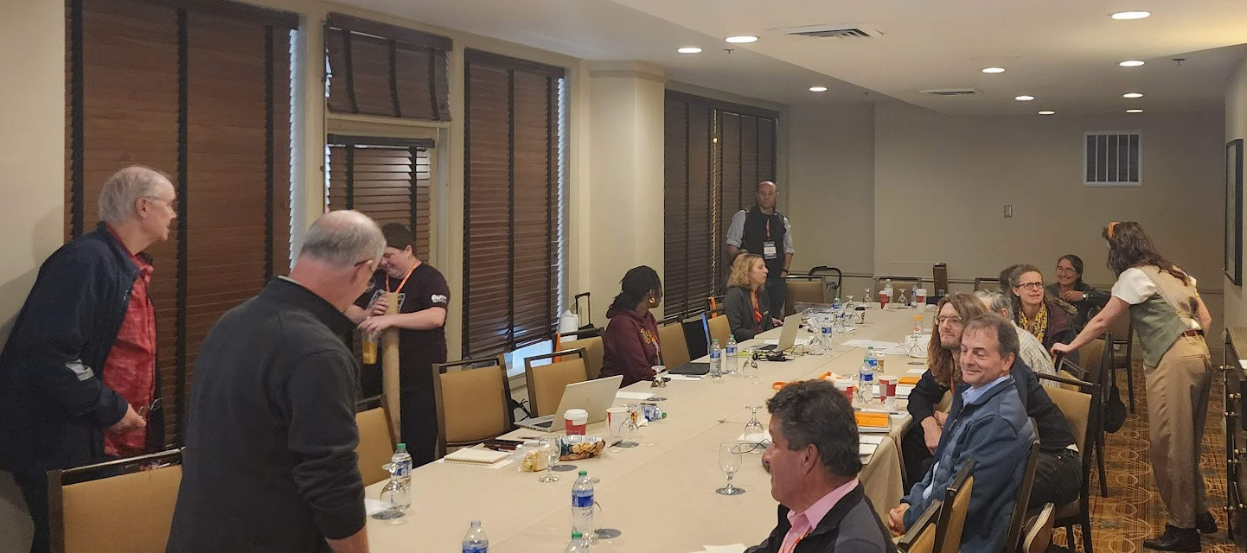

- Approval of minutes of the last meeting (11:00-11:02 PM)
TP motioned
LW seconded

2) Peter Bretting, USDA-ARS, Research Leader, National Germplasm Resources Laboratory
Gary R. Kinard, USDA-ARS, Research Leader, National Germplasm Resources Laboratory (20 minutes) (11:02-11:22 AM)

NPGS status
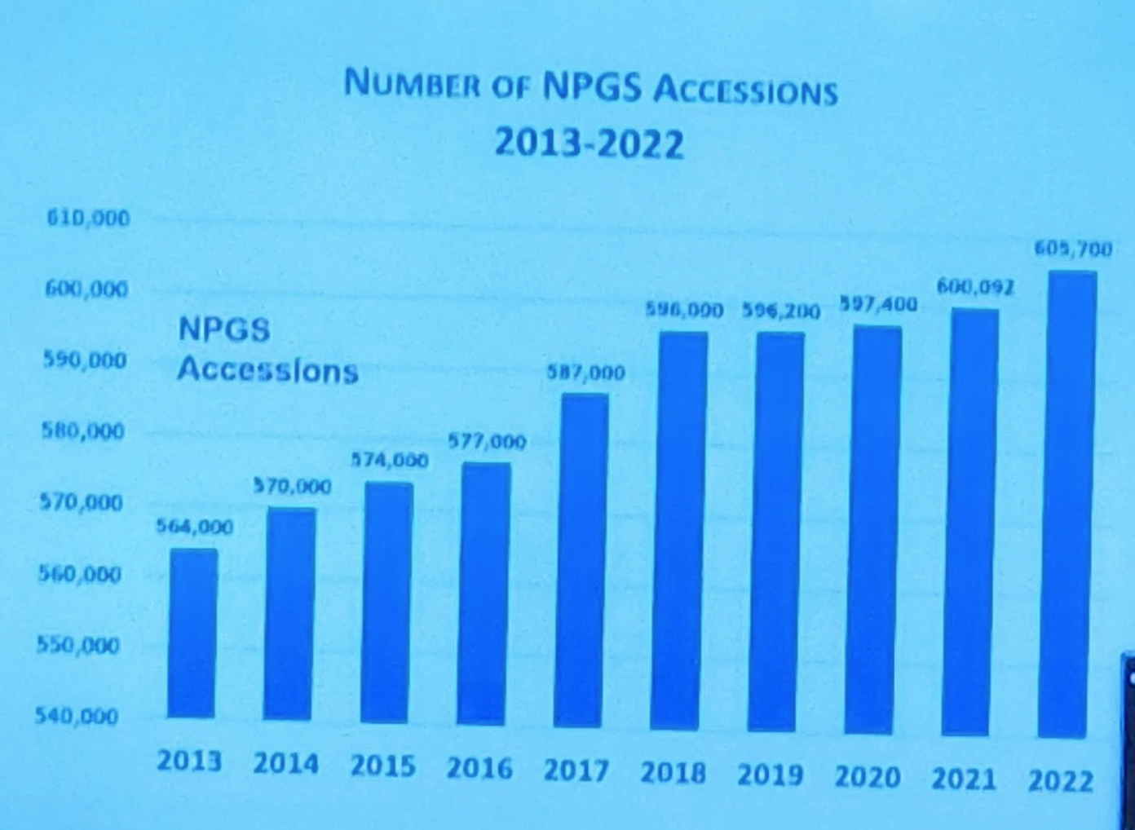
22 sites, 2 primary aspects of the location of genebanks cover most of the growing regions of USA.
Growth of accessions in the recent years, growth in funding

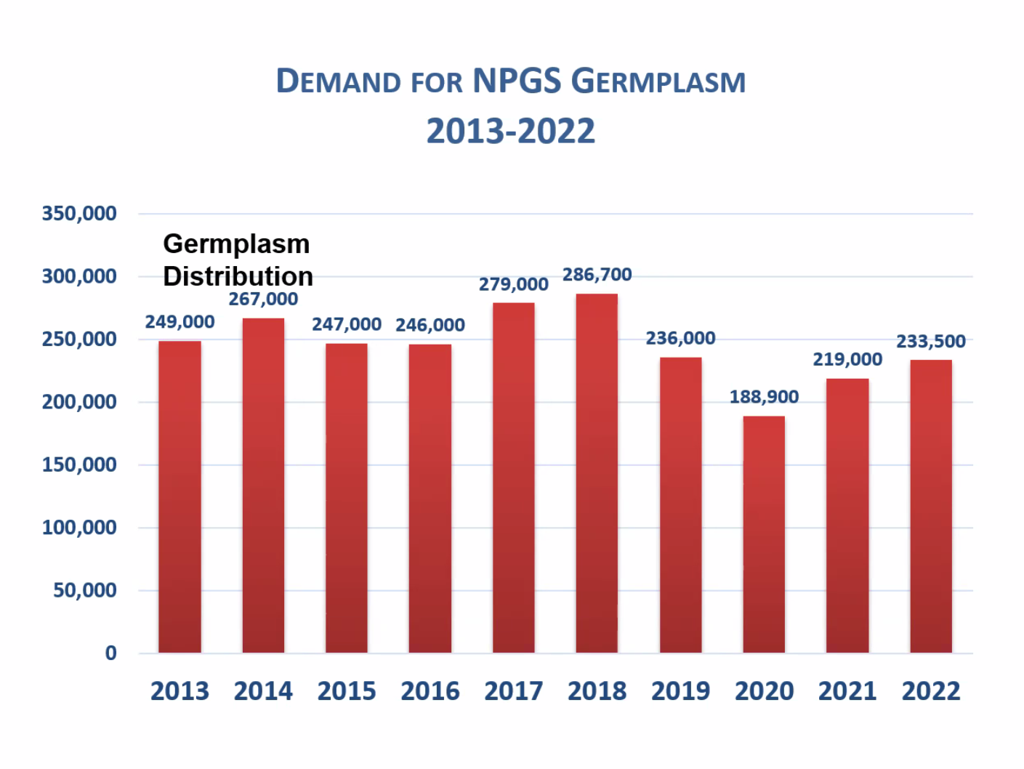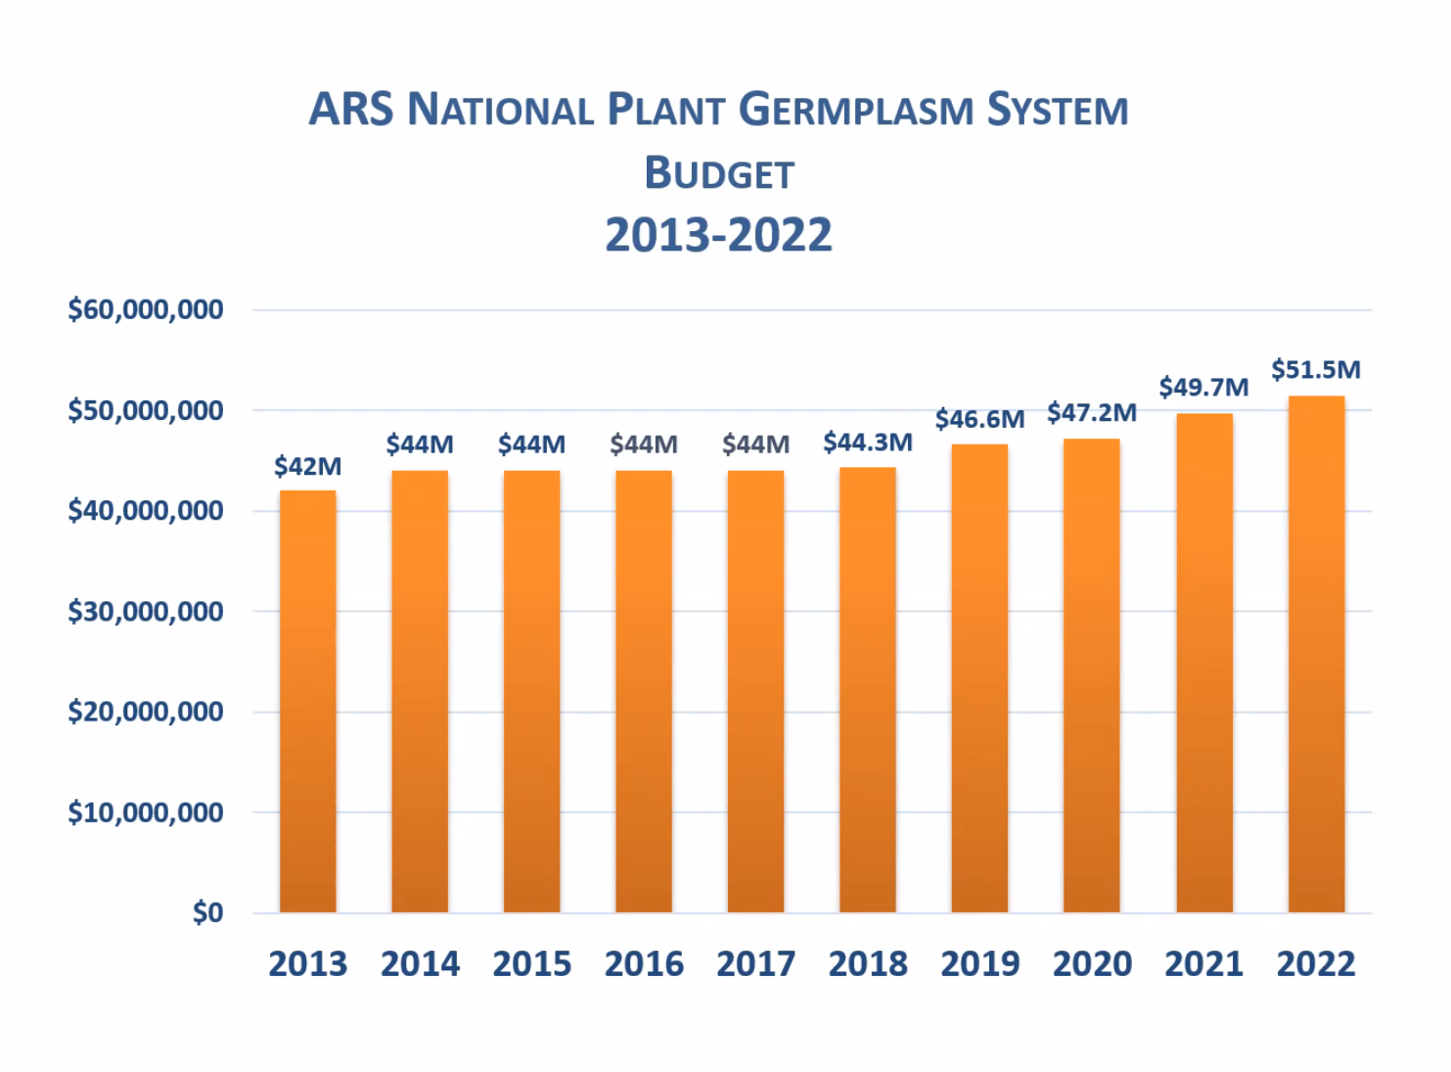

However, in NPGS real budget figures, the situation is not as optimistic. NPGS still underfunded.
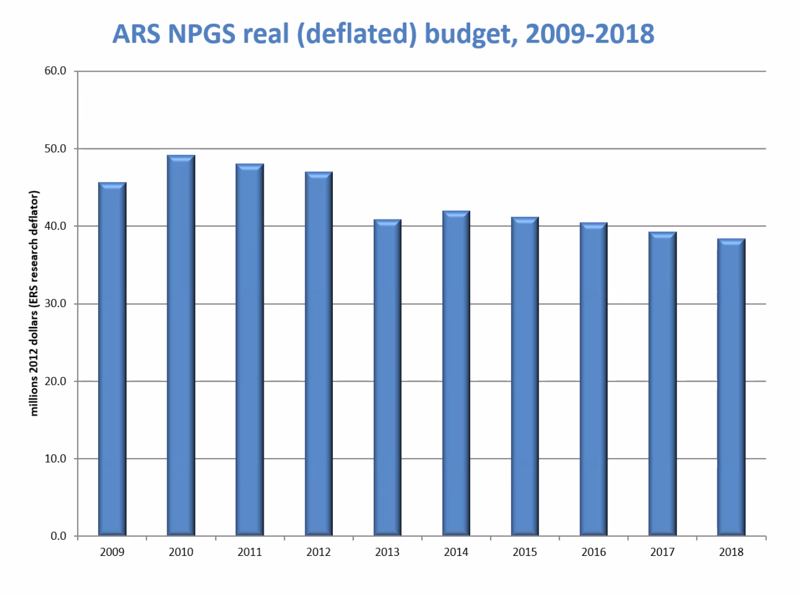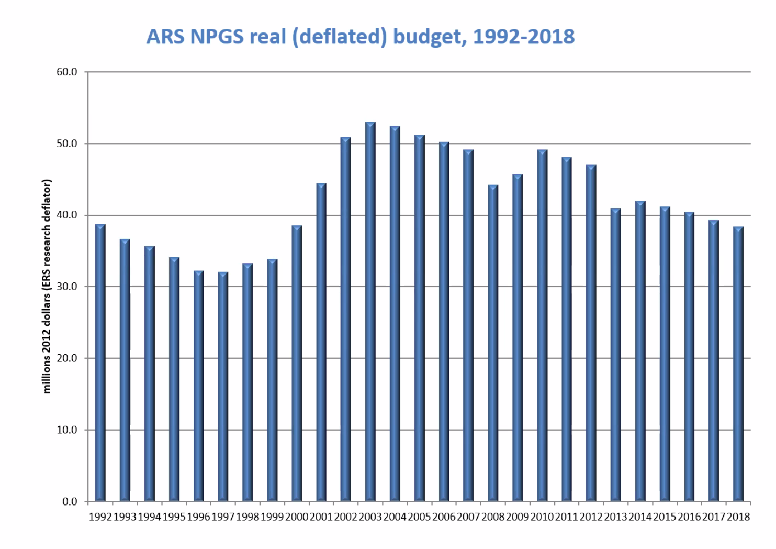

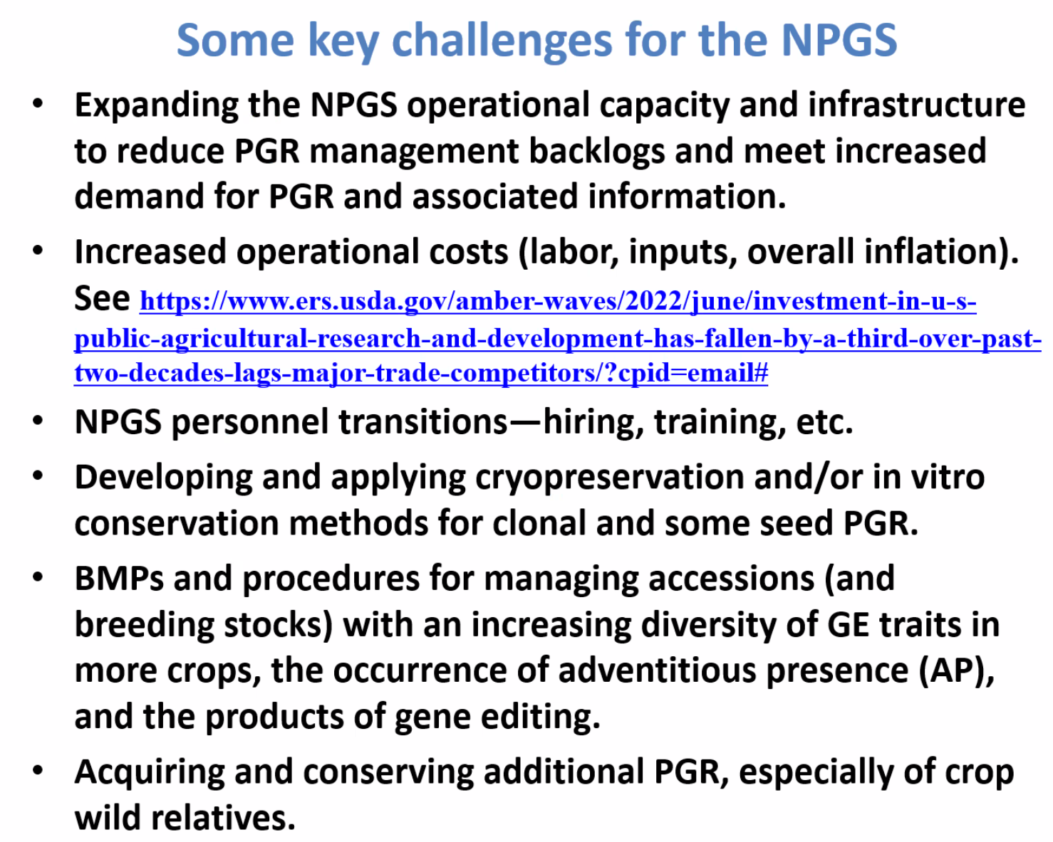

The USA's R&D investment has fallen due to inflation and the static effect of nominal budgets.

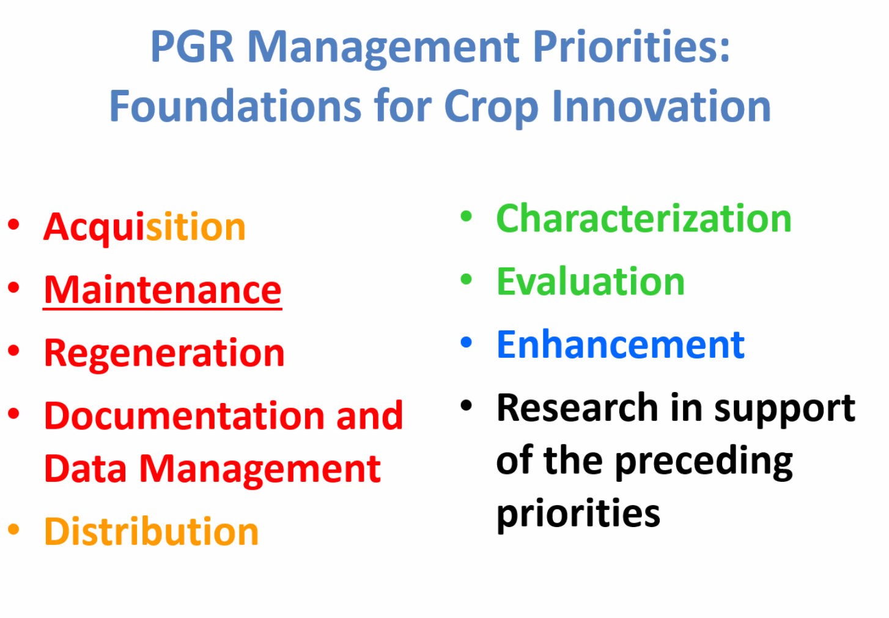
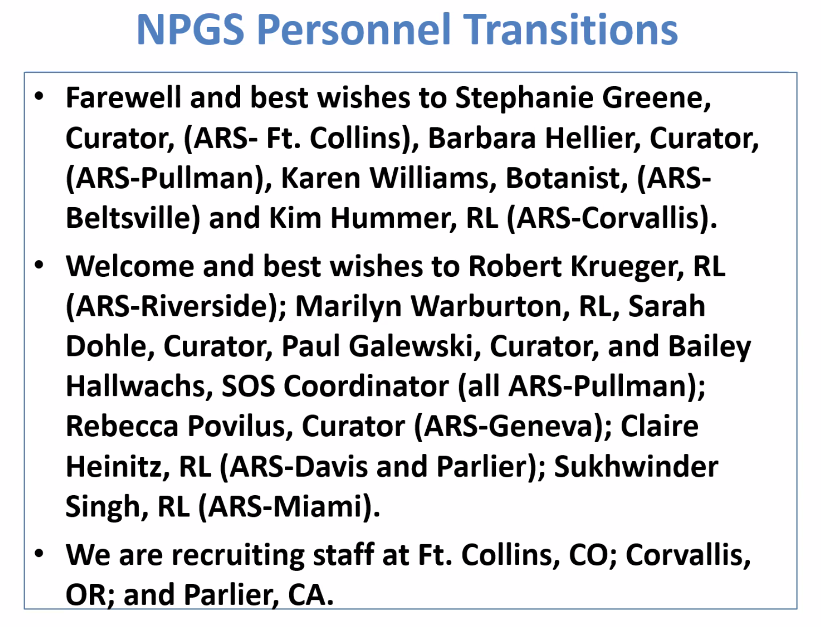

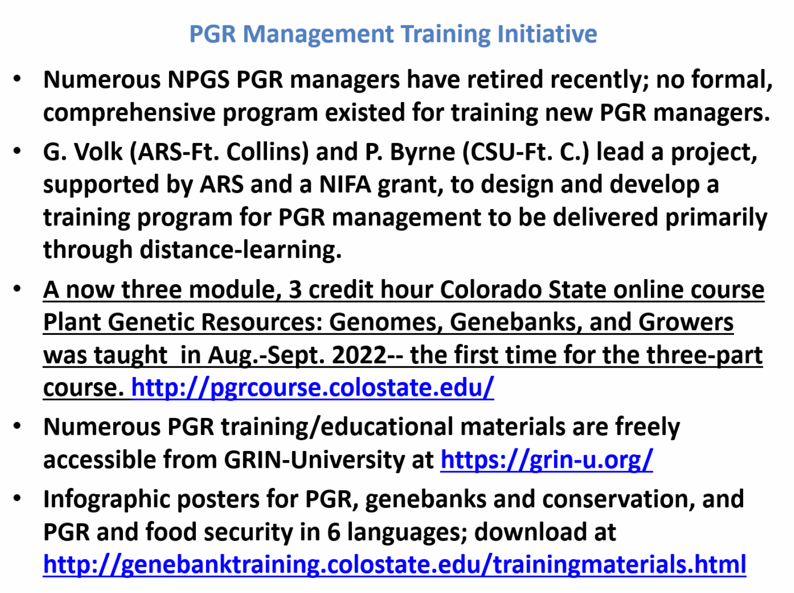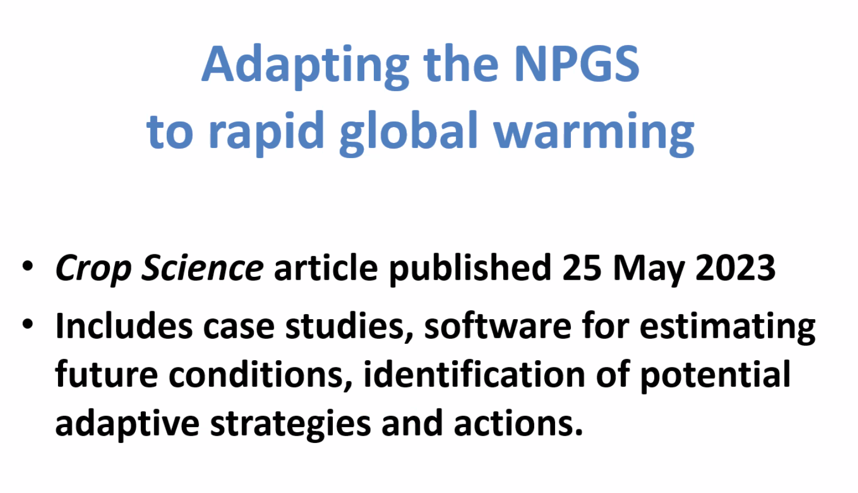
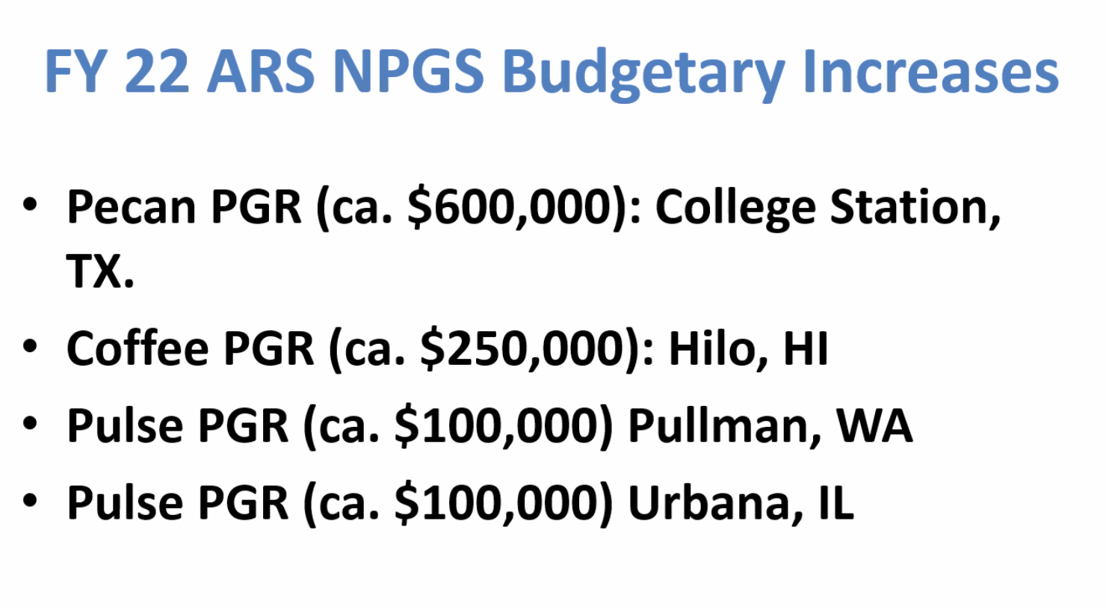

3) Exploration proposals:
- Phaseolus collecting mission in New Mexico, USA. Daniel Debouck (10 minutes) (11:22-11:32 AM)
Debouck:
Mission in new Mexico. Heat tolerance proposal, priorities on tepary.
Sampled between boundaries of tepary areas. Picked up rhizobium, nodules, partitioning of photosyntates seem to be different. Wild tepary and P. filiformis.
Dohle:
Difficult year to conduct exploration. Ranches and other barriers prevented access to some of the land. Cowpies in areas from records showed presence of grazing.
Plant exploration office. Nc2 exploration mission. Grant exploration office 12k for trips are available.
NMSU will see about root microbiome, collaboration is with CIAT (Milan Urban).
- Collect Phaseolus polystachios germplasm in Florida and Georgia. Lyle Wallace (10 minutes) (11:32-11:42 AM)

Rationale was to explore range from Debouck’s book. Wild kidney bean or polystachios, when compared with usda collection is very well collected across northern range but never in GA or FL -limited geographically.

Tertiary genepool of limas, most temperate of all wild Phaseolus – may be valuable.

Seed and herbarium collected. Hurricane cut trip short.

Collected from Jones Center and cummings landing in GA. No burn management vs good burn management, savannahs. Distinct environment, cacti and tortoises.

Subspecies of poly (thicket bean), forms thickets and growing in “devil’s walking stick”

Flowering in the spring of this plant. But produces seed in odd times.

North entrance is deciduous forest.

Phasmasifolius (?), first location no seed, flowered and seed found in crystal river FL. Suggest that native americans brought in this plant.

Spread by tortoises in south America, hypothesis.

Eight sites collected overall in FL and GA. 2 in GA and 6 FL.

Found all plants that they set out to collect.

4) Update of PCGC-funded projects:

2020. Screening of the NPGS tepary bean collection for response to the common bean weevil (Acanthoscelides obtectus Say) and the Mexican bean weevil (Zabrotes subfasciatus). Timothy Porch, Tropical Agriculture Research Station, USDA-ARS, and James Beaver, University of Puerto Rico, Mayagüez, PR (10 minutes). (11:42-11:52 AM)

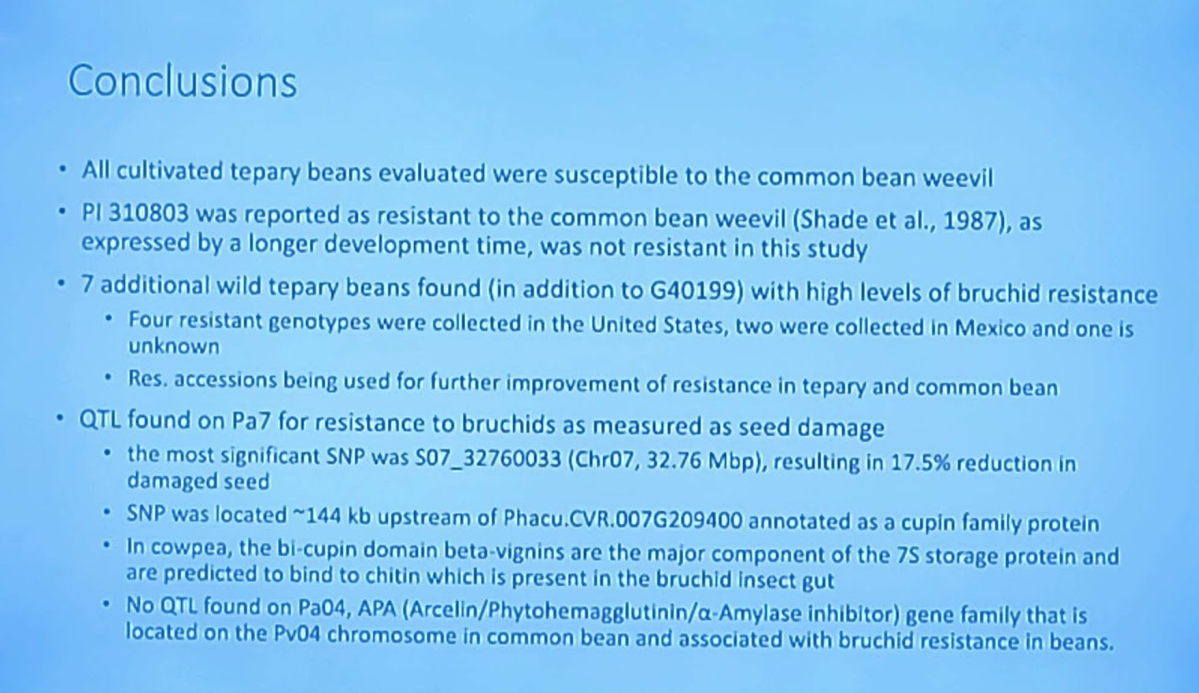

2022. Evaluation and Genome-wide Association Study for Ashy Stem Blight (Macrophomina phaseolina) Resistance in USDA Common Bean (Phaseolus vulgaris) Germplasm. Ainong Shi, University of Arkansas, Diego M. Viteri and Angela Linares, University of Puerto Rico (10 minutes) (11:52-12:02 PM)

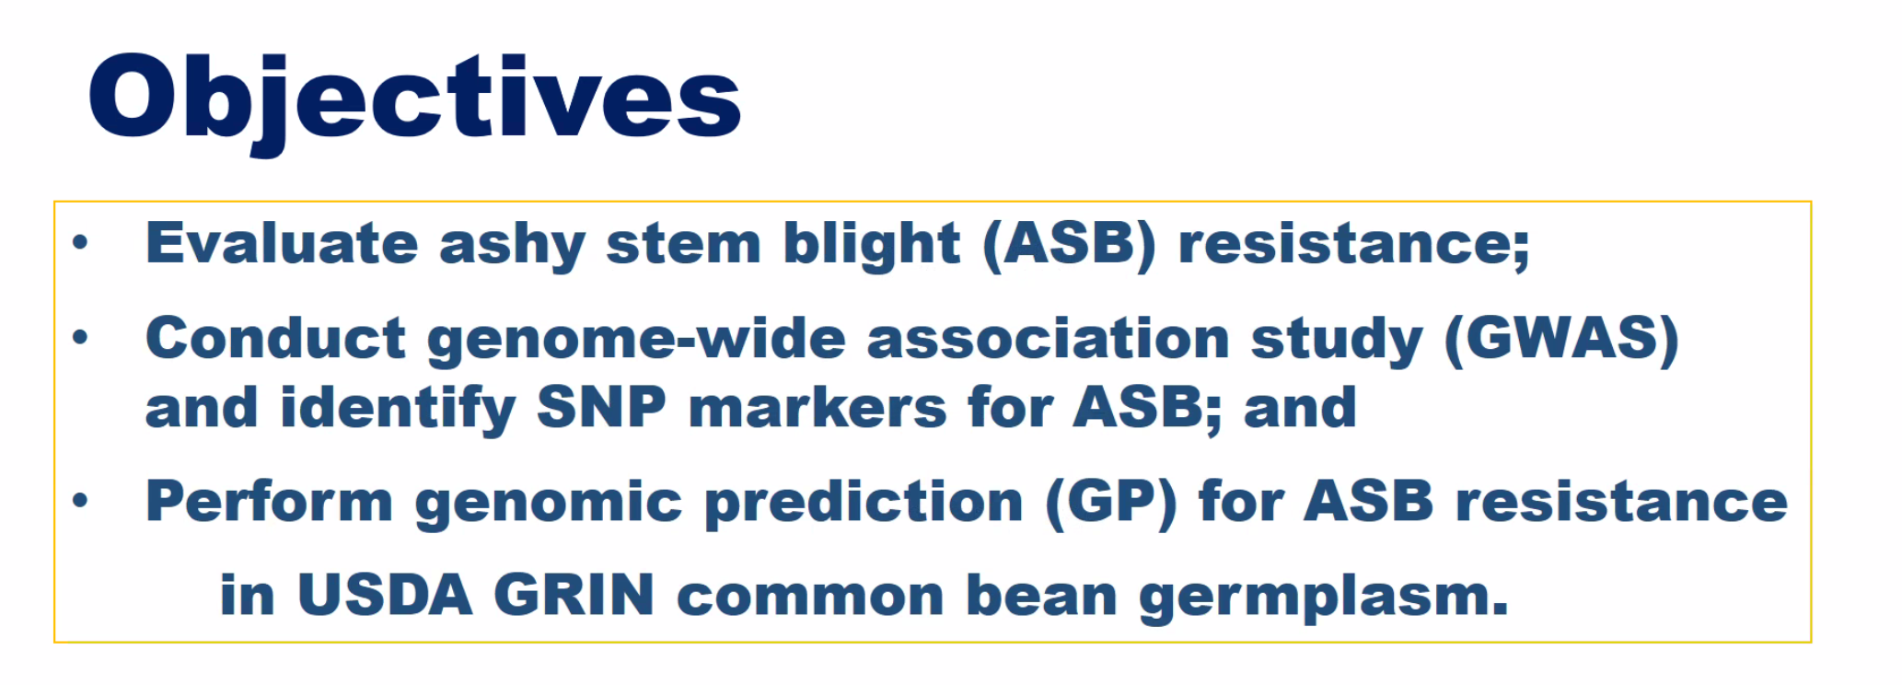
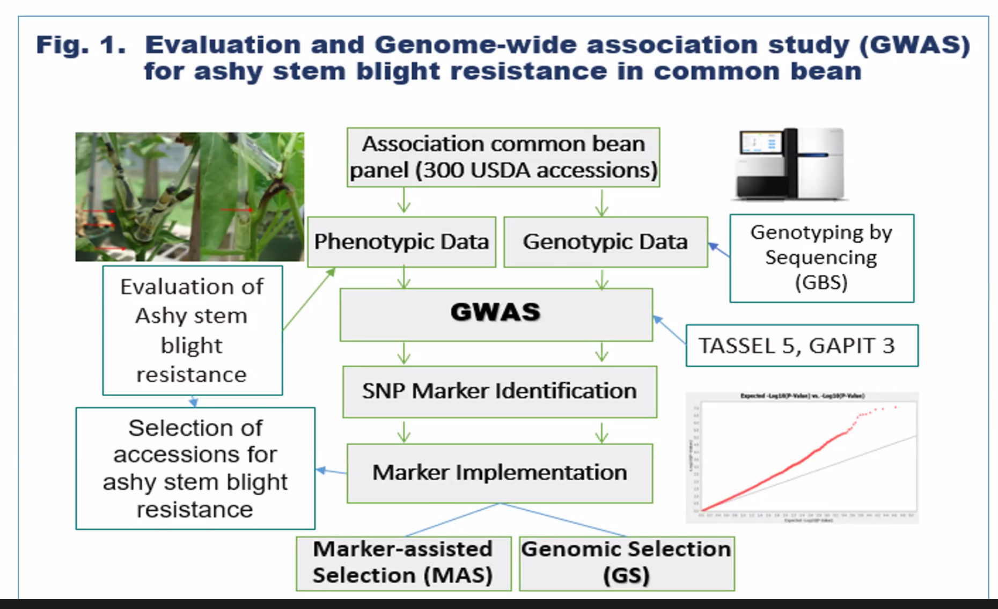

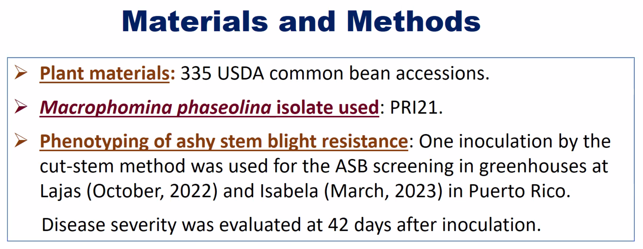

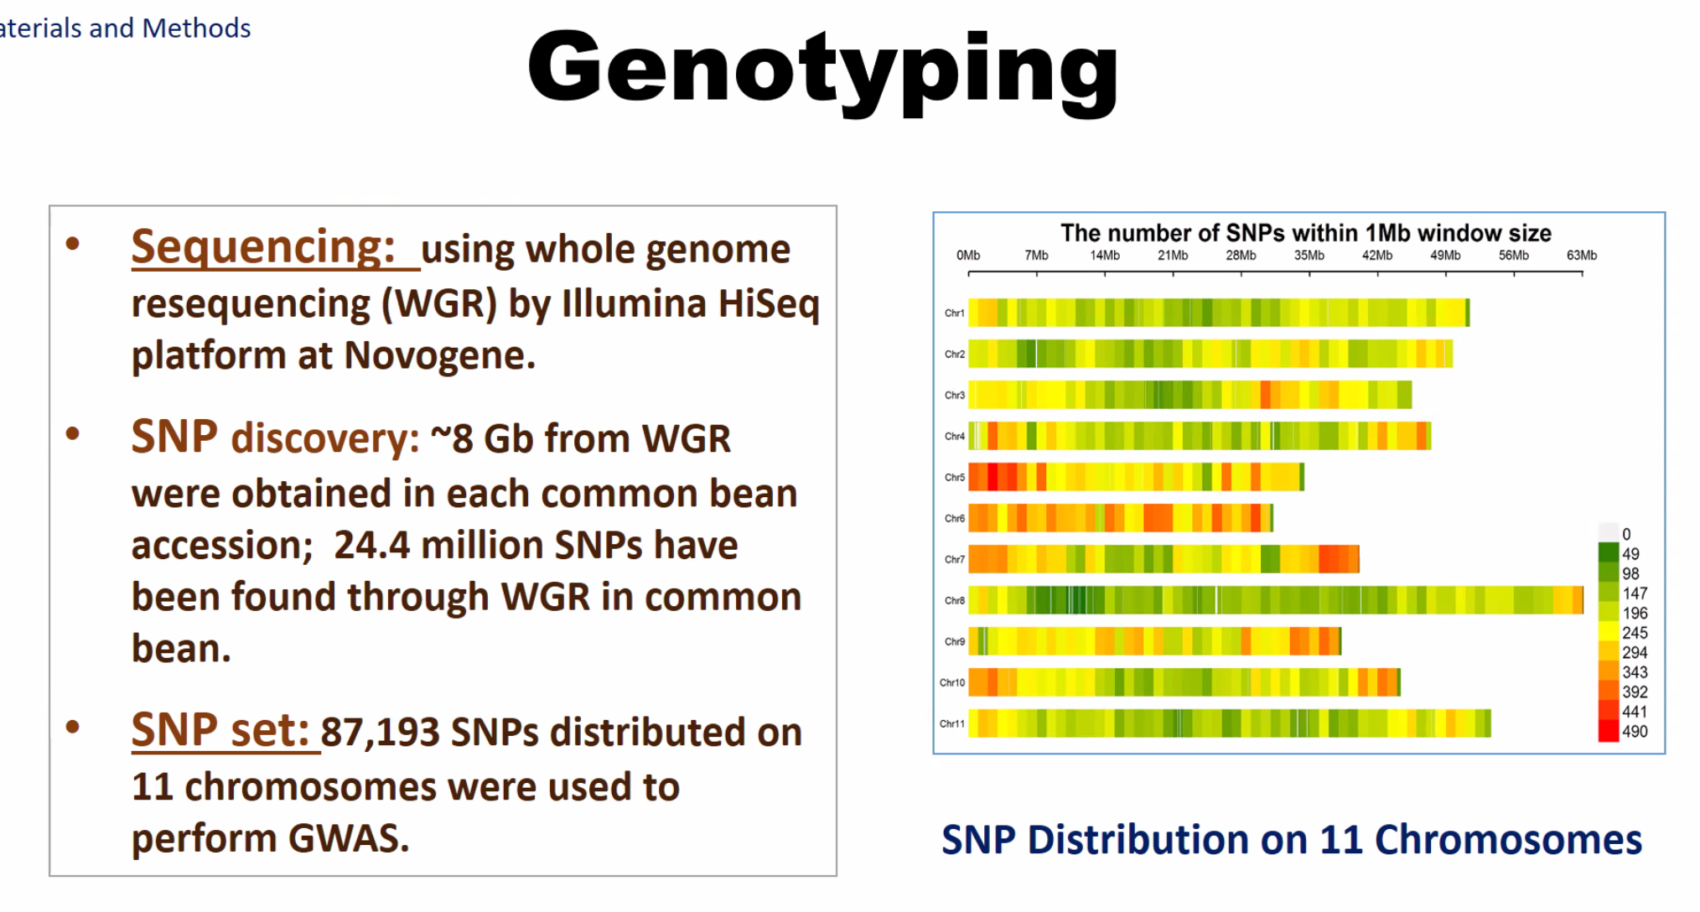

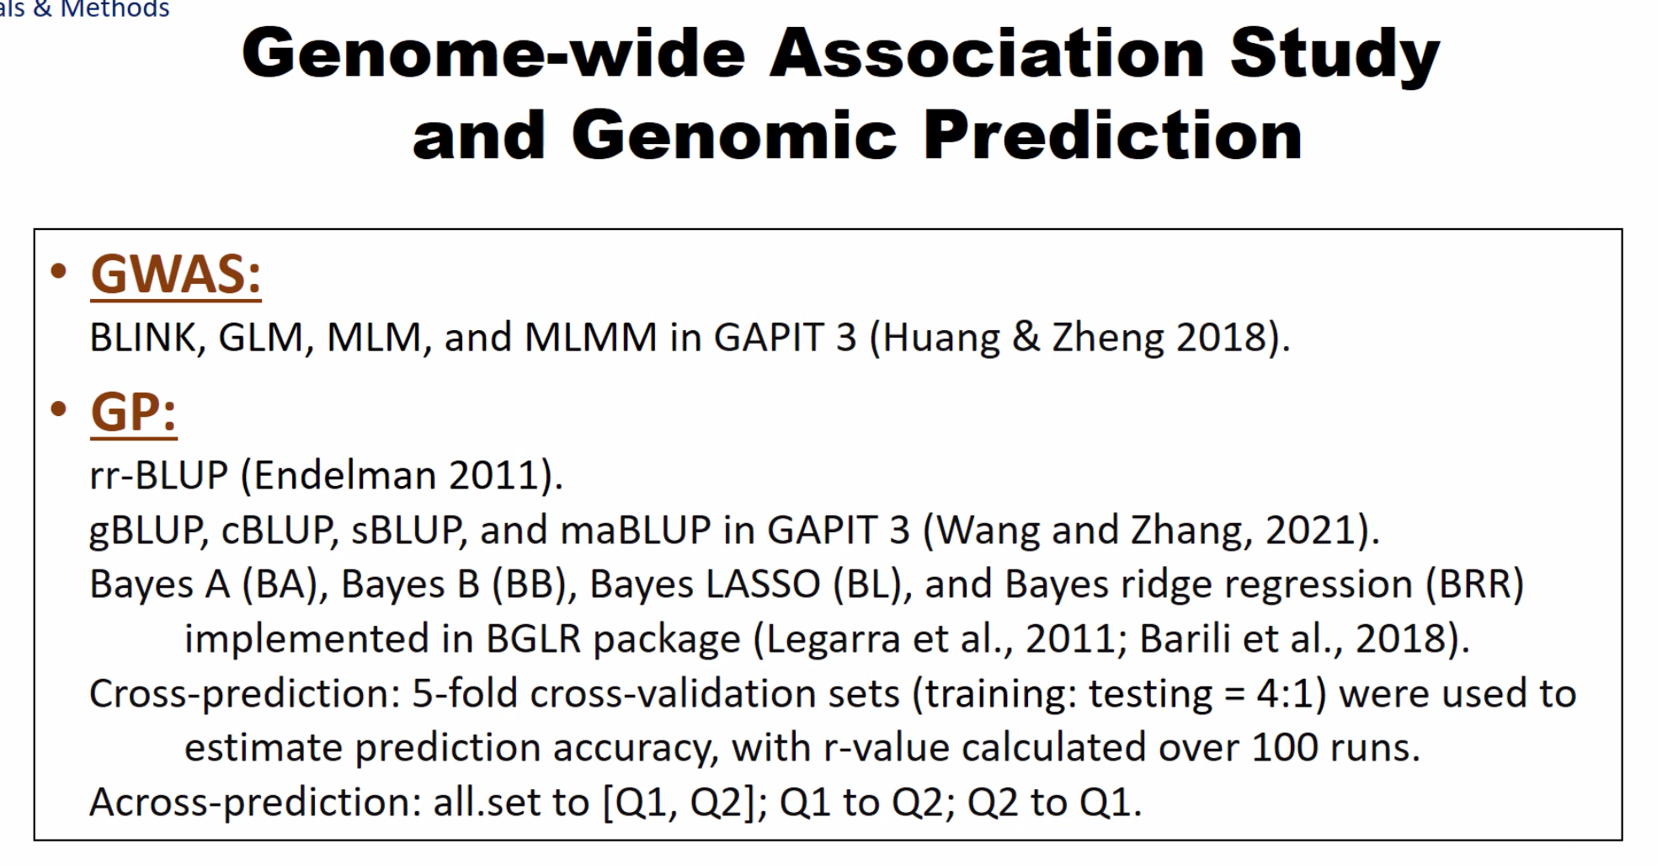

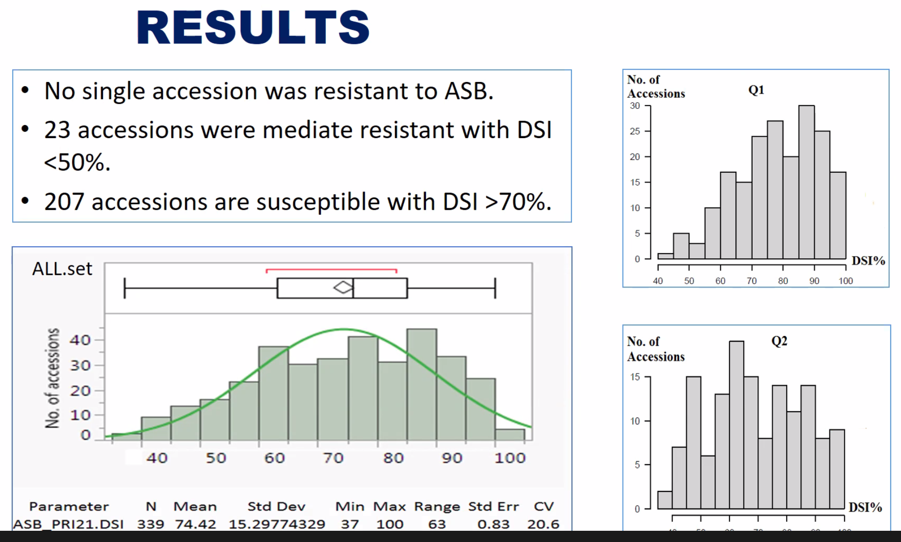
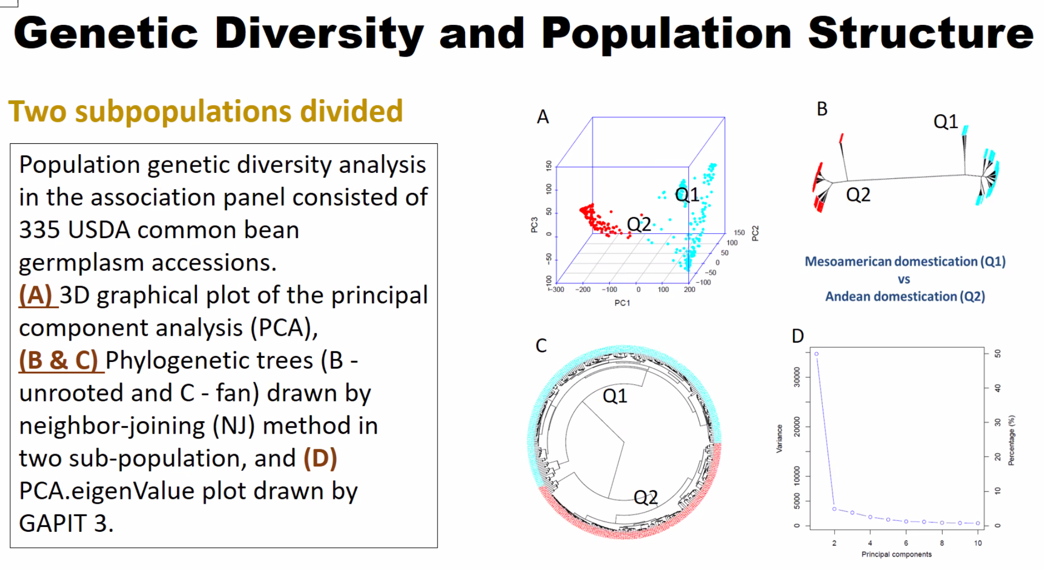
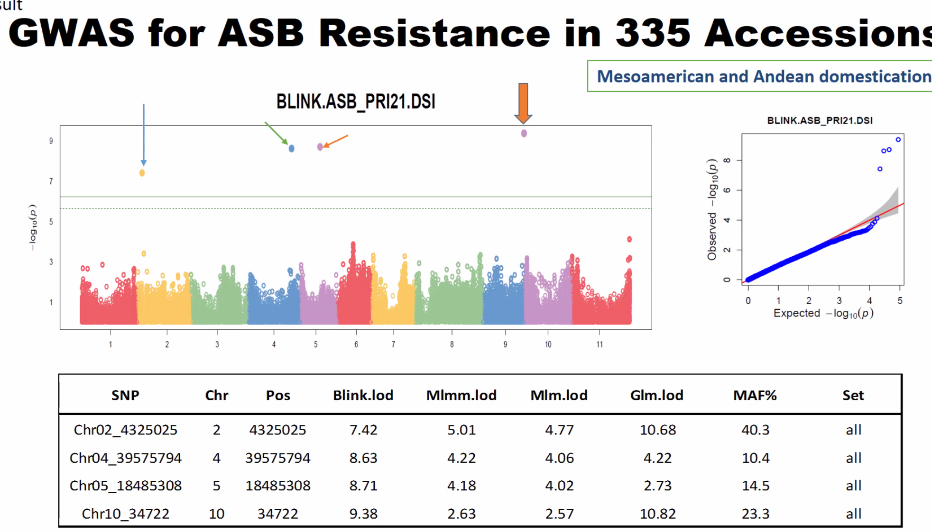
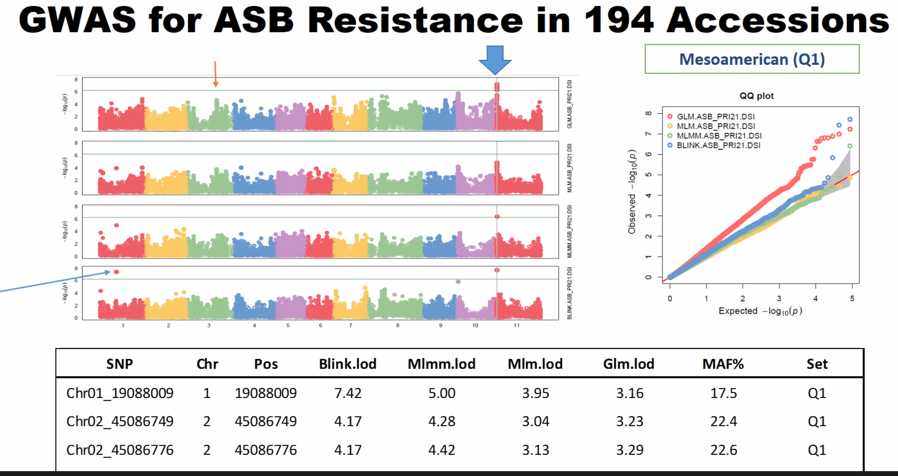

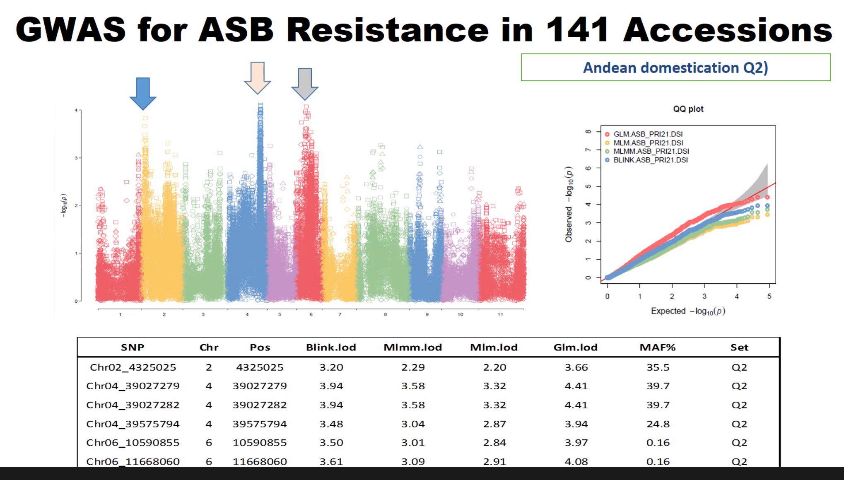

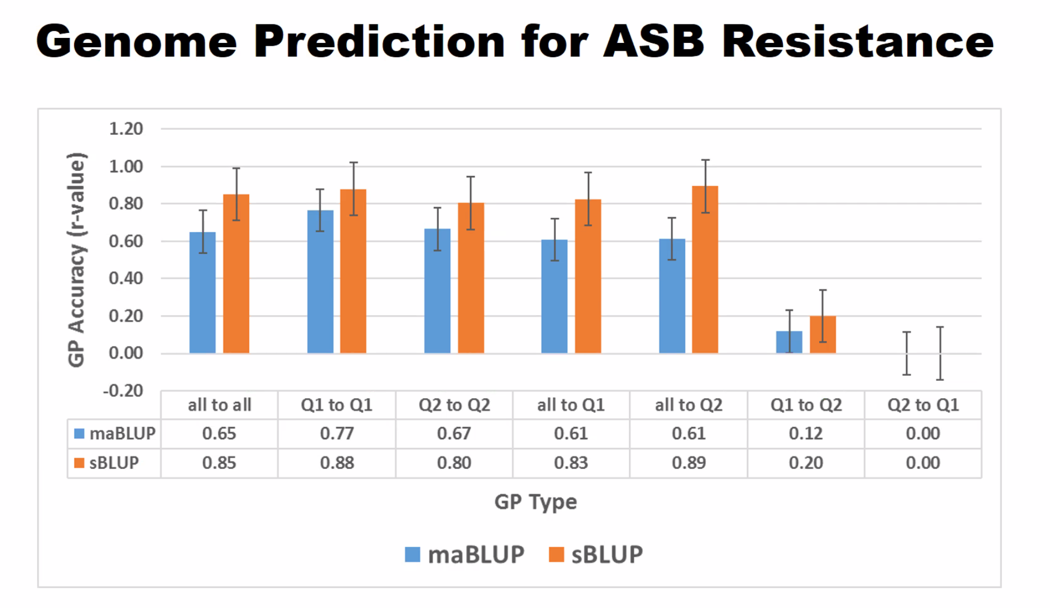

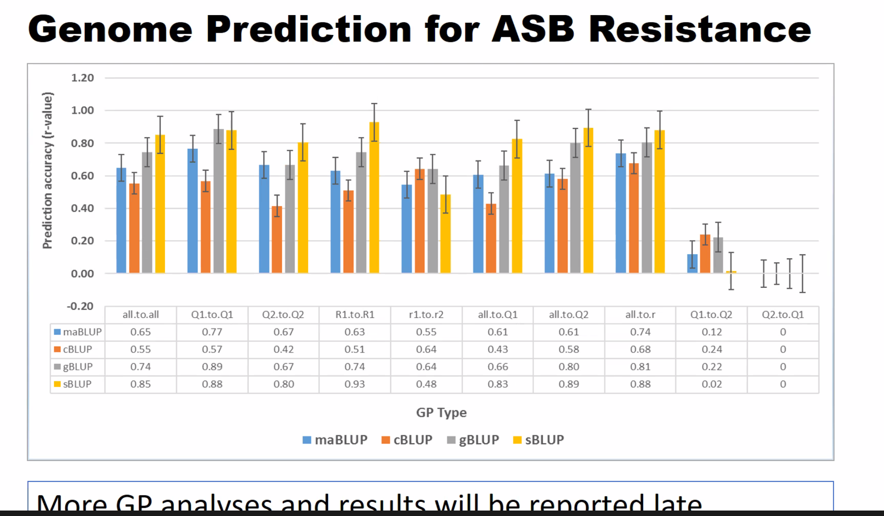

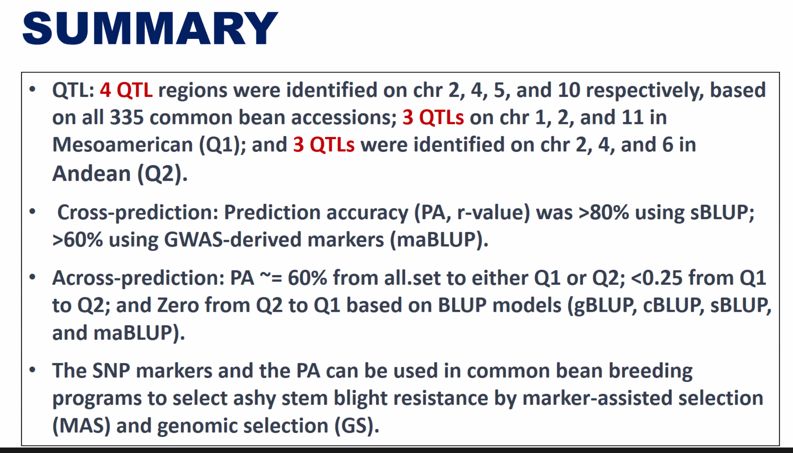

5) Status of the Phaseolus Germplasm Collection, Sarah Dohle (Phaseolus Curator) (20 minutes) (12:02-12:22 PM)

Notes were handed out. Collect from there.

6) New business

a. Change of Committee Officers, Membership (12:22-12:30 PM)

7) Next meeting

Osorno motioned
Cichy seconded

8) Adjourn

