Standard Material Transfer Agreement (SMTA) Standard Operating Procedure and Guide

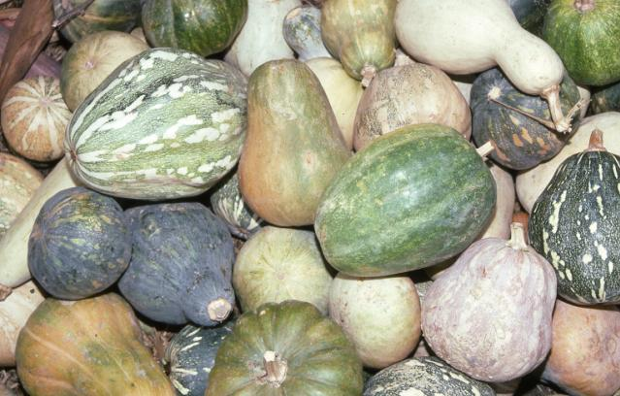

March 2008
Table of Contents
Standard Material Transfer Agreement (SMTA) Standard Operating Procedure and Guide 1
Accepting and distributing material covered by the SMTA on behalf of the NPGS 3
The first steps with SMTA Material 4
Step 1: After accepting the SMTA, enter the documentation into the Accession form to create an Accession. 4
Step 2: Go directly into the IPR (Intellectual Property Rights) Form with your SMTA Accession to enter documentation there. 4
The Next Steps 5
Handling a Request from the Shopping Cart on the Web 5
Handling a Request without the Shopping Cart 9
Documenting an Order for an SMTA with an email address that has not come through the Shopping Cart 11
Documenting an order with no email 17

Accepting and distributing material covered by the SMTA on behalf of the NPGS
- When you accept material into the NPGS accompanied by an SMTA, you are accepting the SMTA on behalf of the NPGS and ARS. Further, the SMTA and the conditions in the SMTA will accompany this material, or anything derived from it, into perpetuity.
- Curators in the NPGS are authorized to accept material covered by the SMTA provided it is a crop they curate and they enter the documentation into GRIN. Instructions for entry into GRIN are included below. Entry in the IPR table that the material is covered by the SMTA is critical and begins the process for the rest of the steps that are necessary if someone should choose to request this material.
- It is your responsibility when accepting material to ensure the SMTA you are accepting is the accepted and official SMTA or foot noted SMTA (*SMTA). This SMTA can be found at http://www.planttreaty.org. If you have any questions regarding the authenticity of the SMTA you are being asked to accept, contact June Blalock at June.Blalock@ars.usda.gov
- It is up to the donor to define if the material is covered by the SMTA. If an SMTA does not accompany material, the NPGS assumes the material is not covered by the SMTA.
- The NPGS will accept the SMTA or the footnoted SMTA from any entity and for any crop. If the material is accompanied by an SMTA, we accept it. Note that the footnoted SMTA covers all crops for food and agriculture, including non-Annex 1 crops.
- Acceptance of the SMTA is based on it being non-negotiable and part of a multi-lateral treaty.
- Distribution of material accompanied by the SMTA will always require acceptance of the SMTA by the recipient prior to release of the material. This includes distribution to all non-NPGS requestors.
- Notification to the requestor, as well as electronic acceptance of the SMTA, will be done on line when the order is placed and via email or post when the order is not placed on line.
- These guidelines and the authorization to accept the SMTA does not cover material used for research or material which is not immediately upon receipt documented in GRIN as part of the NPGS.
- Other MTAs received by the NPGS must be reviewed by the Office of Technology Transfer. Technology Transfer Coordinators will assist NPGS curators with reviewing the terms of such MTAs for acceptability.

The first steps with SMTA Material

Step 1: After accepting the SMTA, enter the documentation into the Accession form to create an Accession.

To create an accession, you must fill in the following fields:
- Accession prefix acp
- Accession number acno
- Taxonomy taxon
- Received date received

Step 2: Go directly into the IPR (Intellectual Property Rights) Form with your SMTA Accession to enter documentation there.

In the IPR table you must fill in these fields:
- Accession prefix acp
- Accession number acno
- IPR Type iprtype

In the IPR Type field, you must list the type as MTA-SMTA, see the IPR Type list of values pop-up window below:

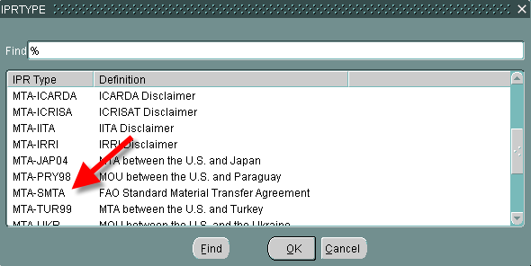

This will ensure the rest of the steps will be followed when someone requests an SMTA accession.

The Next Steps

If you get a request for this material from anyone outside the NPGS (including other ARS scientists), follow these guidelines. We have arranged it so that you don’t have too much work.

You can get an order with an SMTA accession in it any of several ways:
- Through the Shopping Cart on the GRIN website.
- Through the website without use of the Shopping Cart
- Any other way, phone, letter, etc.

The following explains how to deal with each of these situations.

Handling a Request from the Shopping Cart on the Web

If the request comes from the Shopping Cart on the web, the requestor has already seen the SMTA information and has already accepted it.

Your email order will state something like the following:

"New order from the web shopping cart. Some of the order items are covered under the SMTA and have been accepted under the terms of the SMTA by the requestor."

Because the web is totally separate from the database, this information has to be loaded into the database. Follow the next steps to keep track of the requestor’s acceptance in the database. You should retain this email message as further confirmation.

- Add the documentation for your order into the Order Header form
- Add the documentation for your order items in the Order Items form
- Requery your order. Requery your order. Note that oldest date for what you’ve queried, shows up at the top, not most recent date. After that, local order is sorted on, before GRIN DB order. To correct this, either be very specific in your query or change the sort of your query once you get the answer.

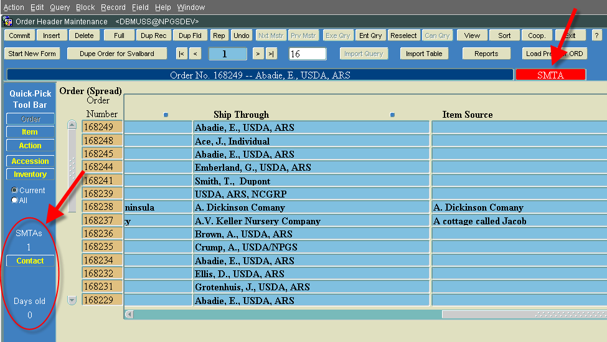

The two red arrows in the above figure point out the additions that you will see when you work with an order that includes one or more SMTA accessions.
        - The top right arrow informs you that this order contains one or more SMTA accessions.
        - The left arrow points out the modifications to the Quick Pick tool bar, I’ve pulled out the changes and will explain them below:

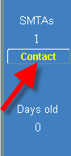 | - The top line instructs you that this order contains an SMTA.  - The next line contains the number of SMTA accessions that are included in the order.  - Next is the Contact button that you will use to get to the next form adding contact information to the database.  - The next two lines listed here tell you how long the SMTA order is in the database. This is important if the order did not come through the Shopping Cart. That will be explained in the next set of instructions, too!

- Mark your Order in the Current Status field as one of the following:
        - Shipped
        - APHIS
        - Done
- Click Commit
g. The following form automatically appears:

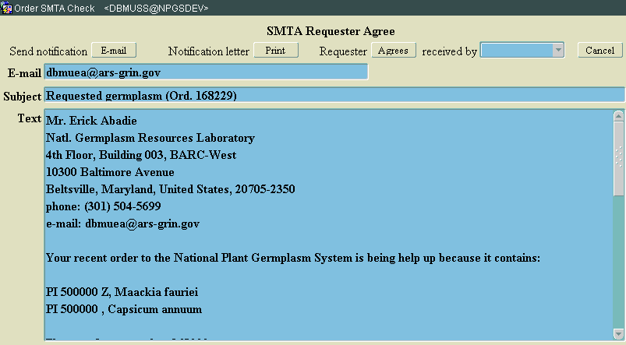

h. On the Requestor Screen, click the List of Values button for the “Received by” field, to document in the database how you received the request for the SMTA, see the arrow on the figure below:

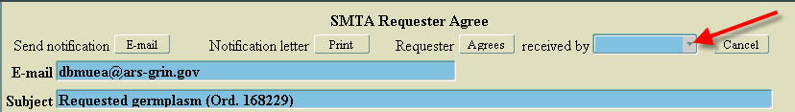

Your choices follow:

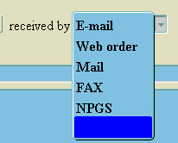

i. In this example, the requestor’s acceptance came from the Shopping Cart, so choose “Web order”
j. Then click on the Agrees button, see arrow below:

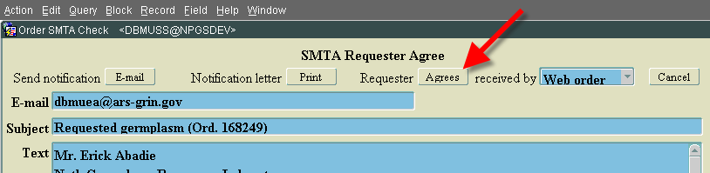

You return to the form with a note that you have shipped 2 items and debited 2 inventories:

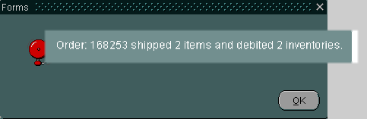

Click OK to leave this little pop-up.

Notice that the left side navigation bar is also updated, see below:

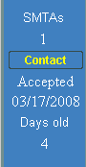 | You are now done with the order header and items for your order from the Shopping Cart. The information on the left side nav bar appears with Accepted in it. If you requery this order, the left side nav bar (as seen on the right) shows the SMTA and that it was accepted. | 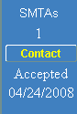

The next step is to create picking and packing lists.

- Click the Reports button on the top right side of the Order Header form, see below.

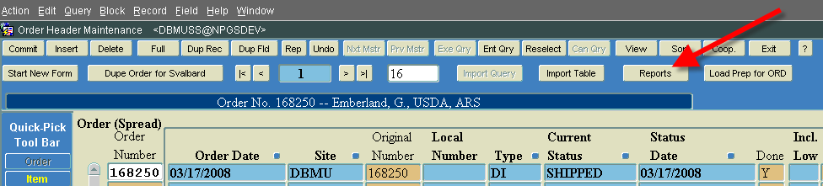

The Reports page appears with
    - Picking List
    - Packing List
    - Incomplete SMTA Orders

Run any of the reports you want.
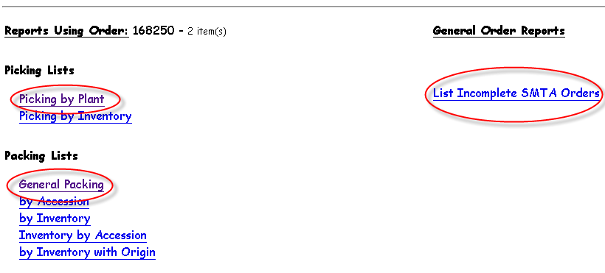
When you choose the General Packing List, you see that the SMTA accession appears in red, and that the restrictions for the SMTA appear below the items, reminding the requestor of his (her) responsibilities.

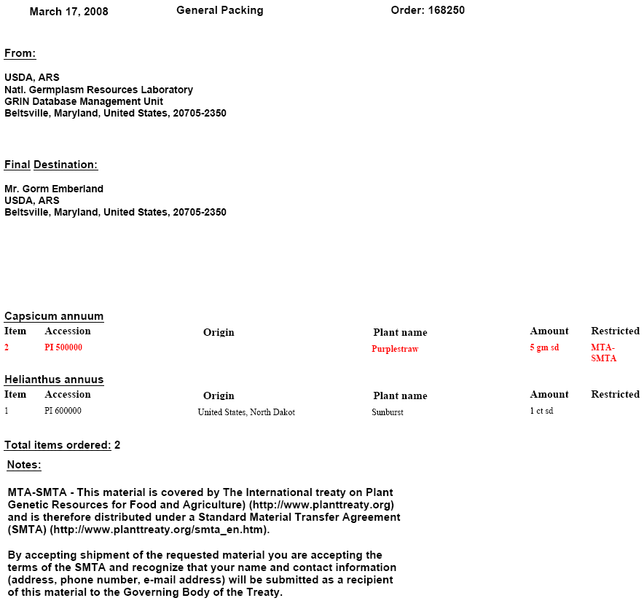

Handling a Request without the Shopping Cart

All the other ways to handle SMTA requests are explained here. If the requestor does not use the shopping cart, they do not know about the SMTA restrictions, and have not seen the fact that their name and contact information will be passed on to other countries. You have to send the SMTA information to the requestor and he(she) must accept it before you can send them the SMTA material. If items other than SMTA items were also part of the order, you can either hold on to them while you wait for acceptance of the SMTA material or you can send the non-SMTA material ahead as partial shipment.

The instructions begin similarly to the start of the above instructions.

Again, because the web is totally separate from the database, the Order information has to be added to the database. Follow the next steps to keep track of the requestor’s acceptance in the database.

  - Add the documentation for your order into the Order Header form. If the person, place is not already in the database, you must add their information to the cooperator area. Be sure to include any email addresses you get. If you don’t get an email address, that’s okay, you will see how we handle that below.
  - Add the documentation for your order items into the Order Items form.
  - Requery your order. Note that if you weren’t specific with your query and your results present you with numerous orders, you will see the oldest date for your query appears at the top, not the most recent date. After that, local order is sorted on, before GRIN DB order. To modify this, either get very specific in your query or change the sort of your query once you get your results.
  - You will then see your order with the SMTA information in the left side navigation bar.

The two red arrows in the above figure point out the changes.
        - The top right arrow points out that this order contains one or more SMTA accessions.
        - The left arrow and the red oval points out the modifications in the Quick Pick tool bar. I’ve pulled out the changes and will explain them below:

- The top line informs you that this order contains an SMTA.
- The next line contains the number of SMTA accessions that are included in the order.
- Next is the Contact button that you will use if you want to get to the next form.
- The next two lines listed here tell you how long the SMTA order is in the database. This is important if the order did not come through the Shopping Cart. This will be explained in the next set of instructions, too!

  - Click the Contact button
  - You automatically go to the form below:

Documenting an Order for an SMTA with an email address that has not come through the Shopping Cart

  - If the person’s email address is not there, you need to type it in (green filled field with green arrow). Then click the E-mail button (blue arrow).

***

  - I typed in an email address (green field) and clicked the E-mail button (blue arrow).
  - As you can see in the next screen, I returned automatically to the Order Header form and the information on the left side navigation bar was updated:

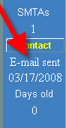

The email was just sent, but the software will keep track of the number of days that pass by after it was sent. If the email was sent 8 weeks or 56 days ago, you can assume the requestor is not going to get back to you to accept the restrictions on this material. You should then remove the SMTA material from the request and send the rest of the accession(s) they asked for if you haven’t already done so.

The database will run a “Chron” job weekly to check for SMTA orders that have not already shipped and will automatically send you an E-mail telling you when your order is 8 weeks or more. If you want to see what SMTA’s are outstanding, though, click the Reports option on any Order Header, see the red arrow on the right hand side of the following screen. Click on the link to see what SMTA orders are still outstanding:

If you do get acceptance information from the requestor, you can send the order on after you mark this in the database. To do so, the first thing to do is type into the Current Status field one of the following actions or status(es):
    - APHIS
    - DONE
    - SHIPPED

Tabbing out of the field brings up the Requestor form, allowing you to mark in the database that the requestor accepted the SMTA just like you did in the previous example. However, I will give you the directions again so you don’t have to figure out where to find them.

On the Requestor Screen, click the List of Values button for the “Received by” field to choose how you received the acceptance of the SMTA, see the arrow on the figure below:

Your choices follow:

In this example, the requestor’s acceptance came from an E-mail, so choose E-mail

Print the email and save with hard copy of order
- Then click on the Agrees button, see arrow below:

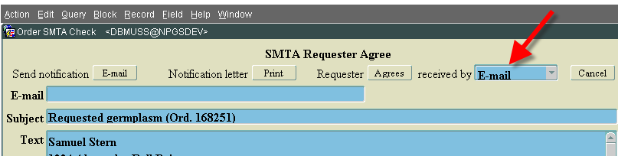

You return to the form with a note that you have shipped 2 items and debited 2 inventories:

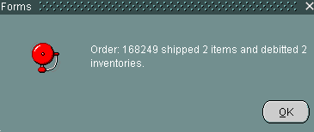

And the left side navigation bar is also updated, see below:

You are now done with the order header and items for your order from the Shopping Cart. The information on the left side nav bar appears with Accepted in it. If you requery this order, all the information on the left side nav bar will disappear, because you are finished with the SMTA.

The next step is to create picking and packing lists.

- Click the Reports button on the top right side of the Order Header form, see below.

The Reports page appears with
    - Picking List
    - Packing List
    - Incomplete SMTA Orders

Run any of the reports you want.

When you choose the General Packing List, you see that the SMTA accession appears in red, and that the restrictions for the SMTA appear below the items, reminding the requestor of his (her) responsibilities.

Documenting an order with no email

- If you have not received an email address for the requestor, click the “Notification letter” button (red arrow) that says “Print” and print out a notification letter. You will then have to put the letter in an addressed envelope and send the requestor a letter seeking approval fo the SMTA.

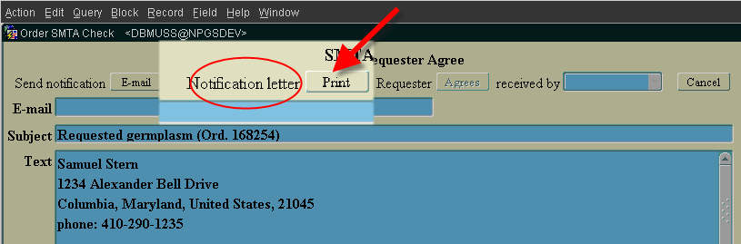

A letter informing the requestor of the SMTA for this order is created.
Print it out and send it to the requestor

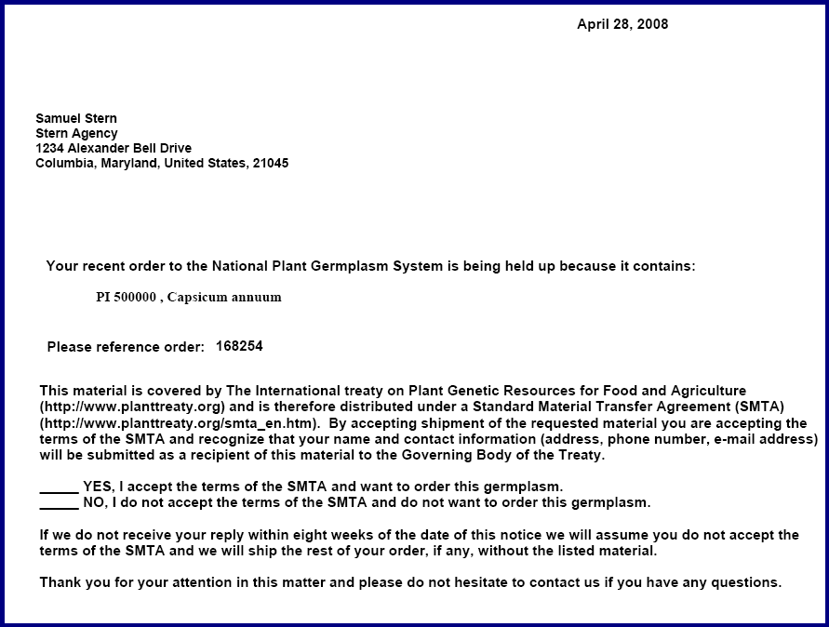

Then close the window with the letter printed on it.

You return to the Order Header. Rquery the Order Header.

As you can see in the next screen, I returned automatically to the Order Header form and the information on the left side navigation bar was updated:

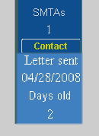

I see that a letter was sent and the software will keep track of the number of days that pass by after it was sent. If the letter was sent 8 weeks or 56 days ago, you can assume the requestor is not going to get back to you to accept the restrictions on this material. You should then remove the SMTA material from the request and send the rest of the accession(s) they asked for if you haven’t already done so.

The database will run a “Chron” job weekly to check for SMTA orders that have not already shipped and will automatically send you an E-mail telling you when your order is 8 weeks or more. If you want to see what SMTA’s are outstanding, though, click the Reports option on any Order Header, see the red arrow on the right hand side of the following screen. Click on the link to see what SMTA orders are still outstanding:

If you do get acceptance information from the requestor, you can send the order on after you mark this in the database. To do so, the first thing to do is type into the Current Status field one of the following actions or status(es):
    - APHIS
    - DONE
    - SHIPPED

Tabbing out of the field brings up the Requestor form, allowing you to mark in the database that the requestor accepted the SMTA just like you did in the previous example. However, I will give you the directions again so you don’t have to figure out where to find them.

- On the Requestor Screen, click the List of Values button for the “Received by” field to choose how you received the acceptance of the SMTA, see the arrow on the figure below:

Your choices follow:

In this example, the requestor’s acceptance came from a letter, so choose mail or FAX unless the requestor emailed acceptance in which case click email.
Save the hard copy of the acceptance with a hard copy of order
Then click on the Agrees button, see arrow below:

You return to the form with a note that you have shipped 2 items and debited 2 inventories:

And the left side navigation bar is also updated, see below:

You are now done with the order header and items for your order from the Shopping Cart. The information on the left side nav bar appears with Accepted in it. If you requery this order, all the information on the left side nav bar will disappear, because you are finished with the SMTA.

The next step is to create picking and packing lists.

- Click the Reports button on the top right side of the Order Header form, see below.

The Reports page appears with
    - Picking List
    - Packing List
    - Incomplete SMTA Orders

Run any of the reports you want.

When you choose the General Packing List, you see that the SMTA accession appears in red, and that the restrictions for the SMTA appear below the items, reminding the requestor of his (her) responsibilities.

